
 | Huawei IP Phone V200R003C30  Feature Description |  | 
 | Issue | 01
 | Date | 2018-01-29
 | HUAWEI TECHNOLOGIES CO., LTD.

Copyright © Huawei Technologies Co., Ltd. 2015. All rights reserved.
No part of this document may be reproduced or transmitted in any form or by any means without prior written consent of Huawei Technologies Co., Ltd.

Trademarks and Permissions
 and other Huawei trademarks are trademarks of Huawei Technologies Co., Ltd.
All other trademarks and trade names mentioned in this document are the property of their respective holders.

Notice
The purchased products, services and features are stipulated by the contract made between Huawei and the customer. All or part of the products, services and features described in this document may not be within the purchase scope or the usage scope. Unless otherwise specified in the contract, all statements, information, and recommendations in this document are provided "AS IS" without warranties, guarantees or representations of any kind, either express or implied.
The information in this document is subject to change without notice. Every effort has been made in the preparation of this document to ensure accuracy of the contents, but all statements, information, and recommendations in this document do not constitute a warranty of any kind, express or implied.

Huawei Technologies Co., Ltd.
Address: | Huawei Industrial Base  Bantian, Longgang  Shenzhen 518129  People's Republic of China
Website: | http://enterprise.huawei.com

About This Document
Change History
Version | Date | Description | Author
V1.05 | 2013-08-13 | First Release | Chu Cheng (00188407)
V1.11 | 2015/01/14 | V200R003C00 Release | Chu Cheng (00188407)
V1.12 | 2015/02/13 | V200R003C00 Release | Chu Cheng (00188407)
V1.13 | 2016/12/02 | V200R003C30 Release | Chu Cheng (00188407)
V1.14 | 2017/12/29 | V200R003C30 Release | Liuxiaoqiang(00213779)

Contents
About This Document ii
1 Basic Features 1
1.1 Multi-line Support 1
1.2 Audio Mute 2
1.3 Video Mute 3
1.4 Self-Video 4
1.5 Caller ID 5
1.6 Call History 6
1.7 Phone Lock 7
1.8 Multi-language Support 7
1.9 Local Conference 8
1.10 Hotline 9
1.11 Speed Dial 10
1.12 Emergency Call 11
1.13 Contacts 12
1.14 LDAP Directory 13
1.15 IPv6 14
1.16 Dial Plan 14
1.17 Preferences 15
1.18 Android-bundled Applications 16
1.19 External Camera 17
1.20 PoE 20
2 IPT Features 22
2.1 Audio Call 22
2.2 Audio Codec 23
2.3 Video Call 25
2.4 Video Codec 26
2.5 Call Hold 28
2.6 Call Waiting 29
2.7 Call Transfer 30
2.8 Call Divert 31
2.9 Call Forward 33
2.9.1 Call Forward All 33
2.9.2 Call Forward Busy 34
2.9.3 Call Forward No Answer 36
2.9.4 Call Forward Offline 37
2.9.5 Call Forward All to Voicemail 38
2.9.6 Call Forward Busy to Voicemail 39
2.9.7 Call Forward No Answer to Voicemail 40
2.9.8 Call Forward Offline to Voicemail 41
2.10 Distinctive Ring 42
2.11 BLF 43
2.12 Intercom 43
2.13 DND 44
2.14 Callback on No Reply 45
2.15 Callback on Busy 46
2.16 Shared Line 47
2.17 Hunt Group 50
2.18 Paging Group 51
2.19 Password-based Call Barring 52
2.20 One-Key Switch 53
2.21 Call Recording 54
3 UC Features 57
3.1 IP Phone Linkage 57
3.2 Corporate Directory 59
3.3 Tree-Structure Directory 60
3.4 Name and Department Display 61
3.5 Profile Picture Display 62
3.6 Mobile Connect 63
3.7 Extension Mobility 64
3.8 Presence 66
3.8.1 Status Display 66
3.8.2 Status Publishing 67
3.8.3 Real-Time Buddy Status and Information Notification 67
3.9 Voicemail 68
3.10 Visual Voicemail 69
4 Conference Features 71
4.1 Instant Conference 71
4.2 Scheduled Conference 72
4.3 Audio Conference 73
4.4 Video Conference 74
4.5 Conference Control 76
5 Security Features 78
5.1 Transport Layer Security 78
5.2 Configuration File Encryption 79
5.3 802.1x Authentication 80
5.4 802.1x Logoff-Proxy 81
6 Reliability Features 82
6.1 Multi-Registration 82
6.2 Corporate Directory Redundancy 85
6.3 eSight Redundancy 85
6.4 AA Server Redundancy 86
7 Openness Features 88
7.1 XML 88
7.2 Third-party Application Installation 90
8 Management Features 91
8.1 eSight Deploy (TR-069) 91
8.2 DHCP Deploy 93
8.3 Log Export 94
9 Media Features 95
9.1 Audio Pickup 95
9.2 Audio VQE 96
9.3 Audio HAC 97
9.4 QoS Marking 98
9.5 Echo Cancellation 99
9.6 Jitter Buffer 100
9.7 VAD and CNG 102
9.8 Automatic Gain 103
9.9 PIP 103
9.10 HDMI Output 104
9.11 Video Resolution 105
10 Acronyms and Abbreviations 107

Basic Features

Multi-line Support
Applicability
IP Phone Model | Supported or Not (√: Supported; ×: Not Supported)
7910 | √
7950 | √
8950 | √

Description
Definition
The feature of multiple lines allows an IP phone to provide multiple lines at the same time. Each line can support multiple concurrent calls.
An IP phone displays the usage of each line on its LCD screen, including the number, availability, and call status of the line.
Users can also switch between lines. On each line, users can perform operations such as call hold and resume.
Application scenarios
When user A is having a call with user B over line 1 (corresponding line button: 1), user C calls user A. At this time, user A's IP phone displays an incoming call notification screen for line 2 (corresponding line button: 2)
User A can press line button 2 to answer the call from user C. Then, the call with user B is placed on hold.
When having a call with user C over line 2, user A can press line button 1 to resume the call with user B.
Implementation
None
Dependencies
None
Restrictions
None

Audio Mute
Applicability
IP Phone Model | Supported or Not (√: Supported; ×: Not Supported)
7910 | √
7950 | √
8950 | √

Description
Definition
With audio mute enabled during a call, the local party can still hear the peer party, but the peer party cannot hear the local party. The Mute LED and Mute icon both indicate that the local IP phone has not sent audio to the peer party when audio mute is enabled.
Application scenarios
Users A, B, C, and D are having a discussion over the IP phones, but user A wants to have some private discussion. In this case, user A presses the Mute button on his or her phone. Then, users B, C, and D cannot hear user A, but user A can still hear them.
Implementation
None
Dependencies
None
Restrictions
None

Video Mute
Applicability
IP Phone Model | Supported or Not (√: Supported; ×: Not Supported)
7910 | ×
7950 | ×
8950 | √

Description
Definition
Users can stop their video transmission during a video call. After video transmission is stopped, the local end can still view the video of the peer end, but the peer end cannot view the video of the local end.
Application scenarios
User A and user B are engaged in a video call over video IP phones, and user A stops his or her video transmission to user B.
After video transmission is stopped on user A's video IP phone, self-video (local video preview) is generally disabled. The camera LED on user A's video IP phone indicates that video transmission is stopped.
User A can start video transmission again if necessary.
Implementation
None
Dependencies
None
Restrictions
This feature is available only for a video call.

Self-Video
Applicability
IP Phone Model | Supported or Not (√: Supported; ×: Not Supported)
7910 | ×
7950 | ×
8950 | √

Description
Definition
Self-video allows a user to preview the video of himself or herself that is displayed during video calls.
Application scenarios
A user enables self-video on the video IP phone. Then, video data captured by the local camera is displayed on the phone screen.
Generally, when self-video is enabled, the camera LED indicates that the camera is capturing images.
Self-video can be used during or not during calls. In video preview mode, users can adjust the local video data, such as the brightness, contrast, and size.
Disabled self-video can be enabled again.
Implementation
None
Dependencies
None
Restrictions
This feature is available only when the camera is functional.

Caller ID
Applicability
IP Phone Model | Supported or Not (√: Supported; ×: Not Supported)
7910 | √
7950 | √
8950 | √

Description
Definition
An IP phone can display the information, including the calling number, name, and profile picture, about a calling party when the calling party is added to the IP phone's contact list.
If the IP phone is deployed in a UC network, the IP phone can display the calling party's information stored in the corporate directory, such as the calling party's name, department, and profile picture.
Application scenarios
Scenario 1: User A has added user B to the contact list. When user B calls user A, user A's IP phone displays an incoming call notification screen, on which user B's information (such as calling number, name, department, and profile picture) is displayed.
Scenario 2: User A has not added user B to the contact list, but user B is an enterprise user, just like user A. User B calls user A. Upon receiving the call, user A's IP phone searches the corporate directory for user B's information and displays the information searched out.
Scenario 3: User A has not added user B to the contact list, and user B is an external user. User B calls user A. Upon receiving the call, user A's IP phone searches the corporate directory for user B's information but fails. Then, user A's IP phone parses user B's number from the call signaling and displays the number.
Implementation
None
Dependencies
None
Restrictions
None

Call History
Applicability
IP Phone Model | Supported or Not (√: Supported; ×: Not Supported)
7910 | √
7950 | √
8950 | √

Description
Definition
An IP phone records placed, received, and missed calls, known as the call history. Users can view the call history, delete a call record from the call history, clear the call history, and place calls using the call history.
Application scenarios
Scenario 1: viewing records of missed calls
A call comes in when user A is not at the desk. User A's IP phone displays a missed call notification. When user A goes back, user A presses the Call History button on the phone and views the missed call information.
Scenario 2: placing a call using the call history
User A selects a missed call record on the call history screen and directly places a call.
Implementation
None
Dependencies
None
Restrictions
The maximum number of records for missed calls, received calls, and placed calls supported varies depending on the IP phone model.

Phone Lock
Applicability
IP Phone Model | Supported or Not (√: Supported; ×: Not Supported)
7910 | √
7950 | √
8950 | √

Description
Definition
An IP phone can be locked automatically or manually to prevent unauthorized or accidental phone operations. When a phone is locked, users can answer calls, but cannot place calls excluding emergency calls.
Application scenarios
User A's IP phone is automatically locked when the preset lock time expires. Others cannot place calls using this locked IP phone.
Implementation
None
Dependencies
None
Restrictions
None

Multi-language Support
Applicability
IP Phone Model | Supported or Not (√: Supported; ×: Not Supported)
7910 | √
7950 | √
8950 | √

Description
Definition
An IP phone supports multiple languages.
Application scenarios
- Language display (7910/7950)
Arabic, Chinese (simplified and traditional), English, French, German, Hungarian, Polish, Portuguese, Russian, Spanish, and Turkish
- Language display (8950)
Arabic, Chinese (simplified and traditional), English, French, German, Hungarian, Polish, Portuguese, Russian, Spanish, and Turkish
- Language input (7910/7950)
Arabic, Chinese (simplified and traditional), English, French, Hungarian, Polish, Portuguese, Russian, and Spanish
- Language input (8950)
Arabic, Chinese (simplified and traditional), English, French, Portuguese, and Spanish
In addition, 8950 supports standard Android input method applications from third parties.
Implementation
None
Dependencies
None
Restrictions
To support a new language input on Android devices, install the corresponding input method application.

Local Conference
Applicability
IP Phone Model | Supported or Not (√: Supported; ×: Not Supported)
7910 | √
7950 | √
8950 | √

Description
Definition
A local conference is a type of multi-party call, and is created on the IP phone of the moderator (also known as the conference initiator). After a user creates a local conference by changing a two-party call to a three-party one or by merging calls, this user can manage the conference, including adding more participants, muting participants, and removing participants.
Application scenarios
Scenario 1: User A and user B are having a discussion over the IP phone, and now they need to invite a third party to their discussion.
The initiator (either user A or user B) presses the Conference button on his or her IP phone. The dialing screen is displayed, and the current call is placed on hold. On the dialing screen, the initiator enters user C's number and places a call.
When user C answers the phone, the initiator can first have a private talk with user C. Then, the initiator presses Join to start a local three-party conference.
The initiator can also add more users to the conference if required.
Implementation
None
Dependencies
The local conference function can be used when the conference server is not available.
Restrictions
A local conference supports at most six parties, including the moderator. The gateway used must support six concurrent calls to ensure a successfully six-party local conference.
Currently, a local conference can be audio only, and a local video conference is not supported.

Hotline
Applicability
IP Phone Model | Supported or Not (√: Supported; ×: Not Supported)
7910 | √
7950 | √
8950 | √

Description
Definition
This feature enables an IP phone to automatically dial a preset hotline number upon off-hook.
Application scenarios
User A has set a hotline number (for example, 911) and the delay (for example, 1s) on an IP phone. After user A picks up the IP phone and does not perform any operation with 1s, the IP phone automatically dials 911.
Implementation
None
Dependencies
None
Restrictions
None

Speed Dial
Applicability
IP Phone Model | Supported or Not (√: Supported; ×: Not Supported)
7910 | √
7950 | √
8950 | √

Description
Definition
A user can bind a specified number to a speed dial button or desktop widget so that the user can call the number by pressing the speed dial button or tapping the widget. In this dial mode, the user does not need to enter the peer party's number, and therefore the dialing efficiency is improved.
Application scenarios
- Using speed dial
- A user can bind a number that is frequently dialed to a line button, a programmable button, or an expansion module button. When the user presses the button, the IP phone initiates a call to the configured number.
- A user can bind a frequent contact to a line button, a programmable button, or an expansion module button. When the user presses the button, a dialog box is displayed for the user to select a number of the contact. After the user selects a number, the IP phone initiates a call to the selected number.
- Configuring a speed dial label
A user can add, delete, or modify a speed dial label.
Implementation
None
Dependencies
None
Restrictions
The provision modes of speed dial may vary according to the IP phone model. Widgets are used to implement speed dial on IP phones running Android.

Emergency Call
Applicability
IP Phone Model | Supported or Not (√: Supported; ×: Not Supported)
7910 | √
7950 | √
8950 | √

Description
Definition
An IP phone can place emergency calls even when it is unregistered or locked. The emergency numbers are configured by the administrator. When the IP phone determines that the current called number is the preset emergency number, the IP phone initiates an emergency call request. The emergency call request carries the current geographical location information.
Implementation
None
Dependencies
None
Restrictions
None

Contacts
Applicability
IP Phone Model | Supported or Not (√: Supported; ×: Not Supported)
7910 | √
7950 | √
8950 | √

Description
Definition
An IP phone locally stores a user's contact information, including contacts and contact groups.
Application scenarios
Scenario 1: managing contacts
Users can add, modify, edit, or delete contacts, and add, modify, or delete contact groups.
Scenario 2: importing or exporting contacts
Users can import or export contacts on the web page or through the USB.
Scenario 3: searching for contacts
Users can search for contacts by name or phone number.
Scenario 4: viewing contact status
Users can view the contact status, for example, busy, idle, or offline.
Implementation
None
Dependencies
None
Restrictions
Contact status display relies on the Presence server.

LDAP Directory
Applicability
IP Phone Model | Supported or Not (√: Supported; ×: Not Supported)
7910 | √
7950 | √
8950 | √

Description
Definition
An IP phone can connect to the corporate directory deployed on a directory server using the Lightweight Directory Access Protocol (LDAP).
Common directory servers such as Microsoft Active Directory (AD) and EUA are supported.
Application scenarios
User A wants to query the information (such as name, extension number, and mobile number) about other employees in the company. User A then enters the search criteria in the main window of the corporate directory. The server returns the results that meet the search criteria.
User A can perform further operations on the search results, such as viewing details, saving as contacts, and placing calls. With proper settings, when a call comes in, the IP phone can automatically search the directory server for the calling party's information and displays the information.
Implementation
None
Dependencies
None
Restrictions
None

IPv6
Applicability
IP Phone Model | Supported or Not (√: Supported; ×: Not Supported)
7910 | √
7950 | √
8950 | ×

Description
Definition
Internet Protocol version 6 (IPv6) is the latest version of the Internet Protocol (IP), a successor of Internet Protocol version 4 (IPv4). IPv6 was developed by the Internet Engineering Task Force (IETF) to deal with the long-anticipated problem of IPv4 address exhaustion.
On an IP phone, IP addresses can be IPv6 addresses.
Application scenarios
The IP address of the registrar server is set to an IPv6 address on an IP phone. The IP phone then sends a registration request to this IPv6 address.
Implementation
None
Dependencies
None
Restrictions
None

Dial Rule
Applicability
IP Phone Model | Supported or Not (√: Supported; ×: Not Supported)
7910 | √
7950 | √
8950 | √

Description
Definition
An IP phone supports immediate calling and number replacement. If the number a user dials matches a preset dialing rule, the IP phone performs related operations.
Application scenarios
Scenario 1: The rule of replacing the start digit 9 in a number with 021 has been set on an IP phone. When a user dials a number starting with 9, for example, 94589785, the IP phone automatically changes it to 0214589785 and connects to this new number.
Scenario 2: The rule of automatically connecting to 5-digit number starting with 8 has been set on an IP phone. When a user enters such a number, for example, 85565, the IP phone automatically places a call to this number, with no need for the user to press the corresponding call button.
Implementation
None
Dependencies
None
Restrictions
This feature complies with RFC 3435.

Preferences
Applicability
IP Phone Model | Supported or Not (√: Supported; ×: Not Supported)
7910 | √
7950 | √
8950 | √

Description
Definition
The preferences service allows users to personalize some settings (ringtones, wallpapers, and audio sources) on the phone LCD screen or web management page.
Application scenarios
Scenario 1: setting ringtones
Users can set the default ringtone, ringtone for internal calls, and ringtone for external calls. Besides system ringtones, an IP phone also supports ringtones imported from an external device. The imported ringtones can be deleted, but the system ringtones cannot.
Scenario 2: setting the wallpaper
Users can set the default wallpaper. When setting the wallpaper, users can preview the wallpaper to use. Besides system wallpapers, an IP phone also supports wallpapers imported from an external device. The imported wallpapers can be deleted, but the system wallpapers cannot.
Scenario 3: selecting an audio source
Users can set the default audio output for ringtones of incoming calls. The ringtones can be output from the speaker (default) or headset.
Scenario 4: customizing the desktop
Android terminals (8950 in this document) allow user to customize the desktop. Users can move frequently used applications or widgets to the desktop, and they can also adjust the size and location of widgets on the desktop.
Implementation
None
Dependencies
None
Restrictions
The sizes of ringtones and pictures supported vary depending on the IP phone model.

Android-bundled Applications
Applicability
IP Phone Model | Supported or Not (√: Supported; ×: Not Supported)
7910 | ×
7950 | ×
8950 | √

Description
Definition
Android terminals (8950 in this document) are factory-installed with common Android-bundled applications.
These applications include calculator, calendar, clock, email and gallery.
These applications are released with the device, and users cannot uninstall these applications.
Application scenarios
Scenario 1: using Android-bundled applications
For details, see the related user guide.
Implementation
None
Dependencies
None
Restrictions
None

External Camera
Applicability
IP Phone Model | Supported or Not (√: Supported; ×: Not Supported)
7910 | ×
7950 | ×
8950 | √

Description
Definition
8950 supports an external USB camera, which collects and processes video signals and then transfers video code and streams to the phone through the USB port.
The USB camera is equipped with a dual-color LED (blue/red) to show its operating status. When the camera is not started, the camera LED is off. When the camera is started or exceptions occur, the LED is red. When the camera is working properly, the LED is blue. In addition, if a user does not want the peer end to view the user's video, the user can close the camera shutter.
The camera collects video signals using its lens and complementary metal-oxide-semiconductor (CMOS) sensor. The lens uses an F2.8 aperture, and the sensor's size is 1/2.7''. The camera supports 2 million pixels and 1080p 30-fps output. It does not support auto focus (AF).
The video coding supported includes H.264 Baseline Profile, H.264 Main Profile, and MJPEG/JPEG Baseline.
Product | H.264 MP | H.264.BP | H.264 HP | MJPEG/JPEG
External camera of 8950 | √ | √ | × | √

- Baseline Profile (BP): provides I and P frames, and supports progressive scan and context-based adaptive variable-length coding (CAVLC).
- Main Profile (MP): provides I, P, and B frames, supports progressive and interlaced scan, CAVLC, and context-based adaptive binary arithmetic coding (CABAC).
- High Profile (HP): adds 8 x 8 intra prediction, custom quantization, lossless video coding, and more YUV formats based on MP.
The following table lists the resolutions supported by the camera.
Product | 1080P | 720P | 4CIF | VGA | CIF | QVGA
External camera of 8950 | √  1920 x 1080 | √  1280 x 800 | √  704 x 657 | √  640 x 480 | √  352 x 288 | √  320 x 240

Application scenarios
Scenario 1: starting a video call
After a video call is set up, the USB camera LED is steady on, indicating that the camera is collecting video images. The screen can display both local and remote video.
Scenario 2: stopping video transmission during a video call
If a user does not want the peer end to view the user's video during a video call, the user can stop video transmission. After video transmission is stopped, the window for the local user's video is black on the peer end, and the local user's video preview window is also black. However, the local user can still view the video of the peer end.
Scenario 3: closing the camera shutter
After the camera shutter is closed, the camera cannot capture a user's image. This physical switch does not affect call services.
Implementation
Item | Specification
Protocol | H.264 for video
Connection | USB 2.0
Sensor | 1/2.7'' CMOS, 2 million pixels
Processor | Up to 1080p 30-fps coding
Chief ray angle (CRA) | 20° maximum
Sensitivity | 3300 mV/Lux-sec
Signal-to-noise ratio (SNR) | 39 dB
Dynamic range | 69 dB
Pixel size | 3 um x 3 um
Horizontal angle of view | 63.2°
Vertical angle of view | 38°
Diagonal angle of view | 70°
Aperture | F2.8
Focus type | Fixed focus (FF)
Depth of field | 40–112 cm (optimal video at 60 cm)
Physical video shutdown | Camera shutter
Status LED | Dual-color (red and blue)

Dependencies
None
Restrictions
8950 supports only the Huawei-developed USB camera, which is delivered with the product.

PoE
Applicability
IP Phone Model | Supported or Not (√: Supported; ×: Not Supported)
7910 | √
7950 | √
8950 | √

Description
Definition
Power over Ethernet (PoE) allows a single Ethernet cable to provide both data connection and DC power to IP phones, without the need to change the current cabling. The device that provides PoE is known as the power source equipment (PSE), while the device that receives PoE is called a powered device (PD).
Currently, PoE has two major standards: IEEE 802.11 af and IEEE 802.11 at. In IEEE 802.11 af, the maximum power supported is 12.95 W, and the corresponding power consumption levels are Class 1, Class 2, and Class 3. In IEEE 802.11 at, the minimum power supported is 25 W, and the corresponding power consumption is Class 4.
LAN ports on 7910, 7950, and 8950 also support PoE besides network access.
Application scenarios
Scenario 1: An IEEE 802.11 af-compliant PSE supplies power to an IP phone.
An IP phone obtains power from an IEEE 802.11 af-compliant PSE, which can provide at most 12.95 W power. When the IP phone is not equipped with a USB camera, all services on the IP phone are functional. If a USB camera is connected to the IP phone, functions on the IP phone's two USB ports are unavailable, and the Wi-Fi function fails to be enabled on the related setting screen. These functions become available again after the USB camera is removed.
Scenario 2: An IEEE 802.11 at-compliant PSE supplies power to an IP phone.
An IP phone obtains power from an IEEE 802.11 at-compliant PSE, which can provide at least 25 W power. The power supply is sufficient regardless of whether a USB camera is connected to the IP phone.
Implementation
None
Dependencies
PoE can be used together with the power adapter. The unavailable functions in PoE mode automatically become available after the power adapter is connected to the IP phone.
Restrictions
The power consumption of an IP phone in PoE mode may be slightly different from that when the power adapter is used.

IPT Features

Audio Call
Applicability
IP Phone Model | EC3.0 | IMS+UC | EC6.X
7910 | √ | √ | √
7950 | √ | √ | √
8950 | √ | √ | √
(√: Supported; ×: Not Supported)
Description
Definition
A point-to-point call is a call set up between two users, for example, between user A and user B. User A sends a call request over the IP phone to user B, and user B answers the phone to set up a call. Either party can end the call.
The user who initiates a call is the calling party, and the user who answers the call is the called party.
At least one of user A and user B must be an enterprise user.
Application scenarios
Scenario 1: internal call
Enterprise user A wants to talk to enterprise user B over the phone. User A then picks up the phone and dials user B's number. User's B phone rings. After user B picks up the phone, a call is set up between user A and user B. Either user A or user B can hang up to end the call.
Scenario 2: outgoing call
Enterprise user A wants to talk to external user B over the phone. User A then picks up the phone and dials user B's number. User's B phone rings. After user B picks up the phone, a call is set up between user A and user B. Either user A or user B can hang up to end the call.
Scenario 3: incoming call
External user B wants to talk to enterprise user A over the phone. User B then picks up the phone and dials the enterprise switchboard number and then user A's extension or directly dials user A's long number. User A's phone rings. After user A picks up the phone, a call is set up between user A and user B. Either user A or user B can hang up to end the call.
Implementation
None
Dependencies
None
Restrictions
None

Audio Codec
Applicability
IP Phone Model | EC3.0 | IMS+UC | EC6.X
7910 | √ | √ | √
7950 | √ | √ | √
8950 | √ | √ | √
(√: Supported; ×: Not Supported)
Audio Codecs Supported
Product | Opus | AAC-LD | G.722 | G.722.1 | G.722.2 | G.729AB | iLBC | G.711A | G.711U
7910 | √ | √ | √ | √ | √ | √ | √ | √ | √
7950 | √ | √ | √ | √ | √ | √ | √ | √ | √
8950 | √ | × | √ | × | × | √ | √ | √ | √

Description
Definition
An audio codec format refers to the VoIP codec standard in use. Voice is made of continuous analog signals. To transmit voice over an IP network, it must be sampled into digital signals, and then compressed to reduce bandwidth usage. Digital signals will be decoded back to voice at the receive end. Common VoIP codecs include G.711 and G.729.
The module for converting between analog and digital signals is a media endpoint. The locations of media endpoints vary depending on the terminal type. The media endpoint for an IP phone is located on the IP phone, the media endpoint for a POTS phone is located on a PBX, and that for an IAD is located on the IAD. In a VoIP system, the conversion between analog and digital signals is also required for TDM trunks (including analog and digital trunks). The media endpoint for a TDM trunk is located on an access gateway.
G.729ab is compatible with G.729, G.729a, and G.729b. They use the same bandwidth.
A PBX system can support multiple VoIP codecs. An administrator can configure different priorities for these codecs based on the network bandwidth between terminals and the PBX. During SIP/SDP negotiation in a call, the codec is chosen in the intersection of the codecs supported by the calling and called parties and based on the codec priorities configured for the called party.
The codecs supported by the media endpoints for the calling and called parties respectively must have an intersection; otherwise, the call cannot be set up.
VoIP codecs can be configured for SIP trunks. Outgoing calls use the VoIP codecs configured for SIP trunks.
Application scenarios
Scenario 1: Enterprise users have the same VoIP codec configuration.
Enterprise users A and B have the same VoIP codec configuration on their IP phones: G.711 has the highest priority and G.729 the second highest; the VoIP codec used for the calls between users A and B is G.711.
Scenario 2: Enterprise users have different VoIP codec configurations.
Enterprise users A and B have different VoIP codec configurations on their IP phones. On user A's IP phone, G.711 has the highest priority and G.729 the second highest. On user B's IP phone, the priorities of the two codecs are on the contrary. In a call setup process, the media endpoint of the called party determines the VoIP codec used for the call. Therefore, when user A calls user B, user B's endpoint determines the VoIP codec, which will be G.729. When user B calls user A, the VoIP codec is G.711.
Implementation
None
Dependencies
None
Restrictions
None

Video Call
Applicability
IP Phone Model | EC3.0 | IMS+UC | EC6.X
7910 | × | × | ×
7950 | × | × | ×
8950 | √ | √ | √
(√: Supported; ×: Not Supported)
Description
Definition
A point-to-point video call allows the calling and called parties to see each other's video, in addition to the services provided by a point-to-point audio call.
The IP phones of the calling and called parties must support the video function. If a party does not support video, the call automatically changes to an audio one.
The calling party initiates a video call in the same way as initiating an audio call. The called party can answer the call in audio or video mode.
If the called party answers the call in video mode, a video call is connected where the audio and video are synchronous.
The calling and called parties can switch between audio and video calls seamlessly.
- Either party in a video call can stop the video transmission to end the point-to-point video and switch to an audio call.
- Either party in a video call can hang up to end the call.
- Either party during an audio call can press the To-video button to switch to a video call.
Application scenarios
Scenario 1: answering a video call
The IP phones of enterprise users A and B support the video function. User A places a call to user B, and user B answers the call in video mode. A video call is then set up between user A and user B. Either party can hang up to end the call.
Scenario 2: switching from an audio call to a video one
The IP phones of enterprise users A and B support the video function. User A places a call to user B, and user B answers the call in audio mode. An audio call is then set up between user A and user B. After a period of time, user B presses the To-video button to switch to a video call. Either party can hang up to end the call.
Scenario 3: switching from a video call to an audio one
Enterprise user A is having a video call with enterprise user B. User B stops video transmission. The call then is changed to an audio one. Either party can hang up to end the call.
Implementation
None
Dependencies
None
Restrictions
The quality of VoIP in Wi-Fi mode depends on the wireless network condition, and the audio and video quality is affected by the bandwidth.

Video Codec
Applicability
IP Phone Model | EC3.0 | IMS+UC | EC6.X
7910 | × | × | ×
7950 | × | × | ×
8950 | √ | √ | √
(√: Supported; ×: Not Supported)

Video encoding support
Product | H.264 MP | H.264.BP | H.264 HP
7910 | × | × | ×
7950 | × | × | ×
8950 | √ | √ | ×

Video decoding support
Product | H.264 MP | H.264.BP | H.264 HP
7910 | × | × | ×
7950 | × | × | ×
8950 | √ | √ | √

Description
Definition
A video codec format refers to the video codec standard in use. To transmit video over an IP network, video signals must be encoded, which means collected video digital signals are compressed before transmission to reduce bandwidth usage. Packets will be decoded back to video signals at the receive end.
Common video codecs include H.264 and MJEG1/2/4. Currently, H.264 features best effect. For the same video, H.264 requires the lowest costs among all the codecs. A section of BP, MP, or HP depends on the negotiation result with the peer end. During negotiation, the three modes in descending order of priority are HP, MP, and BP.
The codecs supported by the media endpoints for the calling and called parties respectively must have an intersection; otherwise, the call cannot be set up.
For example, if user A's IP phone supports H.263 but the peer phone supports H.264, codec negotiation will fail and a call cannot be set up between them.
Application scenarios
Scenario 1: consistent profile capabilities for the H.264 codecs used by calling and called parties' IP phones
The H.246 codec employed by enterprise user A's IP phone has the same profile capabilities as that for enterprise user B's IP phone. They both support BP and MP in encoding, and BP, MP, and HP in decoding. The negotiation result is that H.264 BP is used as the video codec.
Scenario 2: inconsistent profile capabilities for the H.264 codecs used by calling and called parties' IP phones
The H.246 codec employed by enterprise user A's IP phone has different profile capabilities from that for enterprise user B's IP phone. In both encoding and decoding, they negotiate the profile mode following the sequence of HP, MP, and BP in descending order of priority.
Implementation
None
Dependencies
None
Restrictions
None

Call Hold
Applicability
IP Phone Model | EC3.0 | IMS+UC | EC6.X
7910 | √ | √ | √
7950 | √ | √ | √
8950 | √ | √ | √
(√: Supported; ×: Not Supported)
Description
Definition
During a call between user A (an enterprise user) and user B, user A can hold the call. The PBX stops audio and video transmission between them. Then, user A and user B cannot hear each other or see each other's video, and user B hears music on hold. While the call with user B is placed on hold, user A can have a private discussion, or place or answer a new call. User A can resume the call with user B at any time. Then, the PBX starts transmitting audio and video between them again.
When the call with user B is placed on hold, user A can switch to another line to place or answer a new call, and user B hears music on hold.
If user A does not switch the line during the call hold, user A is muted and user B hears music on hold.
Application scenarios
Scenario 1: placing a call on hold for a private discussion
During a call between user A (an enterprise user) and user B, user A wants to have a private discussion with another user, so user A places user B's call on hold. The PBX stops audio transmission between user A and user B without ending the call. Then, user A and user B cannot hear each other, and user B hears the music on hold. While the call with user B is placed on hold, user A can have a private discussion. User A can resume the call with user B at any time.
Scenario 2: placing a call on hold for initiating a new call
During a call between user A (an enterprise user) and user B, user A wants to call user C, so user A places user B's call on hold. The PBX stops audio transmission between user A and user B without ending the call. Then, user A and user B cannot hear each other, and user B hears the music on hold. While the call with user B is placed on hold, user A selects another line and calls user C. User B hears music on hold when user A is talking to user C. User A can resume the call with user B at any time.
Scenario 3: placing a call on hold for answering an incoming call
During a call between user A (an enterprise user) and user B, user A wants to answer an incoming call from user C over another line, so user A places user B's call on hold. The PBX stops audio transmission between user A and user B without ending the call. Then, user A and user B cannot hear each other, and user B hears the music on hold. While the call with user B is placed on hold, user A answers the call from user C. User B hears music on hold when user A is talking to user C. User A can resume the call with user B at any time.
Implementation
None
Dependencies
None
Restrictions
None

Call Waiting
Applicability
IP Phone Model | EC3.0 | IMS+UC | EC6.X
7910 | √ | √ | √
7950 | √ | √ | √
8950 | √ | √ | √
(√: Supported; ×: Not Supported)
Description
Definition
If user C calls user A (an enterprise user) while user A is having a call with user B, user C hears the music on hold. The PBX sends the call waiting tone to user A, indicating that there is a new call waiting to be answered. User B is not aware of the new call. User A can end or hold the call with user B and answer the call from user C.
To use the call waiting service, users need to obtain the service rights from the administrator and register the service.
Application scenarios
While user A (an enterprise user) is having a call with user B, user C calls user A. User C hears the music on hold. The PBX sends the call waiting tone to user A, indicating that there is a new call waiting to be answered. After hearing the call waiting tone, user A can end or hold the call with user B and answer the call from user C.
Implementation
None
Dependencies
The following services take precedence over the call waiting service:
- Call forward all
- Call forward busy
If a user enables both the call waiting and call forward no answer services, the call forward no answer service is not triggered when a call comes in to the user.
If a user enables both the call waiting and do not disturb (DND) services, the call waiting service is not triggered when a call comes in to the user.
If a user enables the call waiting service, the call waiting service is not triggered when a call is transferred to the user by blind or consult transfer.
Restrictions
The call waiting service conflicts with the call forward busy service. The call waiting service requires the multi-call service rights.

Call Transfer
Applicability
IP Phone Model | EC3.0 | IMS+UC | EC6.X
7910 | √ | √ | √
7950 | √ | √ | √
8950 | √ | √ | √
(√: Supported; ×: Not Supported)
Description
The following assumes that user A (an enterprise user) and user B are engaged in an ongoing a call, and user C is a third party.
- Blind transfer
Definition
In blind transfer, user A presses the Transfer button, enters user C's number, and disconnects the call with user B immediately to complete the call transfer.
Enterprise users can perform blind transfer regardless of whether they are calling or called parties.
If user B hangs up before user C answers the call, the call cannot be set up when user C picks up the phone.
If user C does not answer the call, user C's phone rings until timeout.
To use the blind call transfer service, users only need to obtain the service right from the administrator.
If user C is an external user, user A must have the right to place outgoing calls.
Application scenarios
During a call between user A (an enterprise user) and user B, user A transfers the call to user C by blind transfer to save time.
- Semi-consult transfer
In semi-consult transfer, user A places the call with user B on hold, transfers the call to user C, and disconnects the call with user B after user C's phone rings. (User A must wait for user C's phone to ring, but does not need to wait for user C to answer the call.)
In the UC2.0 solution, IP phones do not support semi-consult transfer.
- Consult transfer
Definition
In consult transfer, user A presses the Transfer button, enters user C's number, and calls user C. When user C answers the call, user A talks with user B. User A disconnects the call with user B when user C agrees to answer the call from user B.
Enterprise users can perform consult transfer regardless of whether they are calling or called parties.
To use the consult call transfer service, users only need to obtain the service right from the administrator.
If user C is an external user, user A must have the right to place outgoing calls.
Application scenarios
During a call between user A (an enterprise user) and user B, user A transfers the call to user C after user C agrees to answer the call from user B.
Implementation
None
Dependencies
None
Restrictions
None

Call Divert
Applicability
IP Phone Model | EC3.0 | IMS+UC | EC6.X
7910 | √ | √ | √
7950 | √ | √ | √
8950 | √ | √ | √
(√: Supported; ×: Not Supported)

Description
Definition
When user B calls user A (an enterprise user) and user A's phone rings, user A can use the call divert service to directly forward the call to user C without answering the call. User C's phone rings and displays user B's number. User B waits for the call to be answered, and user A's phone stops ringing. When user C picks up the phone, the call between user B and user C is set up.
If user C is an external user, user A must have the right to place outgoing calls.
Application scenarios
User B calls user A (an enterprise user) and user A's phone rings. However, user A cannot answer the call at that moment. Therefore, instead of answering the call, user A uses the call divert service to forward the call to user C. User C's phone rings and displays user B's number. User A's phone stops ringing. When user C picks up the phone, the call between user B and user C is set up.
Implementation
None
Dependencies
- DND
When user B uses the call divert service to forward a call from user A (an enterprise user) to user C who enables the DND service, the call fails to be forwarded.
- Blacklist and whitelist call barring
When user B uses the call divert service to forward a call from user A (an enterprise user) to user C who has added user A to the blacklist, the call fails to be forwarded.
- Call waiting
When user B uses the call divert service to forward a call from user A (an enterprise user) to user C who enables the call waiting service, the call waiting service is triggered.
- Call forward all
When user B uses the call divert service to forward a call from user A (an enterprise user) to user C who enables the call forward all service (call forward all to another user or to the voicemail), the call forward all service is triggered.
- Call forward no answer
When user B uses the call divert service to forward a call from user A (an enterprise user) to user C who enables the call forward no answer service (call forward no answer to another user or to the voicemail), the call forward no answer service is triggered if user C does not answer the call within the specified period.
- Call forward busy
When user B uses the call divert service to forward a call from user A (an enterprise user) to user C who enables the call forward busy service (call forward busy to another user or to the voicemail), the call forward busy service is triggered if user C is busy.
- Call forward offline
When user B uses the call divert service to forward a call from user A (an enterprise user) to user C who enables the call forward offline service (call forward offline to another user or to the voicemail), the call forward offline service is triggered if user C is offline.
- Caller ID
When user B uses the call divert service to forward a call from user A (an enterprise user) to user C, user A's number is displayed on the phones of user B and user C.
Restrictions
None

Call Forward

Call Forward All
Applicability
IP Phone Model | EC3.0 | IMS+UC | EC6.X
7910 | √ | √ | √
7950 | √ | √ | √
8950 | √ | √ | √
(√: Supported; ×: Not Supported)
Description
Definition
If enterprise user A enables the call forward all service, all incoming calls destined for user A are forwarded to the preset number.
If the forward-to number also enables a call forward service and the call forward condition is met, the call is further forwarded until a user answers the call or until the maximum number of times that a PBX internal call can be forwarded is reached. The administrator can configure the maximum number of times that a PBX internal call can be forwarded.
The original services possessed by a forwarded-to number are not affected. To use the call forward all service, users need to obtain the service rights from the administrator and register the service.
If the forward-to number is an external number, user A must have the right to place outgoing calls.
Application scenarios
Scenario 1: call forward all to another user
User A (an enterprise user) is going to have a business trip. To ensure that important business calls are not missed, user A enables the service of unconditionally forwarding calls to user B. When a call comes in to user A, the call is forwarded to user B. User A's phone does not ring, and user B's phone rings.
Scenario 2: call forward all to a mobile phone
User A (an enterprise user) is going to have a business trip. To ensure that important business calls are not missed, user A enables the service of unconditionally forwarding calls to his or her own mobile phone. When a call comes in to user A, the call is forwarded to user A's mobile phone. User A's IP phone does not ring, and user A's mobile phone rings.
Implementation
None
Dependencies
The call forward all service conflicts with the following services:
- Call waiting
- DND
- Caller ID
- One number link you (ONLY)
The call forward all service takes precedence over the following services:
- Call forward busy
- Call forward no answer
- Call forward all to voicemail
- Call forward busy to voicemail
- Call forward no answer to voicemail
- Advanced secretary service
When a user is engaged in a call that is forwarded by others, the privileged user can barge into this call.
Restrictions
The maximum number of times that a call can be forwarded is configurable. The value ranges from 1 to 10, and the default value is 3.

Call Forward Busy
Applicability
IP Phone Model | EC3.0 | IMS+UC | EC6.X
7910 | √ | √ | √
7950 | √ | √ | √
8950 | √ | √ | √

Description
Definition
If enterprise user A enables the call forward busy service, incoming calls destined for user A are forwarded to the preset number when user A is busy.
If the forward-to number also enables a call forward service and the call forward condition is met, the call is further forwarded until a user answers the call or until the maximum number of times that a PBX internal call can be forwarded is reached. The administrator can configure the maximum number of times that a PBX internal call can be forwarded.
The original services possessed by a forwarded-to number are not affected.
To use the call forward busy service, users need to obtain the service rights from the administrator and register the service.
If the forward-to number is an external number, user A must have the right to place outgoing calls.
Application scenarios
Scenario 1: call forward busy to another user
To ensure that important business calls are not missed, user A (an enterprise user) enables the service of forwarding calls to user B when user A is busy. When a call comes in to user A but user A is busy, the call is forwarded to user B. User A's phone does not ring, and user B's phone rings.
Scenario 2: call forward busy to a mobile phone
To ensure that important business calls are not missed, user A (an enterprise user) enables the service of forwarding calls to his or her own mobile phone when user A is busy. When a call comes in but user A's IP phone is busy, the call is forwarded to user A's mobile phone. User A's IP phone does not ring, and his or her mobile phone rings.
Implementation
None
Dependencies
The following services take precedence over the call forward busy service:
- Call forward all
- Call forward conditional
- Call forward all to voicemail
- Advanced secretary
The call forward busy service conflicts with the following services:
- DND
- Call forward all
- Call forward conditional
- Call forward busy to voicemail
- Call forward all to voicemail
The call forward busy service interacts with other services as follows:
- Call waiting
Assume that enterprise user A enables both the call forward busy and call waiting services. When user C calls user A but user A is busy, user A is notified of the new call. If user A rejects the call, the call is forwarded to the preset number.
- ONLY
The call forward busy service takes precedence over the ONLY service.
Restrictions
The maximum number of times that a call can be forwarded is configurable. The value ranges from 1 to 10, and the default value is 3.

Call Forward No Answer
Applicability
IP Phone Model | EC3.0 | IMS+UC | EC6.X
7910 | √ | √ | √
7950 | √ | √ | √
8950 | √ | √ | √
Description
Definition
If enterprise user A enables the call forward no answer service, incoming calls destined for user A are forwarded to the preset number when user A does not answer the calls.
If the forward-to number also enables a call forward service and the call forward condition is met, the call is further forwarded until a user answers the call or until the maximum number of times that a PBX internal call can be forwarded is reached. The administrator can configure the maximum number of times that a PBX internal call can be forwarded.
The original services possessed by a forwarded-to number are not affected.
To use the call forward no answer service, users need to obtain the service rights from the administrator and register the service.
If the forward-to number is an external number, user A must have the right to place outgoing calls.
Application scenarios
Scenario 1: call forward no answer to another user
To ensure that important business calls are not missed, user A (an enterprise user) enables the service of forwarding calls to user B when user A does not answer the calls. When a call comes in to user A but user A does not answer the call, the call is forwarded to user B. User A's phone does not ring, and user B's phone rings.
Scenario 2: call forward no answer to a mobile phone
To ensure that important business calls are not missed, user A (an enterprise user) enables the service of forwarding calls to his or her own mobile phone when user A does not answer the calls. When a call comes in but user A does not answer the call, the call is forwarded to user A's mobile phone. User A's IP phone does not ring, and his or her mobile phone rings.
Implementation
None
Dependencies
The following services take precedence over the call forward no answer service:
- Call waiting
- Call forward all
- Call forward conditional
- Call forward all to voicemail
The call forward no answer service conflicts with the following services:
- DND
- Call forward no answer to voicemail
Restrictions
- The maximum number of times that a call can be forwarded is configurable. The value ranges from 1 to 10, and the default value is 3.
- The maximum waiting duration before a call is forwarded is configurable at the system level. The value ranges from 5s to 60s, and the default value is 20s.

Call Forward Offline
Applicability
IP Phone Model | EC3.0 | IMS+UC | EC6.X
7910 | √ | √ | √
7950 | √ | √ | √
8950 | √ | √ | √
Description
Definition
If enterprise user A enables the call forward offline service, incoming calls destined for user A are forwarded to the preset number when user A is offline.
A user is regarded offline in the following conditions:
- The user is not logged in.
- The user's IP phone disconnects from the PBX.
If the forward-to number also enables a call forward service and the call forward condition is met, the call is further forwarded until a user answers the call or until the maximum number of times that a PBX internal call can be forwarded is reached. The administrator can configure the maximum number of times that a PBX internal call can be forwarded.
The original services possessed by a forwarded-to number are not affected.
To use the call forward offline service, users need to obtain the service rights from the administrator and register the service.
If the forward-to number is an external number, user A must have the right to place outgoing calls.
Application scenarios
Scenario 1: call forward offline to another user
To ensure that important business calls are not missed, user A (an enterprise user) enables the service of forwarding calls to user B when user A is offline. When a call comes in but user A's phone is offline, the call is forwarded to user B. User B's phone rings.
Scenario 2: call forward offline to a mobile phone
To ensure that important business calls are not missed, user A (an enterprise user) enables the service of forwarding calls to his or her own mobile phone when user A is offline. When a call comes in but user A's IP phone is offline, the call is forwarded to user A's mobile phone. User A's mobile phone rings.
Implementation
None
Dependencies
If the call forward all or call forward conditional service is enabled, the call forward offline service is unavailable.
The services of unconditionally forwarding all calls to another phone number or voicemail take precedence over the call forward offline service.
The call forward offline service conflicts with the DND and call forward offline to voicemail services.
Restrictions
The maximum number of times that a call can be forwarded is configurable. The value ranges from 1 to 10, and the default value is 3.

Call Forward All to Voicemail
Applicability
IP Phone Model | EC3.0 | IMS+UC | EC6.X
7910 | √ | √ | √
7950 | √ | √ | √
8950 | √ | √ | √
Description
Definition
If enterprise user A enables the call-forward-all-to-voicemail service, all incoming calls destined for user A are forwarded to the preset voicemail.
To use the call-forward-all-to-voicemail service, users need to obtain the service rights from the administrator and register the service.
Application scenarios
User A (an enterprise user) is going to have a business trip. To ensure that important business calls are not missed, user A enables the service of unconditionally forwarding calls to user A's voicemail.
Implementation
None
Dependencies
The call forward all and call forward conditional services take precedence over the call-forward-all-to-voicemail service.
Restrictions
None

Call Forward Busy to Voicemail
Applicability
IP Phone Model | EC3.0 | IMS+UC | EC6.X
7910 | √ | √ | √
7950 | √ | √ | √
8950 | √ | √ | √

Description
Definition
If enterprise user A enables the call-forward-busy-to-voicemail service, incoming calls destined for user A are forwarded to the preset voicemail when user A is busy.
To use the call-forward-busy-to-voicemail service, users need to obtain the service rights from the administrator and register the service.
Application scenarios
To ensure that important business calls are not missed, user A enables the service of forwarding calls to user A's voicemail when user A is busy.
Implementation
None
Dependencies
The call-forward-busy-to-voicemail service conflicts with the following services:
- DND
- Call waiting
- Call forward busy
- Call forward all
- Call forward conditional
Restrictions
None

Call Forward No Answer to Voicemail
Applicability
IP Phone Model | EC3.0 | IMS+UC | EC6.X
7910 | √ | √ | √
7950 | √ | √ | √
8950 | √ | √ | √

Description
Definition
If enterprise user A enables the call-forward-no-answer-to-voicemail service, incoming calls destined for user A are forwarded to the preset voicemail when user A does not answer the calls.
To use the call-forward-no-answer-to-voicemail service, users need to obtain the service rights from the administrator and register the service.
Application scenarios
To ensure that important business calls are not missed, user A enables the service of forwarding calls to user A's voicemail when user A does not answer the calls.
Implementation
None
Dependencies
The call-forward-no-answer-to-voicemail service conflicts with the following services:
- DND
- Call forward all
- Call forward conditional
- Call forward no answer
Restrictions
None

Call Forward Offline to Voicemail
Applicability
IP Phone Model | EC3.0 | IMS+UC | EC6.X
7910 | √ | √ | √
7950 | √ | √ | √
8950 | √ | √ | √

Description
Definition
If enterprise user A enables the call-forward-offline-to-voicemail service, incoming calls destined for user A are forwarded to the preset voicemail when user A is offline.
To use the call-forward-offline-to-voicemail service, users need to obtain the service rights from the administrator and register the service.
Application scenarios
To ensure that important business calls are not missed, user A enables the service of forwarding calls to user A's voicemail when user A is offline.
Implementation
None
Dependencies
The call-forward-offline-to-voicemail service conflicts with the following services:
- Call forward all
- Call forward conditional
- Call forward offline
Restrictions
None

Distinctive Ring
Applicability
IP Phone Model | EC3.0 | IMS+UC | EC6.X
7910 | √ | √ | √
7950 | √ | √ | √
8950 | √ | √ | √
Description
Definition
This feature enables an IP phone to distinguish between internal and external calls with distinctive ringtones.
The Alert-info message in the SIP Invite signaling specifies whether a call is an internal or external call. Users can set different ringtones for internal and external calls.
Application scenarios
None
Implementation
None
Dependencies
None
Restrictions
None

BLF
Applicability
IP Phone Model | EC3.0 | IMS+UC | EC6.X
7910 | √ | × | √
7950 | √ | × | √
8950 | √ | × | √

Description
Definition
The busy lamp field (BLF) service allows users to monitor the status of specified numbers on the phone. The status includes offline, idle, busy, and away.
Application scenarios
When configuring a speed dial button on an IP phone, the user can select to enable the BLF service. The IP phone lights up the LED in different colors or displays different icons to indicate the status of the corresponding number. A green LED or icon indicates idle, yellow indicates away, and red indicates busy. If the LED is off or the icon is gray, the corresponding user is offline.
Implementation
None
Dependencies
None
Restrictions
None

Intercom
Applicability
IP Phone Model | EC3.0 | IMS+UC | EC6.X
7910 | × | √ | √
7950 | × | √ | √
8950 | × | √ | √

Description
Definition
An intercom line is a special type of line that combines the traditional line function and speed dial function. A user can place an intercom call to a target phone that auto-answers the call in speaker mode with mute enabled (whisper mode). This one-way intercom call becomes a two-way connection if the recipient manually answers the call.
Users can place an intercom call to any intercom number in the group or to a preconfigured number.
Application scenarios
An intercom number can be preconfigured for the intercom service.
A user can place an intercom call to the preconfigured number or any intercom number that automatically answers the call in speaker mode.
Implementation
None
Dependencies
None
Restrictions
None

DND
Applicability
IP Phone Model | EC3.0 | IMS+UC | EC6.X
7910 | √ | √ | √
7950 | √ | √ | √
8950 | √ | √ | √
Description
Definition
DND rejects incoming calls for a user.
The DND service allows users to focus on important work or have a good rest without being affected by incoming calls. This service provides a private list that contains important contacts. The private list allows users to receive calls from these contacts even when they are in DND state while common incoming calls can still be rejected.
To use the DND service, users need to obtain the service rights from the administrator and register the service.
Application scenarios
User B calls user A who has enabled the DND service. User B hears an announcement, indicating that the call cannot be connected. The call fails.
Implementation
None
Dependencies
None
Restrictions
None

Callback on No Reply
Applicability
IP Phone Model | EC3.0 | IMS+UC | EC6.X
7910 | √ | × | √
7950 | √ | × | √
8950 | √ | × | √

Description
Definition
When an enterprise user (for example, user A) calls another enterprise user (for example, user B) but user B does not answer the call, user A can register the callback service. When detecting that user B is reachable, the system calls user A and user B to set up a call between them.
This service allows the calling party to set up a call with the called party once the called party is reachable. The called party is considered reachable when the system detects that the called party has been engaged in a call and hung up. This service helps improve the call efficiency, freeing users of frequently calling others who are actually away from the desk.
Application scenarios
Enterprise extension A has enabled the callback on no reply service.
When user A calls user B but user B does not answer the call (no reply here simply means that the called party does not answer the call, not having to wait for a certain period of time), user A activates the callback on no reply service.
After user A hangs up, the system checks for user B's reachability. If user B is reachable within the callback duration (which is configurable), the system automatically calls user A. When user A goes off-hook, the system calls user B. The call between user A and user B is set up when user B goes off-hook.
If user B is still unreachable upon callback timeout, the system automatically cancels this callback request.
Implementation
None
Dependencies
None
Restrictions
None

Callback on Busy
Applicability
IP Phone Model | EC3.0 | IMS+UC | EC6.X
7910 | √ | √ | √
7950 | √ | √ | √
8950 | √ | √ | √
Description
Definition
When an enterprise user (for example, user A) calls another enterprise user (for example, user B) but user B is busy, user A can register the callback service. When detecting that user B is idle, the system calls user A and user B to set up a call between them.
This service allows the calling party to set up a call with the called party once the called party is idle. This service helps improve the call efficiency, freeing users of frequently calling others who are actually having ongoing calls.
To use the callback service, users need to obtain the service rights from the administrator and register the service.
Application scenarios
Enterprise extension A has enabled the callback on busy service.
When user A calls user B but user B is having a call, user A activates the callback on busy service.
After user A hangs up, the system checks for user B's availability. If user B is idle within the callback duration (which is configurable), the system automatically calls user A. When user A goes off-hook, the system calls user B. The call between user A and user B is set up when user B goes off-hook.
If user B is still busy upon callback timeout, the system automatically cancels this callback request.
Implementation
None
Dependencies
None
Restrictions
None

Shared Line
Applicability
IP Phone Model | EC3.0 | IMS+UC | EC6.X
7910 | √ | √ | √
7950 | √ | √ | √
8950 | √ | √ | √
Description
Definition
The shared line service allows different lines of two or more IP phones to share the same line status. The status of the shared line on any IP phone can be viewed by others who share the line. Two parties that share the line are usually identified as a manager and a secretary. The manger's shared line and the secretary's shared line have the same line status.
The secretary answers incoming calls on behalf of the manager and if the manager agrees to answer, transfers them to the manager. The manager can see information about all incoming calls and directly answer important calls without the transfer from the secretary.
The manager and the secretary have their own private numbers and also share a number. The secretary uses the shared number to handle calls for the manager. When a call destined for the manager comes in, the manager's and the secretary's phones ring at the same time. The secretary and manager both can answer the call. After the secretary answers the call, the secretary can ask the manager over the private line whether he or she wants to answer the call. If the manager agrees to answer, the secretary transfers the call to the manager. When the secretary places the call on hold, the manager can resume the call and answer it.
When a call comes in, the manager and the secretary see the same incoming call information and the shared line status (ringing, call in progress, or idle) on their phones.
The manager can enable the private call function on the shared line when the shared line is idle. After that, that line is no longer shared with the secretary, and the secretary cannot see the status of that line either.
Managers and secretaries are many-to-many mapped. A manager can have multiple secretaries, and a secretary can work for multiple managers.
Application scenarios
Scenario 1: The secretary answers incoming calls for the manager.
            - When a customer or an employee calls the manager's number, the phones of the manager and secretaries ring at the same time.
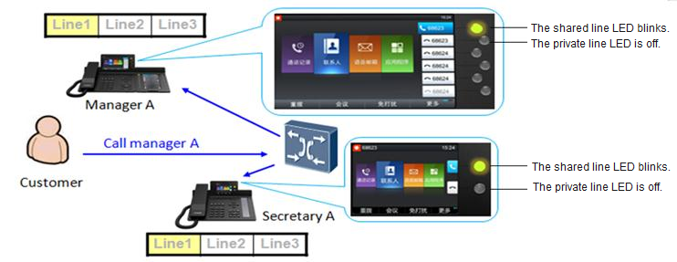

            - Secretary A answers the call. The phones of the manager and the other secretaries stop ringing. The LED of the shared line is steady on. Secretary A talks with the customer or employee.
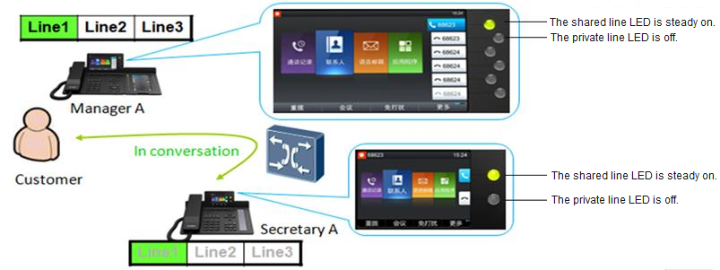

            - Secretary A uses the private line to call the manager. The manager's phone screen displays secretary A's private number. The manager is talking with secretary A, and the customer or employee hears music on hold.
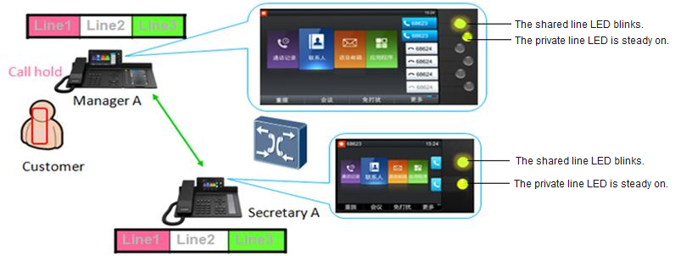

            - The manager presses the line button whose LED blinks to talk with the customer or employee. At the same time, the call between secretary A and the customer or employee is automatically released. If the manager does not want to answer the call from the customer or employee, secretary A presses the line button whose LED blinks to resume the call with the customer or employee.
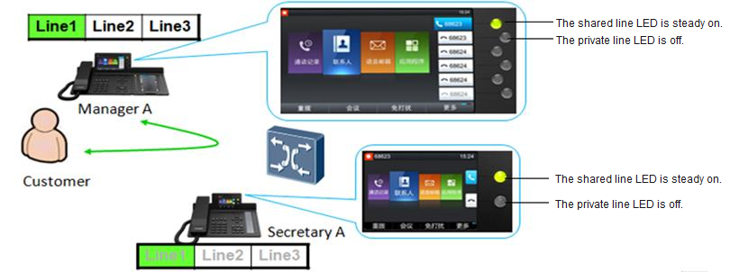

Scenario 2: The manager directly answers incoming calls.
When a call comes in, the manager sees that the call is from a VIP and therefore directly answers the call, without the call being transferred by the secretary. By reading the shared line status, the secretary understands that the manager has answered the call and therefore ignores the call.
Implementation
None
Dependencies
None
Restrictions
None

Hunt Group
Applicability
IP Phone Model | EC3.0 | IMS+UC | EC6.X
7910 | √ | × | √
7950 | √ | × | √
8950 | √ | × | √

Description
Definition
In an enterprise, employees in the same field can be added to a hunt group, with the group access code configured. After a user dials the access code of a hunt group, the system calls users in the hunt group, and the phones in the hunt group ring in the specified ringing mode (simultaneous, sequential, or cyclic ringing). If no one in the hunt group answers the call, the call is forwarded to a specified number or virtual voicemail of the hunt group.
Application scenarios
Signing in to a hunt group
Members in a hunt group can sign in to or sign out of the hunt group with a press on the corresponding programmable button. If authentication is required for the sign-in and sign-out, they need to enter a 6-digit numeric password as prompted.
Using the hunt group service
Enterprise extensions A and B have signed in to a hunt group, and extension B is engaged in an ongoing call.
When user C dials the access code of the hunt group, the system automatically routes the call to extension A as it detects that extension B is busy.
Implementation
None
Dependencies
None
Restrictions
None

Paging Group
Applicability
IP Phone Model | EC3.0 | IMS+UC | EC6.X
7910 | √ | × | ×
7950 | √ | × | ×
8950 | √ | × | ×

Description
Definition
In an enterprise, multiple numbers with the same broadcast subject can be added to a paging group. Members in the paging group are either initiators or recipients. An initiator can dial the access code of their own paging group to implement voice broadcast to all recipients in the same paging group regardless of the services that the receivers have registered (except the DND service). The recipients do not need to answer the calls manually, either.
Application scenarios
The initiator can configure the hunt group access code on a programmable button for speed dial. Then, the initiator can call the paging group by simply pressing this button. Phones of the recipients in the paging group respond as follows:
If a recipient is in an active call, the recipient can still hear the broadcast message.
If a recipient enables the DND service, the system determines whether to play the broadcast message to the recipient based on the service priority set for the paging group.
If a recipient is idle or if a recipient has picked up the phone but is not in a call, the speaker automatically opens and plays the broadcast message after a beep sound.
When the initiator stops talking and hangs up, the broadcast stops on all phones of the recipients.
Implementation
None
Dependencies
For details, see the description of the audio paging service in the U1900 Unified Gateway Product Documentation.
Restrictions
None

Password-based Call Barring
Applicability
IP Phone Model | EC3.0 | IMS+UC | EC6.X
7910 | √ | × | √
7950 | √ | × | √
8950 | √ | × | √

Description
Definition
A password can be set for an IP phone so that unauthorized users must provide the password to use the IP phone.
The password-based call barring service applies to the following call types:
- inter: intra-office call
- local: local call
- ddd: national toll call
- idd: international toll call
Application scenarios
When a user enters a number and attempts to make a national toll call, the gateway IVR prompts the user to enter the password. After the user enters the password, the gateway verifies the password and initiates a call to the specified number only after the verification succeeds. When the user enters the password, the IP phone screen does not display the entered password.
Implementation
None
Dependencies
None
Restrictions
Password-based call barring is supported only in EC3.0 and EC6.X.

One-Key Switch
Applicability
IP Phone Model | EC3.0 | IMS+UC | EC6.X
7910 | × | √ | √
7950 | × | √ | √
8950 | × | √ | √

Description
Definition
PBX user A is bound to a mobile phone. When user A talks with user B, user A can switch between the IP phone and the bound mobile phone.
Application scenarios
Scenario 1: The bound mobile phone answers the ONLY call and switches to the IP phone.
User B calls user A's ONLY number. User A uses the bound mobile phone to answer the call. After a while, user A wants to switch to the IP phone to answer the call. User A presses the one-key switch key on the IP phone and uses the IP phone to talk with user B. User A's bound mobile phone exits the call.
Scenario 2: The IP phone is switched to the mobile phone.
When using an IP phone to talk with user B, user A wants to switch the call to the bound mobile phone. User A presses the one-key switch key on the IP phone, and the call is forwarded to the bound mobile phone. The PBX calls the bound mobile phone through trunks. User A uses the bound mobile phone to talk with user B, and the IP phone exits the call.
Scenario 3: After an IP phone is switched to a mobile phone, the mobile phone is switched back to the IP phone.
User A is talking with user B and presses the one-key switch key to forward the call to the bound mobile phone. After a while, user A wants to switch to the IP phone to answer the call and presses the one-key switch key. User A starts to use the IP phone to talk with user B and the bound mobile phone exits the call.
Implementation
None
Dependencies
None
Restrictions
None

Call Recording
Applicability
IP Phone Model | EC3.0 | IMS+UC | EC6.X
7910 | √ | × | √
7950 | √ | × | √
8950 | √ | × | √

Description
Definition
The service party stores the call recording on the server. Users can select the recording start time.
Application scenarios
During a call, the service party presses the recording button on the IP phone to trigger the server to record the call. Recording files are stored on the server. When the user presses to stop recording, the recording is canceled.
Implementation
None
Dependencies
None
Restrictions
None

UC Features

IP Phone Linkage
Applicability
IP Phone Model | EC3.0 | IMS+UC | EC6.X
7910 | √ | √ | √
7950 | √ | √ | √
8950 | √ | √ | √
Description
Definition
A UC user usually has multiple terminals. In a typical scenario, a UC user has one PC client and one IP phone. An IP phone can be linked with a PC client so that the PC client can perform the following operations for the linked IP phone:
- Answering calls
- Placing calls
- Rejecting calls
- Ending calls
- Holding/Resuming calls
- Redirecting calls using call divert
- Joining or starting instant conferences
- Joining scheduled conferences
Application scenarios
Scenario 1: placing a call for the linked IP phone on the PC client
A user places a call on the PC client, and the linked IP phone automatically goes off-hook and places the call. The dialing window is displayed on both the PC client and IP phone. If the peer party does not answer the call, the no response message is displayed on both the PC client and IP phone. If the peer party answers the call, the calling window is displayed on both the PC client and IP phone. If the peer party rejects the call, the IP phone plays the announcement, indicating that the peer party is busy.
Scenario 2: answering a call for the linked IP phone on the PC client
When a call comes in to an IP phone, an incoming call notification window is also displayed on the linked PC client. After the user clicks the Answer button on the PC client, the calling window is displayed on the PC client and the IP phone automatically goes off-hook in speaker mode. The IP phone carries audio.
Scenario 3: rejecting a call for the linked IP phone on the PC client
When a call comes in to an IP phone, the user clicks the Reject button on the linked PC client. The IP phone then stops ringing. An IM quick reply can be sent from the PC client upon call rejection. The user can click the arrow next to Reject and select a quick reply from the drop-down list. After that, an IM is automatically sent to the peer party when the user rejects the call. Note that the peer party must be a PC client user within the enterprise; otherwise, the IM quick reply will be unavailable.
Scenario 2: ending a call for the linked IP phone on the PC client
When a user is having an audio call over an IP phone, the user can click the Hangup button on the linked PC client to end the call for the IP phone.
Scenario 5: placing a call on hold for the linked IP phone on the PC client
When a call is in progress on an IP phone, the calling window is also displayed on the linked PC client. The user can click the Hold button on the PC client to place the call on hold for the IP phone.
Scenario 5: resuming a call for the linked IP phone on the PC client
When a call is in progress on an IP phone, the calling window is also displayed on the linked PC client. If the call is placed on hold, the user can click the Resume button on the PC client to resume the call for the IP phone.
Scenario 7: redirecting a call for the linked IP phone on the PC client
When a call comes in to an IP phone, both the IP phone and the linked PC client ring. The user can choose Answer > Transfer to new number in the incoming call notification window of the PC client, and enter the target number. Then, the IP phone stops ringing, and the call is redirected to the specified number.
Scenario 8: starting an instant conference on an IP phone
A user starts an instant conference using an IP phone and selects participants. The voice conference window is displayed on the linked PC client. On the PC client, the user can see the conference list and participant status, and perform conference control. The user can also upgrade the voice conference to a multimedia one, or directly start a multimedia conference. The data in the multimedia conference will be displayed on the PC client, and the audio is carried on the IP phone. On the IP phone, the participants and their status can be viewed.
Scenario 9: changing a two-party call to a multi-party conference on an IP phone
A user is having a point-to-point call using an IP phone. Then, the user presses the conference button on the IP phone and selects participants to upgrade the call to a multi-party voice conference. The conference experience is the same as that described in scenario 8.
Scenario 10: starting an instant conference on a PC client
On a PC client, a user initiates a temporary group chat and then clicks the call button to start an instant conference. The conference experience is the same as that described in scenario 8.
Scenario 11: changing a two-party call to a multi-party conference on a PC client
A user is having a point-to-point call using an IP phone. Then, the user selects other contacts on the linked PC client and upgrades the call to a voice conference. The conference experience is the same as that described in scenario 8.
Scenario 12: joining a scheduled conference using an IP phone
Upon receiving a conference notification, a user dials the conference access code and password using an IP phone. After the IP phone joins the conference, the participant list and status are displayed on the linked PC client. If the conference is a multimedia one, the data is displayed on the PC client and the audio is carried on the IP phone.
Scenario 13: joining a scheduled conference using a PC client
Upon receiving a conference notification, a user can join the conference in either of the two ways on a PC client: one-button click in the conference list and dialing the desired number using the keypad. After the IP phone joins the conference, the participant list and status are displayed on the linked PC client. If the conference is a multimedia one, the data is displayed on the PC client and the audio is carried on the IP phone.
Implementation
None
Dependencies
None
Restrictions
Conference control operations can be performed only on the PC client.
In the IP phone linkage scenario, a voice conference supports a maximum of 20 participants.
After IP phone linkage is enabled, the call services configured on the IP phone prevail. For example, when a call comes in to a DND-enabled IP phone, the system considers that DND is also enabled on the linked PC client and therefore does not deliver the call to the PC client.

Corporate Directory
Applicability
IP Phone Model | EC3.0 | IMS+UC | EC6.X
7910 | √ | √ | √
7950 | √ | √ | √
8950 | √ | √ | √

Description
Definition
Users can query the information (such as name, extension number, and mobile number) about other employees in the company. Once the user enters the search criteria in the main window of the corporate directory, the server returns the results that meet the search criteria. The user can further operate the results, for example, viewing detailed information, saving as a contact, or placing a call.
Application scenarios
Before using this function, a user must configure the corporate directory server IP address and port number correctly. After the configuration, the corporate directory function allows the user to query enterprise user information based on the query criteria and view the analyzed information in a list returned by the server.
The user can perform further operations on the search results, such as viewing details, saving as contacts, placing calls, or editing before calling.
The IP phone and the server use HTTP for requests and responses related to the corporate directory service. This feature needs the support of a server.
In addition to corporate directory information query by keyword (for example, name, fixed-line phone number, or mobile number), a user can also query all corporate directory information by department based on the department tree in certain solutions.
Implementation
None
Dependencies
None
Restrictions
Corporate directory information query by department is supported only in the IMS+UC solution.

Tree-Structure Directory
Applicability
IP Phone Model | EC3.0 | IMS+UC | EC6.X
7910 | × | × | ×
7950 | × | × | ×
8950 | √ | √ | √

Description
Definition
The corporate directory can be displayed in the tree or list mode. In tree mode, users can search for contacts by department.
Application scenarios
When a user selects a department, the IP phone displays all contacts in the department. This helps users search for contacts by department.
Implementation
None
Dependencies
None
Restrictions
The ContactTreeListEnable function must be enabled on IP phones.

Name and Department Display
Applicability
IP Phone Model | EC3.0 | IMS+UC | EC6.X
7910 | √ | √ | √
7950 | √ | √ | √
8950 | √ | √ | √

Description
Definition
When placing or receiving a call, an IP phone searches the contact list or corporate directory for the contact name and department of the peer party.
Application scenarios
When placing or receiving a call, an IP phone first searches the contact list for the contact name and department based on the peer party's phone number. If related information is searched out, the contact name and department are displayed on the phone screen. If no information is searched out, the IP phone searches the corporate directory for the contact name and department. If no information is searched out, only the calling number or called number is displayed on the phone screen.
Implementation
None
Dependencies
None
Restrictions
The feature partly depends on the corporate directory feature.

Profile Picture Display
Applicability
IP Phone Model | EC3.0 | IMS+UC | EC6.X
7910 | √ | √ | √
7950 | √ | √ | √
8950 | √ | √ | √
Description
Definition
When placing or receiving a call, an IP phone searches the contact list or corporate directory for the profile picture of the peer party.
Application scenarios
When placing or receiving a call, an IP phone first searches the contact list for the contact based on the peer party's phone number. If related information is searched out, the contact profile picture is displayed on the phone screen. If no information is searched out, the IP phone searches the corporate directory for the contact. If no information is searched out, the default profile picture is displayed on the phone screen.
Implementation
None
Dependencies
None
Restrictions
This feature requires the coordination of the AppServer (UC1.1) or PGM server (UC2.0).

Mobile Connect
Applicability
IP Phone Model | EC3.0 | IMS+UC
7910 | × | √
7950 | × | √
8950 | × | √

Description
Definition
Mobile connect allows a PBX user to switch between an IP phone and the bound mobile phone during a call.
The user can switch between the IP phone and bound mobile phone for multiple times during a call.
Application scenarios
Scenario 1: answering a call using the bound mobile phone and switching the call to the IP phone
User B calls the ONLY number of user A, and user A answers the call using the bound mobile phone. After a while, user A wants to switch the call to the IP phone. To achieve so, user A presses the Mobile Connect button on the IP phone. Then, use A's mobile phone is disconnected from the call.
Scenario: switching from an IP phone to a mobile phone
User A is having a call with user B over the IP phone, but now user A wants to switch the call to the bound mobile phone. To achieve so, user A presses the Mobile Connect button on the IP phone, which triggers the PBX to call the mobile phone through a trunk. Then, use A's IP phone is disconnected from the call.
Scenario 3: switching from an IP phone to a mobile phone and then back to the IP phone
During a call with user B over the IP phone, user A presses the Mobile Connect button to switch the call to the bound mobile phone. After a while, user A wants to switch the call back to the IP phone. To achieve so, user A presses the Mobile Connect button again on the IP phone. Then, use A's mobile phone is disconnected from the call.
Implementation
None
Dependencies
None
Restrictions
None

Extension Mobility
Applicability
IP Phone Model | EC3.0 | IMS+UC | EC6.X
7910 | √ | √ | √
7950 | √ | √ | √
8950 | √ | √ | √

Description
Definition
Extension mobility allows a user to use his or her IP phone's extension number and password to log in to any other IP phone. The user's configuration (including contacts and programmable buttons) and services will be automatically downloaded to the IP phone that the user newly logs in to. If the IP phone that the user newly logs in to is a different model from the user's original one, only the functions that the new login IP phone supports take effect.
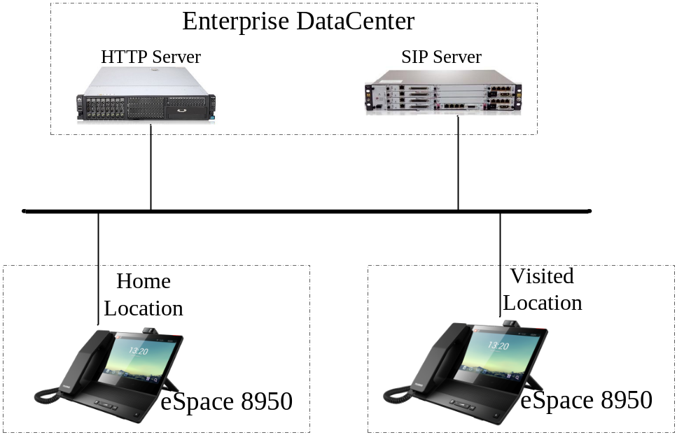

In the home location, after a user configures the IP phone for the first time or modifies the configuration, the IP phone uploads the configuration to the profile server. When this user logs in to another IP phone in the visited location using the account and password of the IP phone in the home location, the IP phone in the visited location downloads the user's configuration from the profile server.
Information that can be carried to the visited location:
- Account information, including the primary-secondary relationships between the configured accounts, phone numbers, names, number of lines, and login passwords.
- Services enabled for each account.
- Programmable buttons.
- Preferences, only for the system wallpapers and ringtones selected. If the wallpapers and ringtones selected are customized ones, they cannot be carried to the visited location.
- User configuration on the expansion module.
- Line button configuration.
Application scenarios
None
Implementation
None
Dependencies
None
Restrictions
None

Presence

Status Display
Applicability
IP Phone Model | EC3.0 | IMS+UC | EC6.X
7910 | × | √ | ×
7950 | × | √ | ×
8950 | × | √ | ×

Description
Definition
An IP phone displays the status of a contact on the phone screen according to the contact's online status and information changes detected by the system.
The contact online status includes online, busy (in-call or in-conference), DND, away, and offline. The contact information includes the profile picture and phone numbers.
Application scenarios
None
Implementation
None
Dependencies
None
Restrictions
The default profile picture set on an IP phone cannot be synchronized to a PC client. The default profile picture set on a PC client cannot be synchronized to an IP phone but can be synchronized to another PC client.
7900 series IP phones support four states: online, busy, away, and offline. The busy state may also indicate the DND state, and 7900 series IP phones do not differentiate between these two states.

Status Publishing
Applicability
IP Phone Model | EC3.0 | IMS+UC | EC6.X
7910 | × | √ | ×
7950 | × | √ | ×
8950 | × | √ | ×

Description
Definition
A user can publish his or her status and information for others to learn.
The status refers to the user's online status, which includes online, busy (in-call or in-conference), DND, away, and offline. The contact information includes the profile picture and phone numbers.
Application scenarios
None
Implementation
None
Dependencies
None
Restrictions
7900 series IP phone can publish three states: online, busy, and DND.

Real-Time Buddy Status and Information Notification
Applicability
Terminal Type | EC3.0 | IMS+UC | EC6.X
7910 | × | √ | ×
7950 | × | √ | ×
8950 | × | √ | ×

Description
Definition
After the status or information changes of a user are sent to the server, the server delivers the changes in real time to the user's buddies.
Application scenarios
None
Implementation
None
Dependencies
None
Restrictions
None

Voicemail
Applicability
IP Phone Model | EC3.0 | IMS+UC | EC6.X
7910 | √ | √ | √
7950 | √ | √ | √
8950 | √ | √ | √

Description
Definition
An IP phone allows calling parties to leave messages when the user of this IP phone cannot answer the incoming calls. The server connects the incoming calls to the voicemail. When the user's voicemail has new messages, the IP phone displays the number of unread messages on its screen. Users can access the voicemail to obtain the voice messages.
Application scenarios
Incoming calls are forwarded to the voicemail when conditions set for the corresponding call-forward-to-voicemail service are met. The service can be call-forward-to-voicemail-all, call-forward-to-voicemail-busy, call-forward-to-voicemail-no-answer, or call-forward-to-voicemail-offline.
The function of manually forwarding incoming calls to the voicemail is also available. When a call comes in, the user can press the corresponding button on the IP phone to forward the call to the voicemail. This function does not need to be enabled beforehand.
On the phone screen, users can view the numbers of unread and total messages in the voicemail. When the voicemail has unread messages, the MWI on the phone blinks.
An IP phone usually provides a button for users to retrieve the voice messages. After new voice messages are retrieved, the numbers of read and unread messages are updated in real time in the voicemail.
Implementation
To retrieve voice messages, a user needs to access the voicemail and perform related operations as prompted by the IVR.
Dependencies
None
Restrictions
The related call-forward-to-voicemail service rights need to be assigned first.
With the common voicemail function, users cannot view the sender, sending time, and size of a voice message, and they can only view the numbers of total and unread voice messages.

Visual Voicemail
Applicability
IP Phone Model | EC3.0 | IMS+UC | EC6.X
7910 | × | √ | √
7950 | × | √ | √
8950 | × | √ | √

Description
Definition
The visual voicemail function allows users to view the sender, sending time, size, and importance of each voice message. Users do not need to use IVR to obtain such information.
Application scenarios
When retrieving voice messages, users can view the message list, where the sender, sending time, size, message status (read or unread), and importance of each message are displayed.
The following operations are available when users listen to voice messages:
- Pause and play: When the pause operation is performed, the message is not played and the progress bar is stopped. In this case, the user can press the play button to resume the message.
- Fast forward and rewind: When the fast forward or rewind operation is performed, the progress bar displayed on the screen is also updated.
- Previous and next: Users can listen to the previous or next voice message, and the current message stops.
- Delete: Users can delete messages. The messages stored on the server are also deleted.
- Forward: Users can forward messages to others.
- Callback: Users can call the message senders when they are listening to the messages.
Visual voicemail allows users to manage voice messages in an intuitive manner.
Implementation
None
Dependencies
None
Restrictions
The related call-forward-to-voicemail service rights need to be assigned first.
To achieve visual voicemail, the visual voicemail server is required. A common voicemail server does not support visual voicemail.

Conference Features

Instant Conference
Applicability
IP Phone Model | EC3.0 | IMS+UC | EC6.X
7910 | √ | √ | √
7950 | √ | √ | √
8950 | × | √ | √

Description
Definition
The instant conference function allows users to hold conferences instantly on the IP phone, without reserving conference resources beforehand.
During a conference, the moderator can add or remove participants freely.
The moderator can select a contact from the personal or corporate directory or enter the contact information to add the contact to an instant conference.
If an IP phone supports only audio, only an audio conference can be created on the IP phone. If it supports video, users can create video conferences.
A user can join a conference even if the user has not been assigned the conference service rights.
Application scenarios
User A directly creates an audio or video conference on the IP phone, without scheduling the conference beforehand.
Implementation
None
Dependencies
None
Restrictions
None

Scheduled Conference
Applicability
IP Phone Model | EC3.0 | IMS+UC | EC6.X
7910 | × | × | ×
7950 | × | × | ×
8950 | × | √ | √

Description
Definition
IP phones can receive notifications for conferences scheduled on the conference system portal. Users can join a conference directly from the conference notification without having to enter the conference ID and password.
Application scenarios
Scenario 1: A user schedules a server conference on the conference system portal. The user specifies the conference subject, time, location, and participants. After the conference is scheduled, the conference server reserves the conference resource. The user can obtain the scheduled conference list on an IP phone and join a scheduled conference from the conference list.
Scenario 2: An IP phone receives a conference notification and displays the information on its screen. The user can join the conference directly from the conference notification.
This scenario is supported only in the IMS+UC solution.
Implementation
None
Dependencies
None
Restrictions
None

Audio Conference
Applicability
IP Phone Model | EC3.0 | IMS+UC | EC6.X
7910 | √ | √ | √
7950 | √ | √ | √
8950 | × | √ | √

Description
Definition
An IP phone allows users to join an audio conference in two ways:
            - By dialing the predefined access number
            - By directly joining the conference after the conference initiator dials a participant's phone number
Application scenarios
User A creates an audio conference on an IP phone and invites user B (mobile phone), use C (landline phone), and user D (soft terminal) to the conference. Then, these users can talk with each other freely.
Implementation
None
Dependencies
None
Restrictions
None

Video Conference
Applicability
IP Phone Model | EC3.0 | IMS+UC | EC6.X
7910 | × | × | ×
7950 | × | × | ×
8950 | √ | √ | √

Description
Definition
Video conferencing allows users to have face-to-face-like communication, helping improve work efficiency and resolve problems (such as time, expense, and safety) caused by off-site conferences.
During a conference, participants can enable and disable their own video. The opened video can be shared with all participants. Participants can also view video in full-screen mode, close the video window, and drag the video window to any place.
Application scenarios
Scenario 1: User A sets up a video call and then changes it to a video conference. User A can add more users to the conference.
Scenario 2: User A directly creates a video conference and invites users in different areas to the conference over the phone.
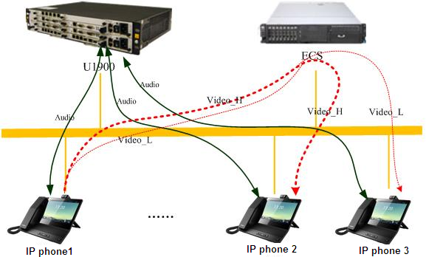

During a video conference, the U1900 server and ECS server are required to implement audio mixing and video stream forwarding respectively.
Audio mixing: After an IP phone sends voice RTP data to the U1900 server, the U1900 server performs audio mixing based on the RTP data and then sends the mixed voice data to other IP phones.
Video stream forwarding: After an IP phone sends video data to the ECS server, the ECS server forwards the video data to other IP phones (IP phone 2 and IP phone 3 in the preceding figure). Generally, video data sent by an IP phone to the ECS server includes high-resolution (Video_H) data and low-resolution (Video_L) data. Users using IP phone 2 and IP phone 3 can select to view the high-resolution data or low-resolution data.
Implementation
None
Dependencies
None
Restrictions
If the resolution of shared video is higher than the QCIF resolution and the resolution is supported in the conference, two streams (one in the original resolution and the other in the QCIF resolution) will be sent to the server.
The transmit end automatically checks the upstream network. If finding that the video fails to be sent, the transmit end automatically drops frames until the video can be sent. This ensures that the frames sent each time are the latest frames. The video frame rate in this case is not fixed. When the network conditions are good, the video frame rate is increased but cannot exceed the maximum frame rate that is preset during conference creation.
The receive end adaptively receives high-bit-rate or low-bit-rate streams based on the current layout and network connection status.
The ECS server does not perform video mixing based on video data. Therefore, an IP phone needs to parse multiple channels of video data to display multiple videos on the screen concurrently. Currently, 8950 supports the display of a 720p and four CIF videos, as shown in the following figure.
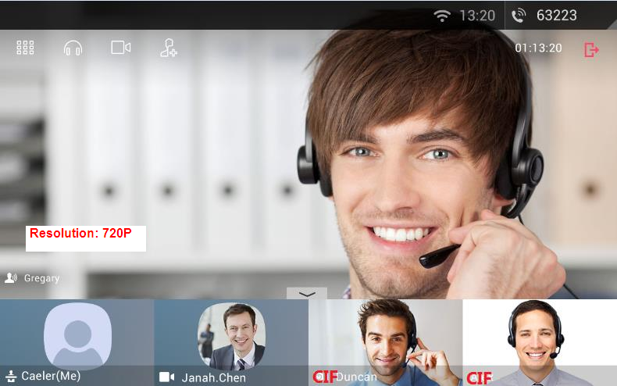

Conference Control
Applicability
IP Phone Model | EC3.0 | IMS+UC | EC6.X
7910 | √ | √ | √
7950 | √ | √ | √
8950 | × | √ | √

Description
Definition
The moderator and participants can perform conference control operations during a conference.
Application scenarios
The conference control operations include the following:
- Adding or removing participants by the moderator
During a conference, only the moderator can add participants by online invitation.
Two invitation methods are available: by directly calling the participant and by sending an invitation email.
During a conference, only the moderator can remove participants.
- Muting and unmuting participants by the moderator
- Local microphone control by participants
A multimedia conference is by default in free mode. Participants can freely control their local microphones during a conference. The participants' rights to control their local microphones override the moderator's rights to control the participant's microphones. When the moderator mutes a participant, the participant can still enable his or her local microphone.
An audio conference is in moderator control mode. That is, participants can control their own local microphones.
- Camera control by participants
In a multimedia conference, participants can freely enable or disable their local cameras. The moderator cannot control the cameras of others in the conference.
If the number of cameras enabled in a conference reaches the maximum number allowed in the conference, no more cameras can be enabled.
- Conference control on an IP phone
The following figure shows the functions available for a participant after the participant taps the video of another participant. In addition, a participant can also swipe left or right to switch videos of other participants.
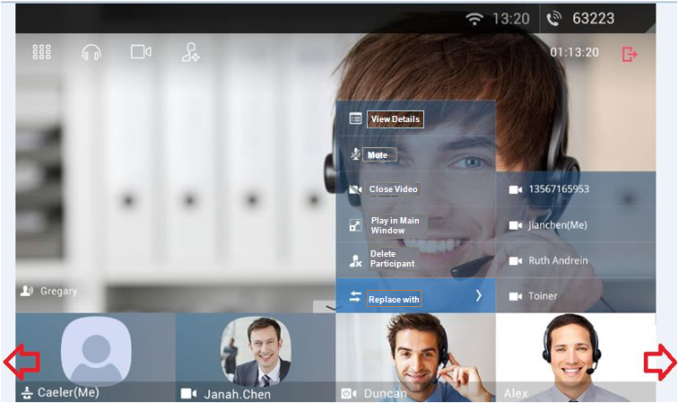
Implementation
None
Dependencies
None
Restrictions
None

Security Features

Transport Layer Security
Applicability
IP Phone Model | Supported or Not (√: Supported; ×: Not Supported)
7910 | √
7950 | √
8950 | √

Description
Definition
An IP phone support Secure Sockets Layer (SSL) encryption transmission. SSL and its successor, Transport Layer Security (TLS), are cryptographic protocols that provide security and data integrity for communications over networks. TLS and SSL encrypt the segments of network connections at the transport layer, using the data encryption technology to ensure data transmission security.
During an audio or video call, the Security Real-Time Protocol (SRTP) protocol is used to encrypt media streams to ensure data security.
Application scenarios
None
Implementation
None
Dependencies
None
Restrictions
None

Configuration File Encryption
Applicability
IP Phone Model | Supported or Not (√: Supported; ×: Not Supported)
7910 | √
7950 | √
8950 | √

Description
Definition
To ensure security of key information (such as passwords) in its configuration file, an IP phone supports download of AES-128-encrypted configuration files from the network management system.
Application scenarios
None
Implementation
None
Dependencies
None
Restrictions
None

802.1x Authentication
Applicability
IP Phone Model | Supported or Not (√: Supported; ×: Not Supported)
7910 | √
7950 | √
8950 | √

Description
Definition
802.1x is a protocol for port-based network access control. It authenticates and controls devices connected to the LAN.
- If a device connected to an 802.1x-enabled port of the upper-layer switch is authenticated, the device can access resources on the LAN.
- If a device fails to be authenticated, the device cannot access resources on the LAN.
An IP phone supports 802.1x access authentication using the EAP-MD5 or EAP-TLS algorithm. This helps ensure network access security.
Application scenarios
None
Implementation
None
Dependencies
None
Restrictions
None

802.1x Logoff-Proxy
Applicability
IP Phone Model | Supported or Not (√: Supported; ×: Not Supported)
7910 | √
7950 | √
8950 | √

Description
Definition
When an IP phone functions as a small switch, a PC or any other network devices can be connected to the PC port of the IP phone. The IP phone automatically detects whether a device is connected to its PC port. With 802.1x authentication enabled, the IP phone, if detecting that its PC port goes offline, instructs the upper-layer switch to invalidate the device access authentication. This helps effectively prevent illegal network access.
Application scenarios
None
Implementation
None
Dependencies
None
Restrictions
None

Reliability Features

Multi-Registration
Applicability
IP Phone Model | Supported or Not (√: Supported; ×: Not Supported)
7910 | √
7950 | √
8950 | √

Description
Definition
An IP phone supports simultaneous registration and sequential registration. The registration mode is selected according to the solution in use.
In sequential registration, an IP phone registers with the active, standby, and local servers in sequence. When a server with which the IP phone registers fails during a call, the IP phone does not switch to the next server for re-registration until the current registration period expires. Within that period, the IP phone does not send the Subscribe and Out-of-dialog SIP messages to the next server either.
In simultaneous registration, an IP phone registers to the active, standby, and local servers simultaneously. When the server in use fails during a call, the IP phone switches the call to the next available server even within the current registration period. Within that period, the IP phone does not send the Subscribe and Out-of-dialog SIP messages to the next available server.
Application scenarios
None
Implementation
              - Sequential registration
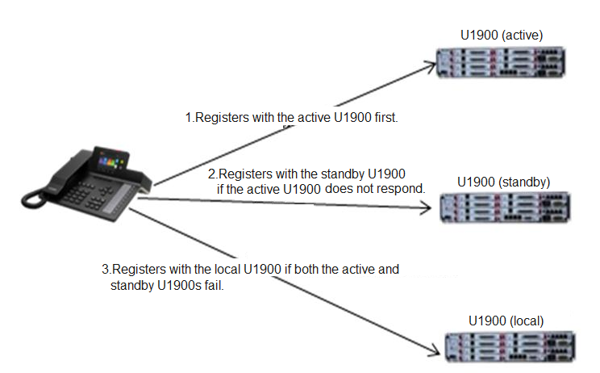

An IP phone initiates a registration request to the active, standby, and local servers in sequence. At every registration update interval (1/2 registration period), the IP phone tries to register with the highest priority server. If this server does not respond within a specified period (3s by default, but configurable), the IP phone tries the server with a lower priority.
              - Simultaneous registration
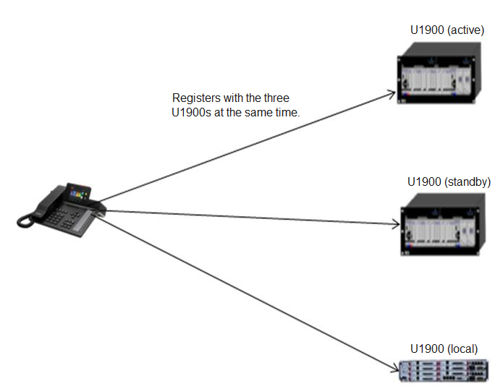

An IP phone registers with the active, standby, and local servers at the same time.
When the IP phone initiates a call, the call is connected to the active server first. If the active server does not respond within a specified period (3s by default, but configurable), the call is switched to the standby server. If the standby server also does not respond within the specified period, the call is switched to the local server.
Subsequent calls will be initiated to the highest priority server until the registration period is updated.
Dependencies
None
Restrictions
This function is related to the redundancy capabilities of the solution to use. Currently, UC1.1 and IPT2.2 support sequential registration of an IP phone, while UC2.0 supports simultaneous registration.

Corporate Directory Redundancy
Applicability
IP Phone Model | EC3.0 | IMS+UC
7910 | × | √
7950 | × | √
8950 | × | √
Description
Definition
If the PGM or uPortal servers are used as the corporate directory servers, they can be deployed redundantly. When the active corporate directory server does not respond, the IP phone automatically switches to the standby corporate directory server for a query.
Application scenarios
None
Implementation
None
Dependencies
None
Restrictions
None

eSight Redundancy
Applicability
IP Phone Model | Supported or Not (√: Supported; ×: Not Supported)
7910 | √
7950 | √
8950 | √
Description
Definition
An IP phone supports eSight redundancy. The eSight server domain name configured on the DNS server is mapped to the IP addresses of both the active eSight and the standby eSight. When the IP phone receives the IP addresses resolved by the DNS server, the IP phone initiates a connection request to the active eSight first. If the active eSight fails to respond, the IP phone connects to the standby eSight.
Application scenarios
None
Implementation
None
Dependencies
None
Restrictions
None

AA Server Redundancy
Applicability
IP Phone Model | EC3.0 | IMS+UC | EC6.X
7910 | × | √ | ×
7950 | × | √ | ×
8950 | × | √ | ×

Description
Definition
8950 supports access agent (AA) server redundancy. In the IMS+UC network environment, when the active AA server does not respond, the IP phone automatically switches to the standby AA server.
Application scenarios
None
Implementation
None
Dependencies
None
Restrictions
This function is available when the AA server is deployed in the solution.

Openness Features

XML
Applicability
IP Phone Model | Supported or Not (√: Supported; ×: Not Supported)
7910 | √
7950 | √
8950 | ×

Description
Definition
An IP phone supports a simple browser function developed based on XML and HTTP/HTTPS, which is XML browser. With the assistance of a tool, an XML file can be generated on the server based on specific syntax to provide desired functions. Then, an IP phone can use HTTP/HTTPS to download the XML file to implement the XML browser function.
Users can assign the XML browser function to a programmable button, a line button, or a button on the expansion module. The corresponding server address also needs to be configured. After a press on the corresponding button, the IP phone sends a query request to the XML server, and the XML responds to the IP phone with the desired service.
The administrator can also deliver XML messages to an IP phone.
Application scenarios
None
Implementation
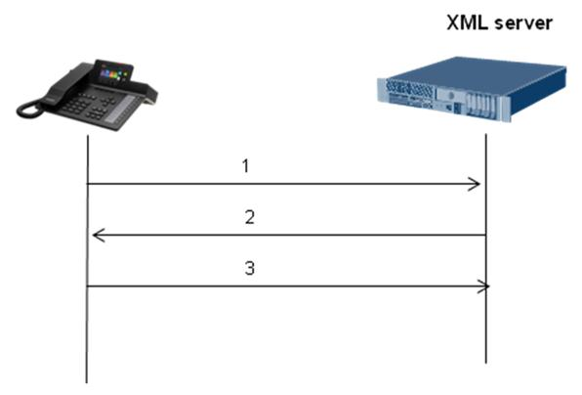

            - An IP phone is registered and sends its information (such as the IP address and phone number) to the XML server.
            - The XML server sends a POST message carrying the XML file path to the IP phone.
            - The IP phone resolves the path, downloads the XML files, and displays the information resolved from the XML file.
Dependencies
None
Restrictions
The coordination of the XML server is required.

Management Features

eSight Deploy (TR-069)
Applicability
IP Phone Model | Supported or Not (√: Supported; ×: Not Supported)
7910 | √
7950 | √
8950 | √

Description
Definition
An IP phone can report its basic information to eSight. On eSight, users can perform the following operations: IP phone deployment, automatic number allocation, restart, batch upgrade, batch configuration, and log export.
Application scenarios
IP phone deployment on eSight
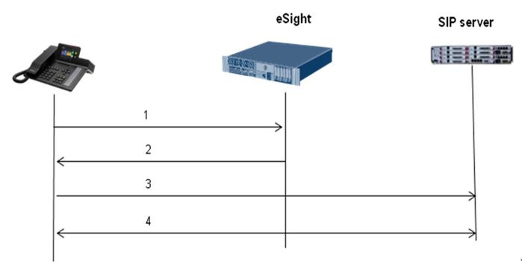

            - IP phones on different sites, after obtaining the eSight IP address through the DNS, report their information (including their IP addresses) to eSight; alternatively, eSight proactively scans online IP phone.
            - eSight classifies IP phones into different subnets according to their IP addresses and delivers different configuration files for IP phones on different sites. A configuration file contains the registrar server addresses and phone-related configurations.
            - IP phones register with the servers according to the information provided in the configuration files.
            - IP phones perform call-related operations by interacting with the SIP server.
Implementation
None
Dependencies
None
Restrictions
None

DHCP Deploy
Applicability
IP Phone Model | Supported or Not (√: Supported; ×: Not Supported)
7910 | √
7950 | √
8950 | √

Description
Definition
During its power-on, an IP phone sends a request to the DHCP server for obtaining its IP address. The DHCP server returns an IP address together with the URL of the server where the UPF file is stored. The server URL is carried in the Option 246 field of the Offer packet returned by the DHCP server. The IP phone parses the packet and obtains the URL of the UPF file. After obtaining the UPF file from that URL, the IP phone updates files such as the configuration file and version file, according to the upgrade policy specified in the UPF file.
Besides Option 246, an IP phone also supports the following options:
Option 15: eSight domain suffix (default: http://esight.huawei.com, which can be changed to http://esight.xxxx.com)
Option 42: NTP server address
Option 132: 802.1Q VLAN ID
Option 133: 802.1p Layer 2 priority
Option 134: DSCP Layer 3 priority
Application scenarios
None
Implementation
None
Dependencies
None
Restrictions
None

Log Export
Applicability
IP Phone Model | Supported or Not (√: Supported; ×: Not Supported)
7910 | √
7950 | √
8950 | √

Description
Definition
Users can export logs to a local computer through the web page or use eSight to export logs to the server.
Application scenarios
The administrator finds that an IP phone malfunctions and therefore exports related logs for technical support engineers to locate faults.
Implementation
None
Dependencies
None
Restrictions
None

Media Features

Audio Pickup
Applicability
IP Phone Model | Pickup Distance
7910 | 3 meters
7950 | 3 meters
8950 | 3 meters

Description
Definition
An IP phone can pick up audio from a distance of up to 3 meters during a call in speaker mode.
The performance of 3-meter audio pickup depends on two aspects:
            - Microphone audio collection capabilities in speaker mode
            - How the audio processing algorithm determines noise, restrain noise, and increase effective audio
Application scenarios
User A is having a call with user B in speaker mode. User A consults user B about a problem, and user C, three meters away from user B, answers the question. User A can hear what user C is saying.
Implementation
None
Dependencies
None
Restrictions
None

Audio VQE
Applicability
IP Phone Model | Supported or Not (√: Supported; ×: Not Supported)
7910 | √
7950 | √
8950 | √

Description
Definition
Audio voice quality enhancement (VQE) encompasses three features: automatic gain control (AGC), acoustic echo cancellation (AEC), and automatic noise restraint (ANR).
Audio VQE provides a series of audio algorithms designed to improve audio quality based on the analysis of echo, noise, and effectiveness of signals for current audio.
Application scenarios
Scenario: moving around within a specific area during calls in speaker mode
During a call with user B in speaker mode, user A is moving around within a specific area. The distance between user A's mouth and the microphone changes. To ensure the quality of audio that user B hears, AGC increases the gain for low voice and decreases the gain for loud voice.
The input noise and echo vary depending on the environment. To eliminate echo and restrain noise, AEC and ANR are employed.
Implementation
None
Dependencies
None
Restrictions
None

Audio HAC
Applicability
IP Phone Model | Supported or Not (√: Supported; ×: Not Supported)
7910 | √
7950 | √
8950 | √

Description
Definition
The handset of an IP phone is hearing aid-compatible (HAC) to prevent electromagnetic interference from affecting users wearing hearing aids.
Application scenarios
User A is wearing a hearing aid. When having a call over an IP phone, user A cannot hear noise caused by electromagnetic interference.
Implementation
None
Dependencies
None
Restrictions
None

QoS Marking
Applicability
IP Phone Model | Supported or Not (√: Supported; ×: Not Supported)
7910 | √
7950 | √
8950 | √
Description
Definition
With quality of service (QoS) marking enabled, NEs mark different types of packets to send (for example, SIP signaling and RTP media) with different priorities. Switches and routers use different queuing and forwarding policies to perform classification, traffic policing, and traffic shaping for packets during packet transmission. Priority marking is usually implemented at Layer 2 (data link layer) or Layer 3 (IP network layer).
The Layer 2 priority marking mechanism is usually 802.1p.
Layer 3 priority marking mechanisms include type of service (TOS) and differentiated services code point (DSCP). DSCP is forward compatible with TOS.
Application scenarios
An IP phone tags different labels on media data packets and signaling packets for flow control on the upper-layer switch or router.
Implementation
None
Dependencies
None
Restrictions
None

Echo Cancellation
Applicability
IP Phone Model | Supported or Not (√: Supported; ×: Not Supported)
7910 | √
7950 | √
8950 | √

Description
Definition
In traditional communications technology, echo can be classified into electrical echo and acoustic echo.
            - Electrical echo
              - Generation of electrical echo
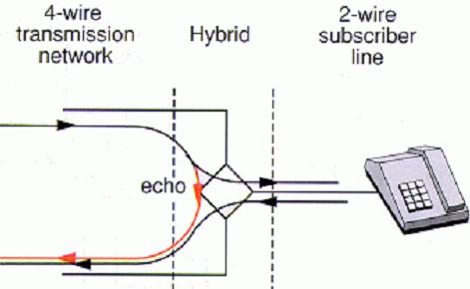

In a communications network, signals are usually transmitted over four wires (one wire for sending signals, one for receiving signals, and two ground wires), and users are connected to the network through two wires (one wire for sending and receiving signals and one ground wire). Therefore, at the user access point of the network, a 2/4-wire converter (hybrid) needs to be installed for conversion (as shown in the Figure 1-1). During conversion, impedance matching cannot be ideal, so some signals received at the receive end of the 4-wire network may leak to the transmit end of the 4-wire network. Such signals are feedback signals, which are also known in electrical echoes. In Figure 1-1, the red line specifies the transmission path of such signals. Ideally, the impedance of the 4-wire network's transmit end to receive end is infinite. In this case, signals received at the receive end of the 4-wire network will not leak to the transmit end, and therefore no echo is generated.
            - Acoustic echo
              - Generation of acoustic echo
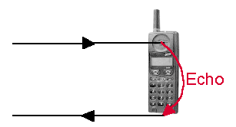

As shown in Figure 1-2, acoustic echo is generated when the voice from the handset is returned to the handset. The echo is more obvious during calls in speaker mode.
Echo cancellation eliminates echoes using digital filter technology. This is important in an IP packet network that features relatively large latency.
Application scenarios
None
Implementation
None
Dependencies
None
Restrictions
None

Jitter Buffer
Applicability
IP Phone Model | Supported or Not (√: Supported; ×: Not Supported)
7910 | √
7950 | √
8950 | √

Description
Definition
In a voice over IP (VoIP) network, a jitter buffer is a shared data area where voice packets can be collected, stored, and sent to the voice processor in evenly spaced intervals. Jitter is a variation in packet arrival time, and can occur because of network congestion, timing drift, or route changes. The jitter buffer, which is located at the receive end of the voice connection, intentionally delays the arriving packets so that the end user experiences a clear connection with minimal sound distortion.
- Adaptive jitter buffer: The depth of the jitter buffer is dynamically adjusted according to the network jitter conditions to achieve optimal balance between the de-jitter performance and the latency.
- Static jitter buffer: The depth of the jitter buffer is not adjusted according to the network jitter conditions. When the network conditions are not good, static jitter buffer can effectively eliminate jitter; but when the network conditions are good, static jitter buffer brings unnecessary call delay.
Application scenarios
The media data packets of VoIP calls do not arrive in sequence because of uncontrollable factors such as network jitter and packet loss. The packet sent later may arrive before those sent later. The destination end uses a buffer to adjust the sequence of the packets received for restoring the original audio or video.
Implementation
None
Dependencies
None
Restrictions
None

VAD and CNG
Applicability
IP Phone Model | Supported or Not (√: Supported; ×: Not Supported)
7910 | √
7950 | √
8950 | √

Description
Definition
- Voice activity detection (VAD) detects the presence and absence of voice and reduces the transmission of data packets during the silence period to save bandwidth. Statistics show that 40% of the time during a call, people do not talk. VAD can detect the continuous silence period and send only silence packets (in compliance with RFC 3889) during the period.
Daily voice communication is conducted in an environment with more or less noise. Silence periods that are absolutely quiet will make calling and called parties feel uncomfortable. When the transmit end is silent, only silence packets are sent at intervals during the silence period. When the receive end receives silence period, comfort noise is generated, telling the receive end that the call is still connected. Comfort noise generation (CNG) generates appropriate background noise during silence periods to deliver a comfortable user experience in voice communications.
VAD and CNG are usually used together, and VAD is usually implemented through system configurations.
Application scenarios
IP phones of both the calling and called parties use VAD to detect whether the current network has data packets. If no, they use CNG to generate conform noise to ensure a good user experience.
Implementation
None
Dependencies
None
Restrictions
None

Automatic Gain
Applicability
IP Phone Model | Supported or Not (√: Supported; ×: Not Supported)
7910 | √
7950 | √
8950 | √

Description
Definition
The digital-analog conversion percentage has different levels of impact on voice quality over different call lines. Generally, a larger percentage indicates a higher volume but more noise signals. Therefore, Appropriate gain must be set for the lines to achieve optimal audio effect. The gain is adjusted in unit of dB.
Application scenarios
An IP phone automatically adjusts the audio gain of the voice sent to the peer end according to the size of the video data collected by the microphone. This automatic gain control avoids voice problems, such as cracking and clipping, caused by excess gain. Voice packets with excess gain may exceed the upper limit of the hardware's frequency response.
Implementation
None
Dependencies
None
Restrictions
None

PIP
Applicability
IP Phone Model | Supported or Not (√: Supported; ×: Not Supported)
7910 | ×
7950 | ×
8950 | √

Description
Definition
Picture in Picture (PIP) supports four video display modes: large local image and small remote image, large remote image and small local image, local image only, and remote image only. During a video call, users can switch the position of the local preview image and remote image, or display the local or remote image only.
Application scenarios
Scenario 1: changing the video of a person in the video conference to be displayed in a large resolution
During a video conference, user A clicks the video window of a participant and changes the display of this participant's video to a large resolution. Only one video window can use the 720p resolution at a time. The other video windows use CIF.
Scenario 2: displaying only the presenter's video window during a video conference
During a video conference, user A wants to see only the presenter's video. To achieve so, user A needs to swipe down to hide the video windows of others. To see the video of all participants gain, swipe up in the specific position.
Implementation
None
Dependencies
None
Restrictions
None

HDMI Output
Applicability
IP Phone Model | Supported or Not (√: Supported; ×: Not Supported)
7910 | ×
7950 | ×
8950 | √

Description
Definition
HDMI output enables an IP phone (8950 in this document) to display video on another display connected to its HDMI port, in addition to the LCD screen of the IP phone. This feature allows users to display video on a large display.
Application scenarios
Scenario: watching video in a large display during a video call
User A is having a video call with user B, but the LCD screen of user A's IP phone is not large enough. User A then connects a large TV or LCD display to the HDMI port on the IP phone.
Implementation
None
Dependencies
None
Restrictions
None

Video Resolution
Applicability
IP Phone Model | Supported or Not (√: Supported; ×: Not Supported)
7910 | ×
7950 | ×
8950 | √

Description
Definition
Video resolutions supported by different IP phone models:
IP Phone Model | Supported or Not (√: Supported; ×: Not Supported)
7910 | ×
7950 | ×
8950 | √  QVGA: 320X240  CIF (352 x 288 pixels)  VGA (640 x 480 pixels)  4CIF (704 x 576 pixels)  720p (1280 x 720 pixels)  1080p (1920 x 1080 pixels)

The administrator sets the maximum resolution supported according to the actual network conditions. A larger resolution requires higher bandwidth.
Application scenarios
During video call setup between user A and user B, the two phones send the information about their own supported resolutions to each other for negotiation. The maximum resolution that the two phones both support is used for the video call.
Implementation
None
Dependencies
None
Restrictions
None

Acronyms and Abbreviations
                - Acronyms and abbreviations
Acronym or Abbreviation | Full Name
PoE | Power over Ethernet
LDAP | Lightweight Directory Access Protocol
TR069 | Technical Report 069, DSL forum
SSL | Secure Socket Layer
TLS | Transport Layer Security
PBX | Private Branch Exchange
UC | Unified Communications
XML | Extensible Markup Language
UPF | Upgrade Policy File
IPT | IP Telephony

