 | Huawei TaiShan 2280
 | Rack Server White Paper
 | Issue | 02
 | Date | 2018-06-19

 | HUAWEI TECHNOLOGIES CO., LTD. |  | 

Copyright © Huawei Technologies Co., Ltd. 2018. All rights reserved.
No part of this document may be reproduced or transmitted in any form or by any means without prior written consent of Huawei Technologies Co., Ltd.

Trademarks and Permissions
 and other Huawei trademarks are trademarks of Huawei Technologies Co., Ltd.
All other trademarks and trade names mentioned in this document are the property of their respective holders.

Notice
The purchased products, services and features are stipulated by the contract made between Huawei and the customer. All or part of the products, services and features described in this document may not be within the purchase scope or the usage scope. Unless otherwise specified in the contract, all statements, information, and recommendations in this document are provided "AS IS" without warranties, guarantees or representations of any kind, either express or implied.
The information in this document is subject to change without notice. Every effort has been made in the preparation of this document to ensure accuracy of the contents, but all statements, information, and recommendations in this document do not constitute a warranty of any kind, express or implied.

Huawei Technologies Co., Ltd.
Address: | Huawei Industrial Base  Bantian, Longgang  Shenzhen 518129  People's Republic of China
Website: | http://e.huawei.com

Contents
1 Overview 1
2 Features 3
3 Logical Structure 5
4 Hardware Description 6
4.1 Appearance 6
4.2 Ports 9
4.3 Indicators and Buttons 10
4.4 Physical Structure 12
5 Technical Specifications 15
6 Physical Specifications 17
7 Component Compatibility 19
7.1 Memory 19
7.2 Storage 21
7.3 I/O Expansion 24
7.4 PSU 25
7.5 Supported OSs 26
8 System Management 27
9 Warranty 29
10 Certifications 30

Overview
The TaiShan 2280 server is a 2-socket rack server developed based on Huawei HiSilicon advanced reduced instruction set computing machines (ARM) 64-bit CPUs. It combines high-performance computing with large storage capacity, low power consumption, easy management, and easy deployment, and is ideal for Internet, distributed storage, and cloud computing applications.
The TaiShan 2280 server supports:
- Two Huawei-developed ARM64 CPUs. Each CPU supports up to 32 cores, 2.4 GHz frequency, and eight DDR4 DIMMs.
- Two types of chassis supporting 12 x 3.5-inch and 25 x 2.5-inch disks at the front. Each disk can be independently maintained.
- A maximum of four 2.5-inch or 3.5-inch disks at the rear of a 12 x 3.5-inch chassis. Each disk can be independently maintained.
- A maximum of two 2.5-inch or 3.5-inch disks at the rear of a 25 x 2.5-inch chassis. Each disk can be independently maintained.
- A maximum of five standard PCIe slots for expansion cards and SSD cards.
3.5-inch disk trays are required to support 2.5-inch disks.
              - TaiShan 2280
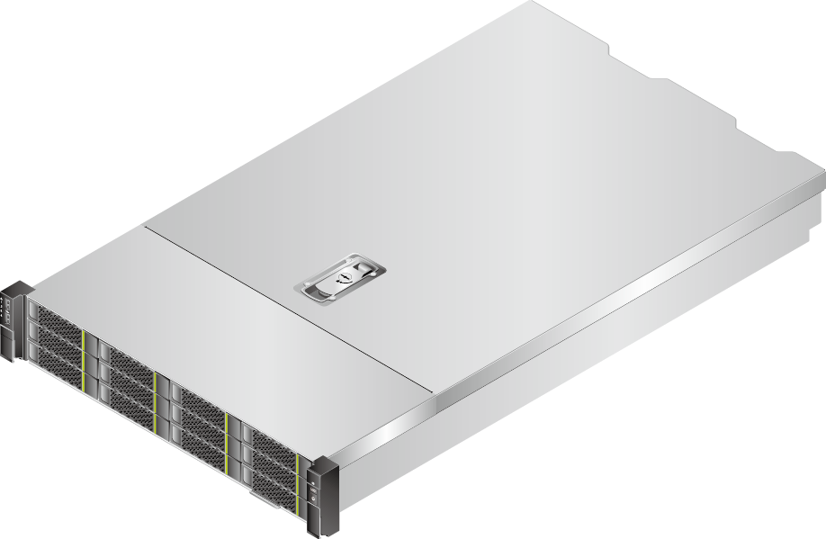

The figure shows a 12 x 3.5-inch chassis. If you have any questions about the hard disk configuration, contact your local Huawei sales representatives.

Features
Performance and Scalability
The TaiShan 2280 provides the following features to enhance performance and scalability:
- Uses two HiSilicon server-oriented 64-bit high-performance multicore ARM CPUs, which integrate DDR4, PCIe 3.0, 10GE, and GE ports and provide the system-on-chip (SOC) function.
- Supports two CPUs and 64 cores, which maximizes the concurrent execution of multithreaded applications.
- Supports sixteen DDR4 error checking and correcting (ECC) DIMMs with up to 512 GB memory capacity.
- Provides two 10GE optical ports and two GE electrical ports on the mainboard.
- One half-height half-length PCIe 3.0 x8 slot and four full-height full-length PCIe 3.0 x8 slots.
Availability and Serviceability
The TaiShan 2280 provides the following features to improve availability and serviceability:
- The TaiShan 2280 uses carrier-class components and follows the engineering process to dramatically improve system reliability.
- The TaiShan 2280 is equipped with one RAID controller card that supports RAID 0, 1, 1E, 10, 5, 50, 6, and 60, provides RAID cache, uses a supercapacitor for power-off data protection, and allows non-system disk hot swap.
- The UID and HLY indicators on the panel and iBMC WebUI help technical support personnel promptly obtain the status of key components and locate failed or failing components. This simplifies maintenance, accelerates troubleshooting, and improves system availability.
- The Huawei intelligent baseboard management controller (iBMC) monitors system parameters in real time, triggers alarms, and performs recovery actions in case of failures. This helps minimize system downtime.
Manageability and Security
The TaiShan 2280 provides the following features to ensure manageability and security:
- The iBMC monitors server operating status and provides remote management.
- The integrated industry-standard Unified Extensible Firmware Interface (UEFI) increases efficiency of setup, configuration, and update, and simplifies fault handling.
Energy Efficiency
The TaiShan 2280 provides the following features to improve energy efficiency:
- The TaiShan 2280 supports Platinum power supply units (PSUs), which provide 94% power efficiency at 50% load.
- The voltage regulator-down (VRD) PSUs reduce the energy loss in DC/DC power conversion.
- The TaiShan 2280 supports Proportional-Integral-Derivative (PID) intelligent fan speed adjustment, reducing power consumption.
- The improved thermal design with energy-efficient fan modules ensures optimal heat dissipation and reduces overall system power consumption.
- Hard disks can be powered on at different times to reduce startup power consumption.
- An ARM CPU is more energy-efficient than an x86 CPU.

Logical Structure
Figure 1-1 shows the logical structure of the TaiShan 2280.
- The TaiShan 2280 supports two Huawei-developed ARM64 CPUs, each supporting eight DDR4 DIMMs.
- The mainboard provides two 10GE optical ports and two GE electrical ports.
- The TaiShan 2280 supports two hard disk connection modes:
- If a RAID controller card is configured, the RAID controller card connects to the CPUs through the hard disk backplane by PCIe bus.
- If no RAID controller card is configured, the CPUs directly connect to the hard disks.
              - TaiShan 2280 logical structure
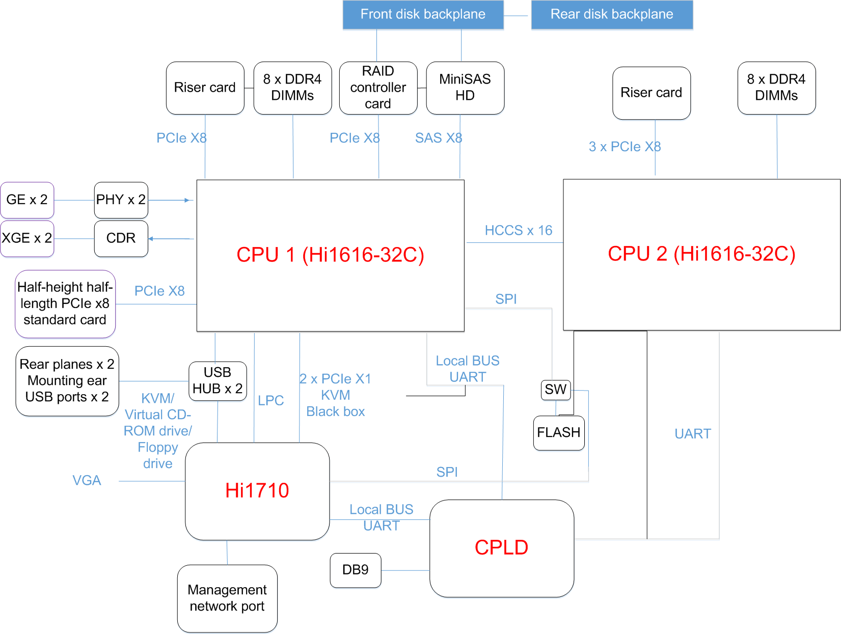

Hardware Description
4.1 Appearance
4.2 Ports
4.3 Indicators and Buttons
4.4 Physical Structure

Appearance
Front Panel
Figure 1-1 shows the front panel (with 12 x 3.5-inch disks) of the TaiShan 2280.
              - Front panel (12 x 3.5-inch disks)
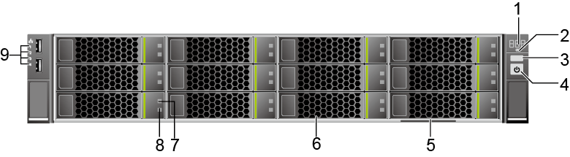

1 | Fault diagnosis LED | 2 | Health indicator
3 | UID button/indicator | 4 | Power button/indicator
5 | Label plate | 6 | Hard disks (slots numbered 0 to 11 from top to bottom and from left to right)
7 | Hard disk fault indicator | 8 | Hard disk activity indicator
9 | Network port connection status indicators (1 to 4 from top to down) | - | -

Figure 1-2 shows the front panel (with 25 x 2.5-inch disks) of the TaiShan 2280.
              - Front panel (25 x 2.5-inch disks)
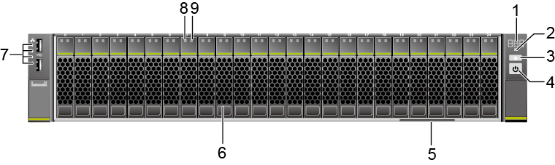

1 | Fault diagnosis LED | 2 | Health indicator
3 | UID button/indicator | 4 | Power button/indicator
5 | Label plate | 6 | Hard disks (numbered 0 to 24 from left to right)
7 | Network port connection status indicators (1 to 4 from top to down) | 8 | Hard disk fault indicator
9 | Hard disk activity indicator | - | -

Rear Panel
Figure 1-1 shows the rear panel of the TaiShan 2280.
              - Rear panel
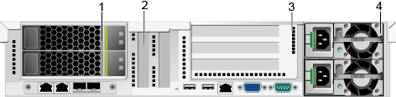

1 | I/O module 1 | 2 | LOM PCIe slots
3 | I/O module 2 | 4 | PSU

PCIe Slot Layout
Figure 1-1 shows the PCIe slot layout for the TaiShan 2280.
              - PCIe slot layout
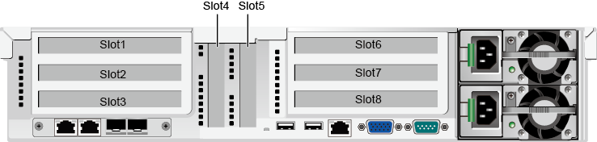

- When both I/O module 1 and I/O module 2 use a PCIe riser card that provides three x8 PCIe slots, slots 1, 6, 7, and 8 are available, and slots 2 and 3 is unavailable.
- When I/O module 1 uses a PCIe riser card that provides one x8 PCIe slot and I/O module 2 uses a PCIe riser card that provides three x8 PCIe slots, slots 3, 6, 7, and 8 are available, and slots 1 and 2 is unavailable.
- The mainboard provides slots 4 and 5, where slot 5 is unavailable.
Table 1-1 describes the mapping between the CPUs and PCIe slots, and the compliant PCIe standards of the TaiShan 2280.
                - PCIe slot description
PCIe Slot | CPU Socket | Compliant PCIe Standard | Connector Bandwidth | Bus Bandwidth | Slot Size
Slot1/Slot3 | CPU1 | PCIe 3.0 | X16 | X8 | Full-height full-length
Slot 4 | CPU1 | PCIe 3.0 | X8 | X8 | Half-height half-length
Slot 6 | CPU2 | PCIe 3.0 | X16 | X8 | Full-height full-length
Slot 7 | CPU2 | PCIe 3.0 | X8 | X8 | Full-height full-length
Slot 8 | CPU2 | PCIe 3.0 | X8 | X8 | Full-height half-length
Note 1: The PCIe slot that supports a full-height full-length PCIe card is backward compatible with a full-height half-length or half-height half-length PCIe card.
Note 2: The PCIe slots that support PCIe x16 cards are backward compatible with PCIe x8, PCIe x4, and PCIe x1 cards.
Note 3: Slots 1 and 3 are mutually exclusive, depending on the riser card used. When I/O module 1 uses a PCIe riser card that provides three x8 PCIe slots, slot 1 is available; when I/O module 1 uses a PCIe riser card that provides one x8 PCIe slot, slot 3 is available.

Ports
Table 1-2 describes the external ports provided by the TaiShan 2280.
                - Ports on the rear panel
Port | Type | Quantity | Description
Video graphics array (VGA) port | DB15 | 1 | The VGA port is used to connect a terminal, such as a monitor or KVM.
USB port | USB2.0 | 2 | The USB port is connected to a USB device.  NOTE  Before connecting to an external USB device, check that the USB device operates properly. A server may operate abnormally if it is connected to an abnormal USB device.
Management network port (Mgmt) | RJ45 | 1 | The 1000 Mbit/s Ethernet port is used to manage the server.
Serial port | DB9 | 1 | The serial port is used as the system serial port by default. You can set it as the iBMC serial port on the iBMC CLI. The port is used for debugging.
GE electrical port | RJ45 | 2 | The GE electrical port is provided by the mainboard.  NOTE  When the maximum transmission unit (MTU) of the TaiShan 2280 GE electrical port is smaller than 6000 bytes but the MTU of the peer device is larger than 6000 bytes, the TaiShan 2280 cannot receive large packets and the communication becomes abnormal.
10GE optical port | SFP+ | 2 | The 10GE optical port is provided by the mainboard.  NOTE  - The 10GE optical port does not support speed adaptation to GE.  - When the MTU of the TaiShan 2280 10GE optical port is less than 6000 bytes but the MTU of the peer port is greater than 6000 bytes, the TaiShan 2280 cannot receive large packages. In this case, the communication is abnormal.

Indicators and Buttons
You can observe the indicators to determine the status of the TaiShan 2280.
Table 1-3 describes the indicators and buttons on the TaiShan 2280 front panel.
                - Indicators and buttons on the front panel
Alarm ID | Meaning | State Description
 | Fault diagnosis LED | - ---: The server is operating properly.  - Error code: A fault occurs in server hardware.
 | Power button/indicator | - Off: The server is not connected to a power source.  - Blinking yellow: The iBMC is starting.  - Steady yellow: The server is connected and ready to power on.  - Steady green: The system is properly powered on.  NOTE  To power off the server, hold down the power button for 6 seconds.
 | UID button/indicator | The UID button/indicator helps identify and locate a server in a chassis. You can turn on or off the UID indicator by pressing the UID button or remotely running a command on the CLI.  - Steady blue: The server is located.  - Off: The server is not located.  To reset the iBMC, hold down the UID button for 4 to 6 seconds.
 | Health indicator | - Steady green: The server is operating properly.  - Blinking red at 1 Hz: A major alarm is generated.  - Blinking red at 5 Hz: A critical alarm is generated.
- | Hard disk activity indicator | - Off: The hard disk is not detected or is faulty.  - Blinking green: Data is being read from or written to the hard disk, or synchronized between hard disks.  - Steady green: The hard disk is inactive.
- | Hard disk fault indicator | - Off: The hard disk is operating properly or hard disks cannot be detected in the RAID group.  - Blinking yellow: The hard disk is located, or rebuilding RAID.  - Steady yellow: The hard disk is not detected or the hard disk is faulty.
 | Network port link status indicators | Each indicator shows the status of an Ethernet port on the NIC.  - Steady green: The port is properly connected.  - Off: The port is not in use or has failed.

Table 1-4 shows the indicators on the TaiShan 2280 rear panel.
                - Indicators on the rear panel
Indicator | State
Data transmission status indicator for the management port | - Off: No data is being transmitted.  - Blinking orange: Data is being transmitted.
Connectivity status indicator for the management network port | - Steady green: The network port is properly connected.  - Off: The network port is not connected.
PSU indicator | - Steady green: The power supply is normal.  - Off: No AC power is supplied or the system is on standby.
UID indicator | - Steady blue: The server is being located.  - Off: The server is not located.
Optical port data transmission status indicator | - Off: No data is being transmitted.  - Blinking orange: Data is being transmitted.
Optical port connectivity status indicator | - Steady green: The network port is properly connected.  - Off: The network port is not connected.
Electrical port data transmission status indicator | - Off: No data is being transmitted.  - Blinking orange: Data is being transmitted.
Electrical port connection status indicator | - Steady green: The network port is properly connected.  - Off: The network port is not connected.

Physical Structure
Figure 1-2 shows the components of a TaiShan 2280 server with 12 disks.
              - TaiShan 2280 components
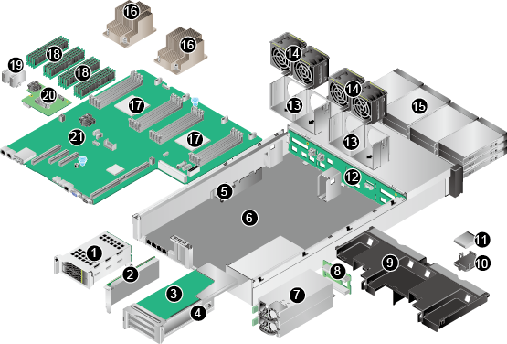

1 | I/O module 1 | 2 | PCIe card on the mainboard
3 | PCIe card on a riser card | 4 | I/O module 2
5 | Cable management arm (CMA) | 6 | Chassis
7 | PSU | 8 | PSU backplane
9 | Air duct | 10 | Supercapacitor tray
11 | Supercapacitor | 12 | Front hard disk backplane
13 | Fan bracket | 14 | Fan module
15 | Front hard disk | 16 | Heat sink
17 | CPU | 18 | DIMM
19 | SATADOM | 20 | RAID controller card
21 | Mainboard | - | -

Table 1-1 describes the TaiShan 2280 components.
                - TaiShan 2280 components
No. | Component | Description
1 | I/O module 1 | I/O module for a CPU.
2 | PCIe card on the mainboard | A PCIe device.
3 | PCIe card on a riser card | A PCIe device.
4 | I/O module 2 | I/O module for a CPU.
5 | Cable management arm (CMA) | A CMA enables neat cabling.
6 | Chassis | A chassis houses all components.
7 | PSU | A PSU supplies power to devices.
8 | PSU backplane | A PSU backplane connects PSUs to the mainboard.
9 | Air duct | An air duct provides ventilation channels.
10 | Supercapacitor tray | A supercapacitor tray secures a supercapacitor for a RAID controller card.
11 | Supercapacitor | A supercapacitor provides power-off protection for a RAID controller card.
12 | Front hard disk backplane | A hard disk backplane supplies power to front hard disks and provides data transmission channels.
13 | Fan bracket | A fan bracket secures a fan module.
14 | Fan module | Fan modules dissipate heat for the server and are hot-swappable. If fan modules are in full configuration, a faulty fan module will trigger speed adjustment of other fan modules by area, maintaining optimal heat dissipation.
15 | Front hard disk | A hard disk stores data.
16 | Heat sink | A heat sink cools a CPU. Each CPU is configured with one heat sink.
17 | CPU | A CPU is a computing and control unit of a PC.
18 | DIMM | A DIMM stores programs and data and support direct addressing by CPUs.
19 | SATADOM | A SATA disk on module (SATADOM) is a SATA SSD or SATADOM electrical hard disk. It is a quick memory storage media unit that features high energy efficiency and stability.
20 | RAID controller card | A RAID controller card connects to hard disks to expand the storage capacity.
21 | Mainboard | As a key component of a server, the mainboard integrates basic components such as the basic input/output system (BIOS) chip and PCIe expansion slots, and provides CPU sockets and DIMM slots.

Technical Specifications
Table 1-2 provides the TaiShan 2280 technical specifications.
                - Technical specifications
Component | Specifications
Form factor | 2U rack server
CPU | The TaiShan 2280 supports two 32-core Hi1616 CPU with a frequency of 2.4 GHz.
Memory | - A maximum of 16 DDR4 DRMM slots are provided and RDIMMs are supported.  - The maximum rate of DIMMs is 2400 MT/s.  - The error checking and correcting (ECC) technology is supported for protecting memory data.  - The capacity of a DIMM is 16 GB or 32 GB.  NOTE  - DIMMs of different specifications (such as the capacity, bit width, rank, and height) cannot be installed on one server. That is, all DIMMs on one server must have the same BOM number.  - DIMMs in same memory channel (for example, 000 and 001) must be provided by the same vendor and have the same specifications. DIMMs of different vendors cannot be mixed.
Storage | - TaiShan 2280 (12 x 3.5-inch chassis): supports 12 x 3.5-inch front SAS/SATA disks + 1 SAS cable or SAS RAID controller card + (optional) 4 x 2.5-inch or 3.5-inch rear SAS/SATA disks or SSDs  - TaiShan 2280 (25 x 2.5-inch chassis): supports 25 x 2.5-inch front SAS/SATA disks + 1 SAS cable or SAS RAID controller card + (optional) 2 x 3.5-inch or 2.5-inch rear SAS/SATA disks or SSDs  - Hot-swappable hard disks  - Support for SR130 (LSI SAS3008) and SR430C (LSI SAS3108) RAID controller cards
RAID support | The TaiShan 2280 supports SR130 (LSI SAS3008) and SR430C (LSI SAS3108) RAID controller cards.  - SR130 (LSI SAS3008): supports RAID 0, 1, 10, and 1E.  - SR430C (LSI SAS3108): supports RAID 0, 1, 10, 5, 50, 6, and 60 and provides a supercapacitor to protect data in the case of power failures.
Network port | Supports a maximum of four network ports: two 10GE SFP+ optical ports and two GE electrical ports, and PXE.
PCIe slot | Supports a maximum of six PCIe 3.0 x8 slots, including one PCIe slot for installing a RAID controller card and five standard PCIe slots.  The specifications of the five standard PCIe slots are as follows:  - I/O module configuration 1: supports one standard full-height full-length PCIe 3.0 x16 slot (bandwidth: PCIe 3.0 x8).  - I/O module configuration 2: supports one standard full-height full-length PCIe 3.0 x16 slot (bandwidth: PCIe 3.0 x8), one standard full-height full-length PCIe 3.0 x8 slot, and one standard full-height half-length PCIe 3.0 x8 slot.  - Mainboard: integrates one standard half-height half-length PCIe 3.0 x8 slot.
Port | - The front panel provides two USB 2.0 ports.  - The rear panel provides two USB 2.0 ports, one DB-15 VGA port, one DB-9 serial port, one RJ-45 system management port, two 10GE SFP+ optical ports, and two GE electrical ports.
Fan module | Four hot-swappable fans allow one-fan failures.
PSU | Hot-swappable PSUs in 1+1 redundancy mode:  - 460 W AC Platinum, support for 240 V HVDC  - 750 W AC Platinum, support for 240 V HVDC  NOTE  The PSUs provide short-circuit protection. The PSUs that support dual input live wires provide double-pole fuse.
System management | Huawei iBMC supports Intelligent Platform Management Interface (IPMI), Serial over LAN (SOL), KVM over IP, and virtual media, and provides one 10/100/1000 Mbit/s RJ45 management network port.
Security | Administrator password
GPU | SM750 graphics card chip integrated in the mainboard, providing a memory capacity of 32 MB and supporting a maximum resolution of 1920 x 1200 at 60 Hz with 16 M colors.
OS | OSs built based on Huawei-provided kernel 4.1

Physical Specifications
Table 1-3 lists the physical and environmental specifications of the TaiShan 2280.
                - Physical specifications
Item | Specifications
Dimensions (H x W x D) | Chassis with 3.5-inch hard disks: 86.1 mm (2U) x 447 mm x 748 mm (3.39 in. x 17.60 in. x 29.45 in.)  Chassis with 2.5-inch hard disks: 86.1 mm (2U) x 447 mm x 727.7 mm (3.39 in. x 17.60 in. x 28.65 in.)
Installation space | The server fits into a common cabinet that complies with the IEC 297 standard.  - Width: 19 in.  - Depth: > 1000 mm (39.37 in.)  Guide rail installation requirements are as follows:  - L-shaped guide rails: apply only to a Huawei cabinet.  - Adjustable guide rails: apply to a cabinet with a distance of 543.5 mm to 848.5 mm (21.40 in. to 33.41 in.) between the front and rear mounting bars.  - Holding rails: apply to a cabinet with a distance of 610 mm to 914 mm (24.02 in. to 35.98 in.) between the front and rear mounting bars.
PSU power rating | The PSUs support the following power ratings:  - 460 W AC Platinum PSU  - 750 W AC Platinum PSU
Weight in full configuration | - Net weight:  - With twelve 3.5-inch hard disks: 30 kg (66.15 lb)  - With twenty-five 2.5-inch hard disks: 30 kg (66.15 lb)  - Packing material weight: 5 kg (11.03 lb)
Input voltage | 460 W AC Platinum PSU/750 W AC Platinum PSU:  100 V AC to 240 V AC, or 192 V DC to 288 V DC
Operating temperature | - Operating temperature: 5°C to 40°C (41°F to 104°F)  - Storage temperature: –40°C to +65°C (–40°F to +149°F)  - The temperature change rate is less than 20°C/h (36°F/h)
Relative humidity (RH, non-condensing) | - Operating humidity: 8% to 90%  - Storage humidity: 5% to 95%  - Humidity change rate: < 20% RH/h
Altitude | ≤ 3000 m  When the altitude is higher than 900 m (2952.72 ft), the operating temperature decreases by 1°C (1.8°F) as the altitude increases by 300 m (984.24 ft).
Acoustic noise | The data listed in the following is the declared A-weighted sound power levels (LWAd) and declared average bystander position A-weighted sound pressure levels (LpAm) measured when the server is operating in a 23°C (73.4°F) ambient environment. Noise emissions are measured in accordance with ISO 7779 (ECMA 74) and declared in accordance with ISO 9296 (ECMA 109).  Operating:  - LWAd: 46.625 dB(A)  - LpAm: 69.6 dB(A)  NOTE  The actual sound levels generated during server operating vary depending on the server configuration, load, and ambient temperature.

Component Compatibility
This chapter describes the software and hardware compatibility of the TaiShan 2280.
The software and hardware models supported by the TaiShan 2280 listed in this chapter are for reference only. For details, see the compatibility list.
7.1 Memory
7.2 Storage
7.3 I/O Expansion
7.4 PSU
7.5 Supported OSs

Memory
Memory Capacity Configuration Rules
The TaiShan 2280 supports up to 16 DIMMs. Each CPU supports four memory channels, and each memory channel supports up to two DIMMs.
                - RDIMM configuration rules
Item |  | RDIMM
Rank |  | Dual rank
Rated speed (MT/s) |  | 2400
Rated voltage (V) |  | 1.2
Operating voltage (V) |  | 1.2
Maximum number of DIMMs |  | 16
Maximum capacity per DIMM (GB) |  | 32
Maximum memory capacity (GB) |  | 512
Maximum memory capacity at the maximum operating speed (GB) |  | 256
Maximum operating speed (MT/s) | One DIMM per channel | 2400
Maximum operating speed (MT/s) | Two DIMMs per channel | 2133

Memory Slot Configuration Rules
- The TaiShan 2280 supports DIMMs of 16 GB and 32 GB. When the TaiShan 2280 is fully configured with DIMMs, the maximum memory capacity is 512 GB.
- In the TaiShan 2280, each CPU has eight DDR4 DIMM slots, integrating four memory channels (channels 0, 1, 2, and 3). Table 1-1 describes the composition of each channel. Figure 1-2 shows the DIMM installation positions.
- DIMMs of different specifications (such as capacity, bit width, rank, and height) cannot be mixed on one server. That is, a server must use DIMMs of the same BOM number.
- DIMMs in same memory channel (for example, 000 and 001) must be provided by the same vendor and have the same specifications. DIMMs of different specifications cannot be installed in the same memory channel.
                - Memory channels
Memory Channel | Composition
CPU1 | 020(B),021(F),000(A),001(E),011(G),010(C),031(H),030(D)
CPU2 | 120(B),121(F),100(A),101(E),111(G),110(C),131(H),130(D)

              - DIMM installation positions
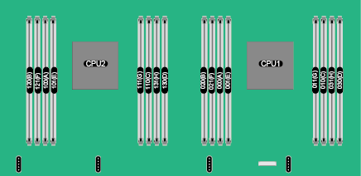

Figure 1-3 describes the DIMM installation rules.
              - DIMM installation rules
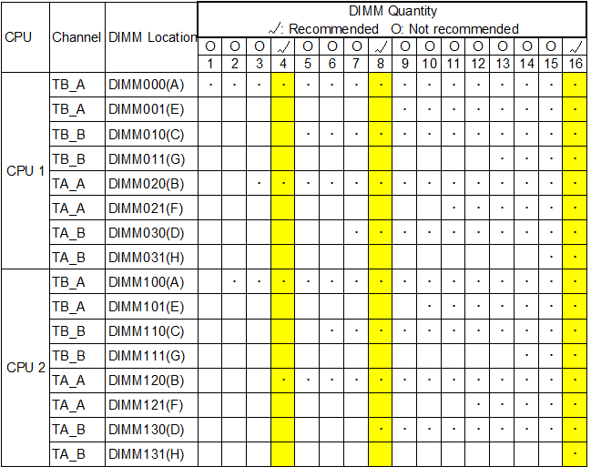

Supported DIMMs
Table 1-1 lists the DIMMs supported by the TaiShan 2280.
                - Supported DIMMs
Part Number | Description | Remarks
06200225 | Memory Module,DDR4 RDIMM,16GB,288pin,0.83ns,2400000KHz,1.2V,ECC,2Rank(1G*8bit) | -
06200224 | Memory Module,DDR4 RDIMM,32GB,288pin,0.83ns,2400000KHz,1.2V,ECC,2Rank(2G*4bit) | -

Storage
Table 1-2 lists the supported hard disks.
                - Hard disks supported by the TaiShan 2280
Part Number | Description | Remarks
02311AYT | 7200 RPM - 3.5' SATA 6Gbps - 2000GB HDD | -
02311AYV | 7200 RPM - 3.5' SATA 6Gbps - 4000GB HDD | -
02311DYQ | 7200 RPM - 3.5' SATA 6Gbps - 6000GB HDD | -
02311JRE | 7200 RPM - 3.5' SATA 6Gbps - 8000GB HDD | -
02311SXE | 7200 RPM - 3.5' SATA 6Gbps – 10TB HDD | -
02311HAS | 10000 RPM - 2.5' SAS 12Gbps - 300GB HDD-3.5' front panel | -
02311HAT | 10000 RPM - 2.5' SAS 12Gbps - 600GB HDD-3.5' front panel | -
02311NAJ | 10000 RPM - 2.5' SAS 12Gbps - 900GB HDD-3.5' front panel | -
02311NHV | 10000 RPM - 2.5' SAS 12Gbps - 1200GB HDD-3.5' front panel | -
02311KSV | 10000 RPM - 2.5' SAS 12Gbps - 1800GB HDD-3.5' front panel | -
02311TKK | LE 2.5' SATA 6Gbps - 480GB SSD-3.5' front panel | -
02311TKL | LE 2.5' SATA 6Gbps - 800GB SSD-3.5' front panel | -
02311TKM | LE 2.5' SATA 6Gbps - 960GB SSD-3.5' front panel | -
02311TKN | LE 2.5' SATA 6Gbps -1600GB SSD-3.5' front panel | -
02311TKP | LE 2.5' SATA 6Gbps - 1920GB SSD-3.5' front panel | -
02311UFY | LE 2.5' SATA 6Gbps - 3840GB SSD-3.5' front panel | -
02311HAK | 10000 RPM - 2.5' SAS 12Gbps - 300GB HDD | -
02311HAP | 10000 RPM - 2.5' SAS 12Gbps - 600GB HDD | -
02311HAL | 10000 RPM - 2.5' SAS 12Gbps - 900GB HDD | -
02311HAN | 10000 RPM - 2.5' SAS 12Gbps - 1200GB HDD | -
02311FMR | 10000 RPM - 2.5' SAS 12Gbps - 1800GB HDD | -
02311TJX | SSD: 480 GB, SATA disk, 2.5-inch, 6 Gbit/s, read-intensive, CloudSpeed2 | -
02311TJY | SSD: 800 GB, SATA disk, 2.5-inch, 6 Gbit/s, read-intensive, CloudSpeed2 | -
02311TKA | SSD: 960 GB, SATA disk, 2.5-inch, 6 Gbit/s, read-intensive, CloudSpeed2 | -
02311TKB | SSD: 1600 GB, SATA disk, 2.5-inch, 6 Gbit/s, read-intensive, CloudSpeed2 | -
02311TKC | SSD: 1920 GB, SATA disk, 2.5-inch, 6 Gbit/s, read-intensive, CloudSpeed2 | -
02311UYE | SSD: 3840 GB, SATA disk, 2.5-inch, 6 Gbit/s, read-intensive, PM863A | -
02311PQC | SSD-960GB-SATA 6Gbps-Mixed Use-SM863-2.5inch(2.5inch Drive Bay)-VE Series | -
02311PPX | SSD-1600GB-SATA 6Gbps-Mixed Use-S3610-2.5inch(2.5inch Drive Bay)-VE Series | -
02311PXY | SSD-1920GB-SATA 6Gbps-Mixed Use-SM863-2.5inch(2.5inch Drive Bay)-VE Series | -
02310YCY | SSD-200GB-SATA 6Gbps-Write Intensive-S3710-2.5inch(2.5inch Drive Bay)-ME Series | -
02310YCX | SSD-400GB-SATA 6Gbps-Write Intensive-S3710-2.5inch(2.5inch Drive Bay)-ME Series | -
02311BAE | SSD-800GB-SATA 6Gbps-Write Intensive-S3710-2.5inch(2.5inch Drive Bay)-ME Series | -
02311HAH | SSD-400GB-SAS 12Gbps-Write Intensive-HGST SSC Plus-2.5inch(2.5inch Drive Bay)-ME Series | -
02311HAG | SSD-800GB-SAS 12Gbps-Write Intensive-HGST SSC Plus-2.5inch(2.5inch Drive Bay)-ME Series | -
02311HAJ | SSD-1600GB-SAS 12Gbps-Write Intensive-HGST SSC Plus-2.5inch(2.5inch Drive Bay)-ME Series | -

Table 1-3 lists the compatible RAID controller cards for the TaiShan 2280.
The information in Table 1-3 is for reference only. For details about the components available, consult the local Huawei sales representatives.
                - RAID controller cards supported by the TaiShan 2280
Part Number | Description | Remarks
02311UBX | Function Module,SR130,BC1M01ESMR,SR130 (LSI3008)-SAS/SATA RAID Card-RAID0,1,10,1E,+630mm MiniSAS HD Cable Module | -
02311UBY | Function Module,SR430C 1GB,BC1M05ESMS,LSI3108 RAID card-Board ID 0X2A-RAID0,1,5,6,10,50,60-Support SuperCap+630mm MiniSAS HD Cable Module | -
02311UCA | Function Module,SR430C 2GB,BC1M01ESMT,LSI 3108 RAID CARD-Board ID 0X23-RAID0,1,5,6,10,50,60-Support SuperCap+630mm MiniSAS HD Cable Module | -

Table 1-4 provides the comparison between RAID levels in performance, minimum number of hard disks, and disk usage.
                - RAID level comparison
RAID Level | Reliability | Read Performance | Write Performance | Minimum Number of Hard Disks | Hard Disk Usage
RAID 0 | Low | High | High | 2 | 100%
RAID 1 | High | Low | Low | 2 | 50%
RAID 5 | Better than medium | High | Medium | 3 | (N - 1)/N
RAID 6 | Better than medium | High | Medium | 4 | (N - 2)/N
RAID 10 | High | Medium | Medium | 4 | M/N
RAID 50 | High | High | Better than medium | 6 | (N - M)/N
RAID 60 | High | High | Better than medium | 8 | (N - M x 2)/N
Note: N indicates the number of member disks in a RAID array, and M indicates the number of spans in a RAID array.

I/O Expansion
The TaiShan 2280 supports one half-height half-length and four full-height full-length PCIe cards.
Part Number | Description | Remarks
02311PBK | Function Module,ES3000 V3,CN2M10FACM,ES3600C-1600GB-3 DWPD-PCIE 3.0 X4-Vendor ID 19e5-Device ID 0123-1,Model number HWE36P43016M000N,HH/HL Card,NVMe SSD | -
02311PBJ | Function Module,ES3000 V3,CN2M10FACP,ES3600C-3200GB-3 DWPD-PCIE 3.0 X4-Vendor ID 19e5-Device ID 0123-1,Model number HWE36P43032M000N,HH/HL Card,NVMe SSD | -
03030WSQ | Finished Board,X6000,CN21ITGAA13,Intel 82599 2*10GE SFP+ Half-height Half-length X8 PCIE Ethernet Card NCSI Supported,PCIE 2.0 X8-Vendor ID 8086-Device ID 10FB-2 | -
02311UPG | Function Module,TaiShan 2280,CN2M01ITGJ,Ethernet Adapter,10Gb Optical Interface(Mellanox MT27712A0),2-Port,SFP+(without Optical Transceiver),PCIe 3.0 x8 | -
02311UPK | Function Module,TaiShan 2280,CN2M02ITGJ,Ethernet Adapter,25Gb Optical Interface(Mellanox CX4-lx EN),2-Port,SFP28(without Optical Transceiver),PCIe 3.0 x8 | -
02311MSP | Function Module,Rack Server,CN2M01ITGD,Ethernet Adapter,10Gb Electrical Interface(Intel X540),2-Port,RJ45,PCIe 2.0 x8 | -
02312BWG | Function Module,SP570,BC5M01ETHB,Ethernet Adapter,25GE/10GE(Hi822),4-Port,SFP+(without Optical Module) | -

PSU
Table 1-5 lists the PSUs supported by the TaiShan 2280.
- Table 1-5 is for reference only. For details about the PSUs available, contact local Huawei sales representatives.
- A server must use PSUs of the same model.
- 460 W and 750 W PSUs can be selected based on different server configurations.
                - Supported PSUs
Part Number | Description | Remarks
02130957 | AC-DC Power,5degC,50degC,90V,264V,12V/38A,460W Platinum Power Module | -
02310QWX | Function Module,EPW750-12A,EN3MCACC,750W platinum AC power supply unit | -

Supported OSs
The TaiShan 2280 supports the OSs built based on Huawei-provided kernel 4.1. Table 1-6 lists the supported OSs.
                - OSs supported by the TaiShan 2280
Vendor | Version
Canonical | Ubuntu 16.04.3
SUSE | SLES 12 SP3
Red Hat | RHEL 7.4 for ARM (CentOS 7.4)
NeoKylin | NeoKylin-Server V7.0 update 2
Huawei | EulerOS V200R002C20  EulerOS V200R005C00

System Management
The TaiShan 2280 uses Huawei's proprietary intelligent baseboard management controller (iBMC) for remote server management. The iBMC complies with IPMI V2.0 standards and provides reliable hardware monitoring and management.
The iBMC supports the following features and protocols:
- KVM and text console redirection
- Remote virtual media
- IPMI
- Simple Network Management Protocol (SNMP)
- Login using a web browser
Table 1-7 describes the iBMC specifications.
                - iBMC specifications
Item | Specifications
Management interface | Integrates with any standard management system through the following interfaces:  - IPMIV2.0  - CLI  - HTTPS  - SNMP V3
Fault detection | Detects faults and accurately locates faults in hardware, for example, a field replaceable unit (FRU).
Alarm management | Supports alarm management and reports alarms using the SNMP trap, Simple Mail Transfer Protocol (SMTP), and syslog service to ensure 24/7 continuous operation.
Integrated virtual KVM | Provides remote maintenance measures for troubleshooting the system, and supports a maximum resolution of 1920 x 1200.
Integrated virtual media | Virtualizes local media devices, images, and folders into media devices on a remote server, simplifying OS installation. (The virtual DVD drive supports a maximum transmission rate of 8 MB/s.)
WebUI | Provides a user-friendly graphical user interface (GUI), which simplifies users' configuration and query operations.  The iBMC WebUI supports OSs, web browsers, and Java Runtime Environment (JRE) of the following versions:  - Windows XP (32-bit); Internet Explorer 8.0/9.0/10.0, Firefox 9.0, or Google Chrome 13.0; JRE 1.6.0 U25 or later  - Windows 7 (32-bit); Internet Explorer 8.0/9.0/10.0, Firefox 9.0, or Google Chrome 13.0; JRE 1.6.0 U25 or later  - Red Hat Enterprise Linux 4.3 (64-bit); Firefox 9.0; JRE 1.6.0 U25 or later  - Red Hat Enterprise Linux 6.0 (64-bit); Firefox 9.0; JRE 1.6.0 U25 or later  - macOS; Safari or Firefox 9.0; JRE 1.6.0 U25 or later
Screen snapshots and videos | Allows you to view screen snapshots and videos without login, which facilitates preventive maintenance inspection.
Domain name service (DNS) and directory service | Supports the DNS and directory service, significantly simplifying network and configuration management.
Dual-image backup | Starts software from a backup image if the software fails.
Asset management | Provides intelligent asset management.
IPv6 | Supports IPv6 to ensure sufficient IP addresses.
NC-SI | Supports NC-SI, which allows you to access the iBMC over the service network port. (Only PCIe cards support NC-SI.)

Warranty
According to the Huawei Warranty Policy for Servers & Storage Products (Warranty Policy for short), Huawei provides a three-year warranty for the server, a one-year warranty for the DVD drive and supercapacitor, and a three-month warranty for software media.
The Warranty Policy stipulates warranty terms and conditions, including the available services, response time, terms of service, and disclaimer.
The Warranty Policy stipulates warranty terms and conditions, including the available services, response time, terms of service, and disclaimer. The warranty terms and conditions may vary by country, and some service and/or parts may not be available in all countries. For more information about warranty services in your country, contact Huawei technical support or your local Huawei office.
For details about warranty, log in to http://e.huawei.com and choose Support > Warranty to obtain warranty documents.

Certifications
No. | Country/Region | Certification | Standard
1 | Europe | ROHS | 2011/65/EU
2 | Europe | WEEE | 2012/19/EU
3 | Europe | REACH | EC 1907/2006
4 | China | CCC | GB4943.1-2011  GB9254-2008 (Class A)  GB17625.1-2012
5 | Europe | ERP | 2009/125/EC
6 | Europe | CE | Safety:  IEC 60950-1: 2005 (2nd Edition) + A1: 2009 and/or EN 60950-1: 2006+A11: 2009+A1: 2010+A12: 2011+A2: 2013  EMC:  EN 55032: 2012/AC: 2013*  CISPR 32: 2012*  EN 55024: 2010  CISPR 24: 2010  EN 55024: 2010+A1: 2015  CISPR 24: 2010+A1: 2015  ETSI EN 300 386 V1.6.1: 2012  ETSI EN 201 468 V1.4.1: 2014  RoHS  EN 50581: 2012  ERP  (EU) No 617/2013, Generalized Test Protocol for Calculating the Energy Efficiency of Internal Ac-Dc  and Dc-Dc Power Supplies Revision 6.6 (April, 2012)
7 | Japan | VCCI | VCCI V-3: 2012

