|  |  |  |  |  |
| --- | --- | --- | --- | --- |
|  |  | | |  |
|  | | |
|  | | |
| 方圆ok1 | | | |
|  | **Huawei eSight**  Agile Reporter Technology White Paper | | 附件1-16K |
|  | |
| **Issue** | **01** |
| **Date** | **2017-01-23** |
|  | |
| HUAWEI TECHNOLOGIES CO., LTD. | |
|  | | |

|  |
| --- |
| Copyright © Huawei Technologies Co., Ltd. 2017. All rights reserved.  No part of this document may be reproduced or transmitted in any form or by any means without prior written consent of Huawei Technologies Co., Ltd.  Trademarks and Permissions  附件3-图 and other Huawei trademarks are trademarks of Huawei Technologies Co., Ltd.  All other trademarks and trade names mentioned in this document are the property of their respective holders.  Notice  The purchased products, services and features are stipulated by the contract made between Huawei and the customer. All or part of the products, services and features described in this document may not be within the purchase scope or the usage scope. Unless otherwise specified in the contract, all statements, information, and recommendations in this document are provided "AS IS" without warranties, guarantees or representations of any kind, either express or implied.  The information in this document is subject to change without notice. Every effort has been made in the preparation of this document to ensure accuracy of the contents, but all statements, information, and recommendations in this document do not constitute a warranty of any kind, express or implied. |

|  |  |
| --- | --- |
| Huawei Technologies Co., Ltd. | |
| Address: | Huawei Industrial Base  Bantian, Longgang  Shenzhen 518129  People's Republic of China |
| Website: | <http://e.huawei.com> |

About This Document

Overview

This document describes the solution, mechanism, key technologies, and typical application of eSight Agile Reporter. It helps you understand the usage method and scenarios of eSight Agile Reporter.

Intended Audience

This document is intended for:

* Technical support engineers
* Maintenance engineers

Symbol Conventions

The symbols that may be found in this document are defined as follows.

|  |  |
| --- | --- |
| Symbol | Description |
| danger | Indicates a hazard with a high level or medium level of risk which, if not avoided, could result in death or serious injury. |
| wanning | Indicates a hazard with a low level of risk which, if not avoided, could result in minor or moderate injury. |
| caution | Indicates a potentially hazardous situation that, if not avoided, could result in equipment damage, data loss, performance deterioration, or unanticipated results. |
| **tip** | Provides a tip that may help you solve a problem or save time. |
| note | Provides additional information to emphasize or supplement important points in the main text. |

Contents

About This Document ii

1 Executive Summary 1

2 Introduction 2

3 Solution 3

3.1 Solution Overview 3

3.2 Key Technologies 3

3.2.1 Data Integration 3

3.2.2 Analytical Agile Reporter 5

3.2.3 Service KPI Dashboard 8

3.3 Function Restrictions 9

3.3.1 Restriction on Report Type 9

3.3.2 Function Restrictions 9

3.4 Typical Application 11

3.4.1 Customizing Reports 11

3.4.2 Customizing the Dashboard 12

3.4.3 Creating Periodic Reports 13

4 Experience 14

5 Acronyms and Abbreviations 15

# Executive Summary

This document describes the solution, key technologies, and typical scenarios of eSight Agile Reporter.

# Introduction

With the development of Internet technologies and popularization of information systems, the Big Data era is coming. Carriers and enterprise need to quickly obtain effective data that can reflect enterprises' operating status from a large amount of dispersed abstract data in the database, to make service operation decisions.

eSight Agile Reporter provides professional smart report services to help carriers and enterprises achieve the purpose. Agile Reporter displays service data through charts and tables and supports the drag-and-drop mode for users to customize their desired reports in the What You See Is What You Get (WYSIWYG) mode, bringing more profits to carriers and enterprises.

# Solution

## Solution Overview

eSight Agile Reporter is a professional end-to-end data analysis and report display platform, which provides data integration, report display, dashboard monitoring, self-service data analysis, periodic reporting, and email notification functions. Users can check and compare data from different dimensions to make correct decisions. Agile Reporter provides professional business intelligence services in terms of data integration, data analysis, and data display.

* Data integration: Agile Reporter extracts useful data from a large amount of data in the database, transforms the data to the required format, and loads the data to the data repository.
* Data analysis: Agile Reporter analyzes massive data stored in the product data source using the defined data model, service model, and report templates, and calculates the latest data based on the models and templates to prepare for data display.
* Data display: Agile Reporter displays service data using agile reports, which are online analytical processing OLAP reports, and on the dashboard. The reports help users better understand service data, obtain warning information about monitored counters, and carry out cause analysis accordingly.

## Key Technologies

### Data Integration

With the increase of service scale, report data to be analyzed increases sharply. For services with massive amount of data, data query takes 10 to 20 minutes or even longer if a traditional reporter is used. Obviously, traditional reporters cannot achieve real-time service monitoring and decision-making in this case.

To solve the preceding problem, eSight Agile Reporter provides the In-Memory MOLAP data ETL solution based on the Mondrian relational online analytical processing (ROLAP) engine. This solution uses multidimensional online analytical processing (MOLAP) and Extract-Transform-Load (ETL) technologies. This solution takes advantages of combinatorial compression, pre-aggregating and in-memory computing, high-speed multidimensional indexing, and lock-free incremental offline cube updating to ensure responses in 5 to 10 seconds to 80% queries. The ETL solution realizes 1/5 to 1/10 data compression through Snappy, without the need to purchase expensive outsourced parts. It features high-performance with low costs. In addition, the Cube model is used to generate summarized tables for service data and high-speed indexes for real-time multi-thread concurrent computing of data added to the memory.



**Combinatorial Compression with Pre-aggregating and In-Memory Computing Realizes Second-Level Query**

Slight compression through the combination of multiple algorithms: The technology ensures that the occupied memory space does not increase sharply when data is loaded to the cube module, and the query performance is not degraded when the data volume increases.

Pre-aggregating: The system generates aggregation tables in advance based on calculation of raw data. Computing is not required for common queries, because only a small amount of data calculation is involved.

**High-Speed Multidimensional MD Key Indexing Facilitates Second-Level Query**

MD Key indexing: MD Key multidimensional indexes are constructed by combining all the dimensions. The system scans data only once for the required dimension. MD Key indexes are divided into groups to speed up the query speed through multi-core concurrency.

CSB tree storage: B-tree storage optimized based on CPU cache implements quick switching and high-speed query.

**Flexible Incremental Update Ensures Uninterrupted Service Query**

Lock-free architecture: Data is added to the cube model in incremental mode, which shortens the update and query time.

Incremental offline cube merging: The MOLAP ETL process completes incremental offline data merging in persistent storage on the server, which greatly shortens the handover time and ensures service continuity.

### Analytical Agile Reporter

Analytical Agile Reporter uses the online analytical processing (OLAP) method, so that analysis personnel can drag and drop required dimensions and measurements on the eSight browser to generate reports. In addition, drilling down, rotating, and slicing operations are supported for flexible display and summarization of service data. Agile Reporter allows users to analyze service data from multiple dimensions, and displays query results using easy-to-understand charts and tables.

Time dimension quick filter

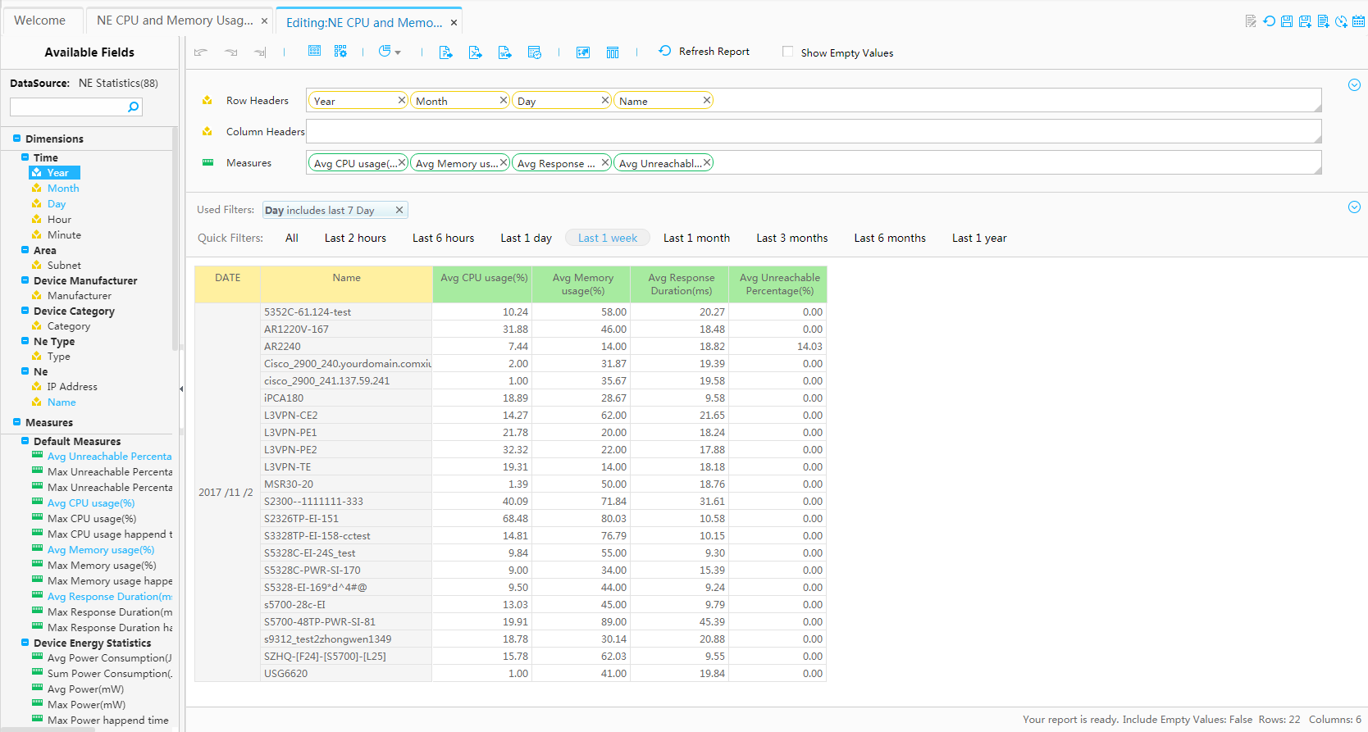

Selected dimensions

Filtering setting

Selected measurements

Creating reports in drag-and-drop mode

Available measurements

Available dimensions

Report preview

Toolbar

Multidimensional analysis is software technology used to share multidimensional information and perform quick data access and analysis for specific problems. Users have different focuses and want to view data from diversified aspects. Multidimensional analysis allows them to analyze data from their desired aspects. Agile Reporter provides interactive pages, so users can quickly select useful service data for analysis from the large amount of information data based on the dimensions and measurements.

Functions of the multidimensional analytical Agile Reporter are summarized as follows:

* Allows users to drag and drop measurements and dimensions on the pages to generate reports.
* Supports value filtering and sorting, flexible selection of search criteria, and quick filtering by the time dimension.
* Provides quick chart-table conversion capability.
* Provides various calculation functions, such as year-on-year and month-on-month data comparison, as well as average and sum calculation.
* Provides diversified report analysis capabilities, such as drilling down, rolling up, slicing, and Top N sorting.
* Supports real-time updating of report data, that is, the system can automatically update reports based the latest report format.
* Exports reports in PDF and Excel formats.

Agile Reporter allows users to convert between chart and table or change one chart to multiple charts.

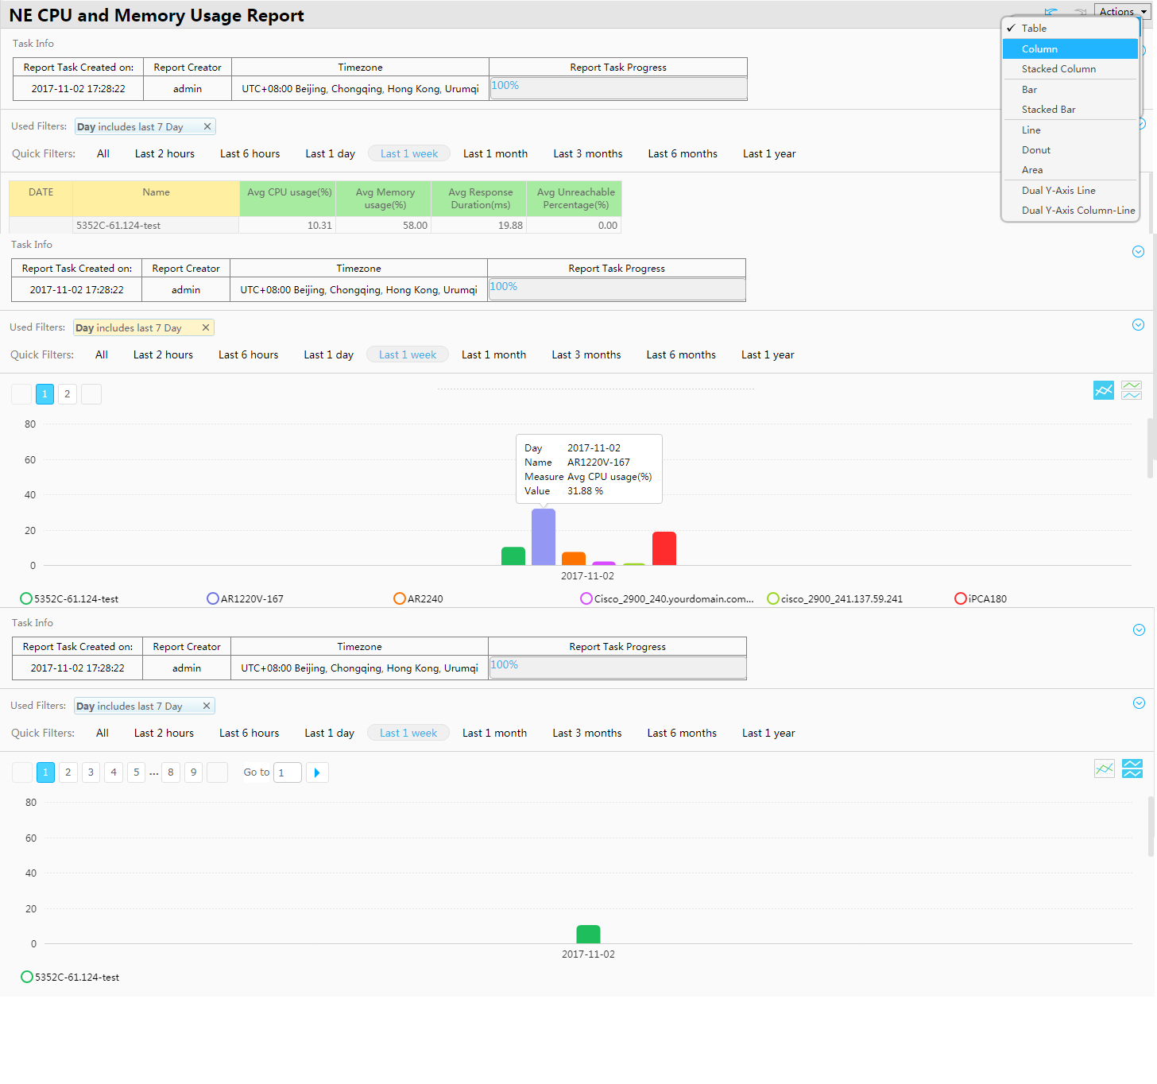

Display data in multiple charts by measurements

Available table and chart types

Table-chart conversion

Splitting a chart

Click the bar chart to view details.

Tips display

Counter axis

Legend

Agile Reporter predefines multiple analysis methods such as year-on-year and month-on-month data comparison and Top N filtering, and allows users to customize computing methods. All these methods help users quickly gain an insight into the service data change trends, and precisely adjust their service strategies accordingly.

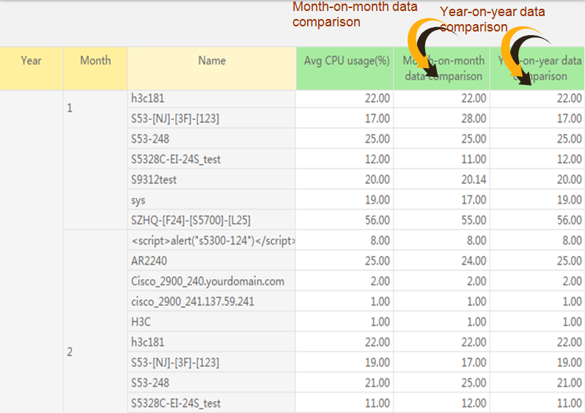

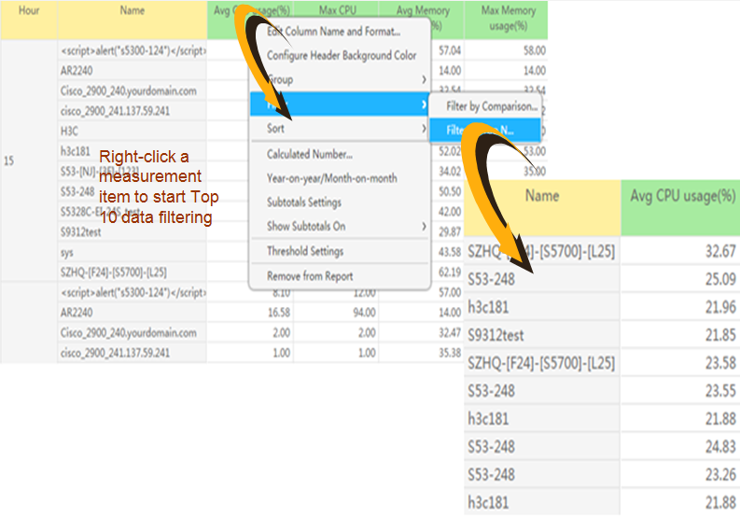

### Service KPI Dashboard

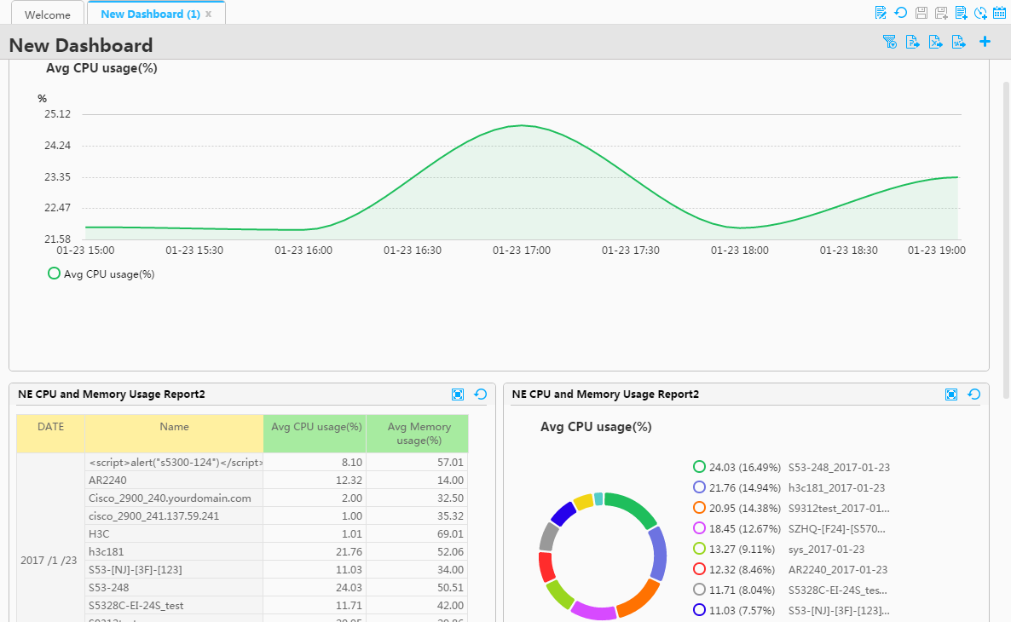

Dashboard is a data visualization tool used to display to measurement data and key performance indicator (KPI) status to enterprise users. It applies to scenarios such as service KPI monitoring, data comparison, and correlation analysis. Dashboard has the following advantages:

* Report data on the dashboard is updated in real time, and users can configure the frequency at which report data is updated.
* Users can customize the layout of Dashboard.
* Association between reports is supported. When there is a dependency between report data of different components, the association function allows users to analyze report data comprehensively.
* Users can import created agile reports to the dashboard to view multiple reports on the same page.
* Users can export Dashboard data in PDF and Excel formats.

## Function Restrictions

### Restriction on Report Type

|  |  |
| --- | --- |
| Version | Supported Report Type |
| eSight V300R006C00 | Performance statistics reports, WLAN service statistics reports, WLAN terminal location reports, resource statistics reports, alarm statistics reports, SLA reports, and high-density stadium reports |
|  |  |

note

Currently, the VLAN statistics report is not supported.

### Function Restrictions

|  |  |  |
| --- | --- | --- |
| Item | Support or Not | Remarks |
| Adding, deleting, modifying, and querying agile reports | Supported |  |
| Adding, deleting, modifying, and querying dashboard reports | Supported |  |
| Exporting reports in Excel and PDF formats | Supported |  |
| Adding, deleting, modifying, and querying periodic report tasks | Supported |  |
| Deploying the two-node cluster | Supported |  |
| Setting the time zone | Supported | Note:  If the time zone set for a report differs from the time zone of the server, pay attention to the following:  1. The current report does not support filtering by year, month, and day.  2. The queried data by year, month, and day is aggregated based on the time zone of the server. |
| Maximum number of periodic report tasks created by a single user | 100 |  |
| Maximum number of periodic report tasks supported by the system | 500 |  |
| Number of historical records on periodic report execution | 20 |  |
| Maximum number of columns in an agile report | 15 |  |
| Maximum number of lines in an agile report | 100000 | If the number of lines in a queried report exceeds the limit, report query fails. A message is displayed, asking the user to add filter conditions to narrow down queried items. |
| Timeout period of ROLAP report query | 3600 | The unit of the timeout period is second. Alarm and resource reports are ROLAP reports. |
| Maximum number of lines in an exported Excel file | 100000 |  |
| Maximum number of columns in an exported Excel file | 20 |  |
| Maximum number of lines in an exported PDF file | 100000 |  |
| Maximum number of columns in an exported PDF file | 20 |  |
| Maximum number of available members in a filter condition | 1000 | For example, you can set a maximum number of 1000 device names when the device name is used as the filter condition. |
| Maximum number of lines in a report which contains a user-defined dimension or measurement | 100 |  |

## Typical Application

### Customizing Reports

Users can flexibly drag and drop items to quickly create new agile report, or edit existing agile reports in the system when they want to analyze data from different perspectives interactively, for example, when they want to analyze historical data to gain insight into the service development trend. In this way, the reports dynamically display service data in the combination of different dimensions, such as application, user, protocol, and terminal type. The operations such as drilling down, rotating, and slicing are available for flexible self-service data analysis.

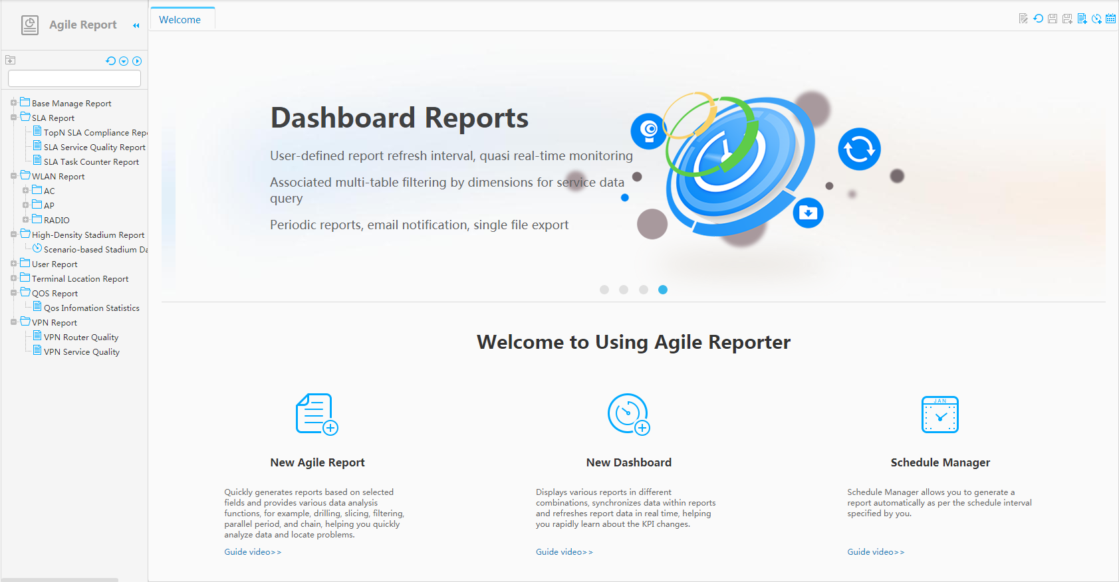

Entrance for creating a report

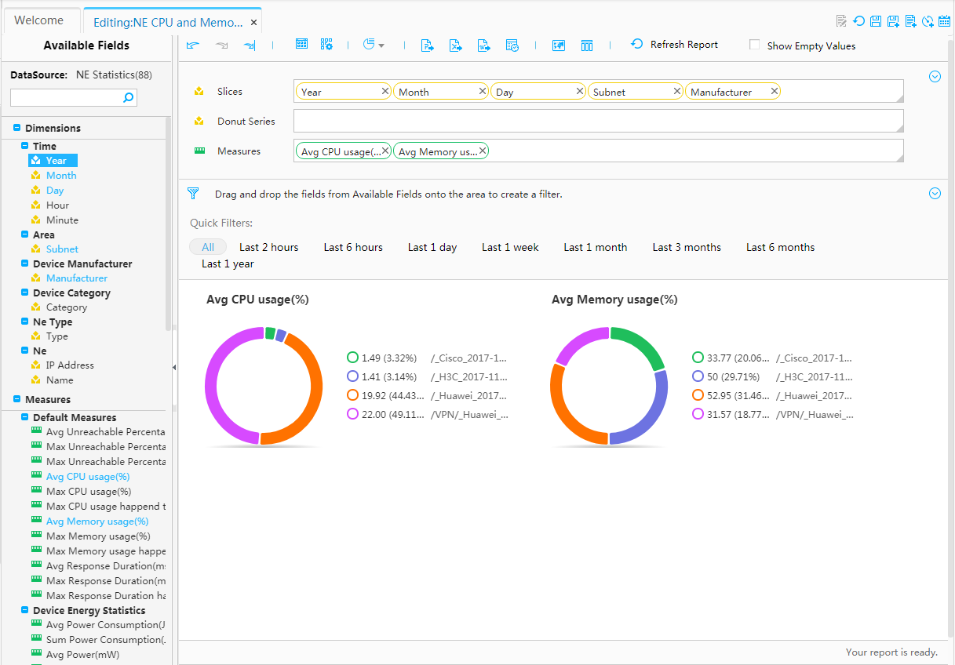

Selected measurements

Selected dimensions

### Customizing the Dashboard

When users want to monitor multiple KPIs on one page in real time and view the association between the KPI data, traditional reports cannot meet their requirements. The dashboard of eSight Agile Reporter displays multiple agile reports on one page and supports association between reports as well as real-time updating of report data. The dashboard helps users obtain KPI change information in a timely manner.

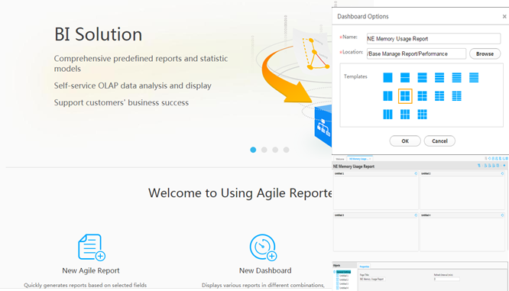



### Creating Periodic Reports

Agile Reporter uses the periodical report task manager to generate reports periodically at the specified time. Users can also set email notification information and manually export historical reports in Excel or PDF format.

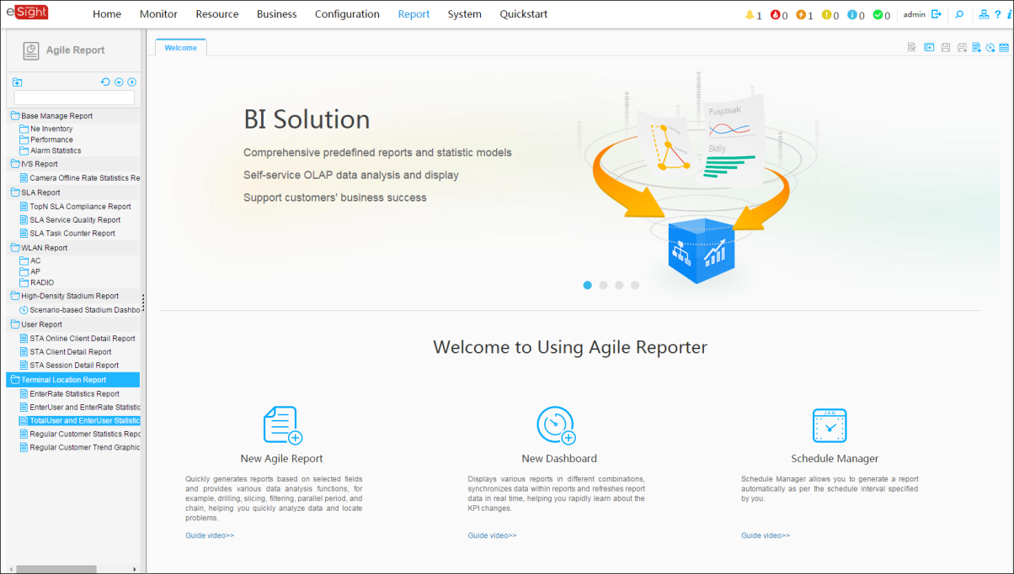

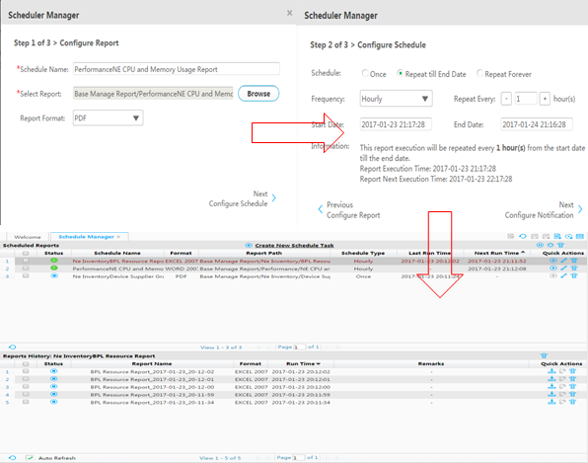

# Experience

The comparison between agile reports and traditional reports is as follows:

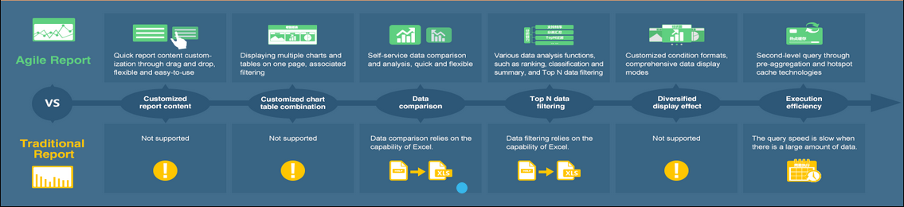

# Acronyms and Abbreviations

|  |  |
| --- | --- |
| Acronym/Abbreviation | Full Name |
| OLAP | Online Analytical Processing |
| MOLAP | Multidimensional Online Analytical Processing |
| ROLAP | Relational Online Analytical Processing |
| UniBI | Unified Business Intelligence |
| ETL | Extract-Transform-Load |
| BI | Business Intelligence |