|  |  |  |  |  |
| --- | --- | --- | --- | --- |
|  |  | | |  |
|  | | |
|  | | |
| 方圆ok1 | | | |
|  | **Huawei eSight**  Hyper-Converged  Infrastructure Management Technical White Paper | | 附件1-16K |
|  | |
| **Issue** | **01** |
| **Date** | **June 12, 2017** |
|  | |
| HUAWEI TECHNOLOGIES CO., LTD. | |
|  | | |

|  |
| --- |
| Copyright © 2017Kept copyright date, since this paper was first published in 2017 Huawei Technologies Co., Ltd.. All rights reserved.  No part of this document may be reproduced or transmitted in any form or by any means without the prior written consent of Huawei Technologies Co., Ltd.  Trademarks and Permissions  附件3-图 and other Huawei trademarks are trademarks of Huawei Technologies Co., Ltd.  All other trademarks and trade names mentioned in this document are the property of their respective holders.  Notice  The purchased products, services, and features are stipulated by the contract made between Huawei and the customer. All or part of the products, services, and features described in this document may not be within the purchase scope or the usage scope. Unless otherwise specified in the contract, all statements, information, and recommendations in this document are provided “AS IS” without warranties, guarantees, or representations of any kind, either express or implied.  The information in this document is subject to change without notice. Every effort has been made in the preparation of this document to ensure accuracy of the contents, but all statements, information, and recommendations in this document do not constitute a warranty of any kind, express or implied. |

|  |  |
| --- | --- |
| Huawei Technologies Co., Ltd. | |
| Address: | Huawei Industrial Base  Bantian, Longgang  Shenzhen 518129  People’s Republic of China |
| Website: | <http://e.huawei.com> |

Contents

1 Executive Summary 1

2 Product Overview 2

2.1 Overview 2

2.2 Key Technical Features 3

3 Product Functions 4

3.1 Hyper-Converged Infrastructure Resource Management 4

3.1.1 Hyper-Converged Infrastructure Access 4

3.1.2 Basic Information About the Hyper-Converged Infrastructure 4

3.2 Hyper-Converged Infrastructure Management Monitoring 5

3.2.1 Performance Management 5

3.2.2 Alarm Management 6

3.2.3 Topology Management 7

A Acronyms and Abbreviations 8

# Executive Summary

eSight is a new-generation enterprise ICT device management solution provided by Huawei. As a component of the Huawei eSight solution, the eSight Hyper-Converged Infrastructure management component helps O&M personnel manage hyper-converged infrastructures throughout their lifecycles to improve O&M efficiency and reduce O&M costs.

# Product Overview

## Overview

To meet enterprise customers’ demands, Huawei eSight introduces technologies including component orientation and web orientation, network-wide status monitoring and restoration measures, such as unified alarm and performance management, and various optional service components. Huawei eSight helps enterprises build customized and easy-to-use O&M environments that allow enterprises to easily manage network-wide ICT devices with only one set of management software.

eSight Hyper-Converged Infrastructure management scheme

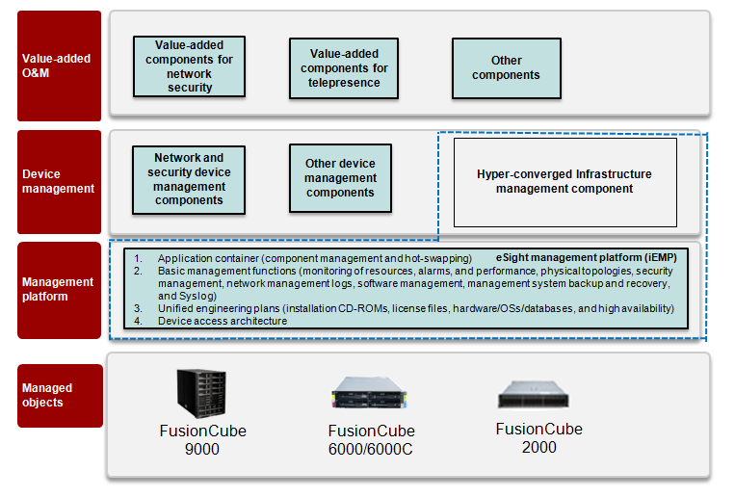

## Key Technical Features

1. Network-Wide Device Status Monitoring for Overall Service Control

The eSight Hyper-Converged Infrastructure management component provides basic management and monitoring capabilities of hyper-converged infrastructure devices. It can implement comprehensive monitoring of the status and performance of hyper-converged infrastructure devices and quickly discover faulty devices.

1. Centralized Network-Wide Device Management

The eSight Hyper-Converged Infrastructure management component supports branch management. It enables users to manage multiple sets of FusionCube hyper-converged infrastructures that are distributed in multiple locations.

# Product Functions

## Hyper-Converged Infrastructure Resource Management

### Hyper-Converged Infrastructure Access

The eSight Hyper-Converged Infrastructure management component provides the following device access modes:

* Adding a single device: Configure basic information about a device and add it to the management system manually.
* Importing devices in batches: Configure key device information in a template and use the template to import devices into the management system manually.

|  |  |  |  |
| --- | --- | --- | --- |
| Component Type | Device Access Mode | | Access Protocol |
| Adding a Single Device | Importing Devices in Batches |
| Hyper-converged infrastructure | Supported | Supported | REST |

### Basic Information About the Hyper-Converged Infrastructure

The eSight Hyper-Converged Infrastructure management component can be used to obtain basic information about hardware, storage, and VMs.

|  |  |  |  |
| --- | --- | --- | --- |
| Scenario | Basic Information | | |
| Hardware | Storage | VM |
| FusionSphere | Supported | Supported | Supported |
| VMware | Supported | Supported | Supported |
| Database | Supported | Supported | Not supported |
| Storage resource pool | Supported | Supported | Not supported |

* Hardware information
* Chassis information: name, product model, Management Module (MM) status, MM floating IP address, cabinet, and chassis
* Server information: name, running status, node type, product model, management IP address, BMC IP address, cabinet, chassis, and slot
* Switch information: name, product model, management IP address, status, cabinet, and chassis
* Storage information

Name, status, management IP address, total capacity, usage, used capacity, allocated capacity, primary storage type, and cache type

* VM information

Name, status, management IP address, cluster to which the VM belongs, and server where the VM is located

## Hyper-Converged Infrastructure Management Monitoring

### Performance Management

The eSight Hyper-Converged Infrastructure management component provides functions such as performance data collection, real-time resource monitoring, historical performance analysis, and visual display to help IT personnel analyze and predict service resource bottlenecks and effectively evaluate the resource utilization and service efficiency. Then IT personnel can optimize device performance and configuration accordingly to improve the IT system production value and business competitiveness.

* Simplified performance monitoring helps O&M personnel eliminate potential system faults in advance so that less time and effort are required for fault diagnosis. The statistical analysis function helps improve device maintenance efficiency.
* Real-time performance and historical performance data is displayed in line graphs. Performance data files (CSV files) can be exported to meet O&M personnel’s requirements for data viewing and statistics collection.
* Users can customize performance data-collection cycles based on different device configurations to meet various performance-data analysis requirements.

The eSight Hyper-Converged Infrastructure management component collects and displays various device performance indicators to help users determine device operating health status. These indicators are reliable for decision-making about device deployment and service adjustment.

Performance management includes the following:

* Preset performance data-collection template: When creating performance data-collection tasks, users can directly load preset performance data-collection templates to quickly configure performance indicators for specified devices.
* Task-based management: Users can create tasks to collect performance data flexibly. After such tasks are executed and data is collected, users can view historical performance data of specified devices.
* Performance indicator monitoring: The eSight Hyper-Converged Infrastructure management component can detect and report service resource-performance threshold alarms promptly.
* Historical performance data viewing: The eSight Hyper-Converged Infrastructure management component shows historical performance trends in graphs and tables to help decision-making.

Server performance indicator list

|  |  |
| --- | --- |
| Object | Performance Indicator |
| CPU | Usage |
| Memory | Usage |
| Storage pool | Usage |

### Alarm Management

1. Overview

The eSight Hyper-Converged Infrastructure management component provides a unified alarm management mechanism to help users quickly locate and rectify faults. This helps reduce the possibility of device faults and improves device reliability.

The eSight Hyper-Converged Infrastructure management component monitors alarms in a unified manner and promptly informs O&M personnel of alarms by using audio and visual notifications, SMSs, or emails. It also supports real-time information updates on the Graphical User Interface (GUI). O&M personnel can take measures promptly to restore services.

Alarm-handling process



The eSight Hyper-Converged Infrastructure management component monitors comprehensive and refined hardware alarm information of servers and alarm information of the eSight system. These comprise CPU hardware alarms, high temperature alarms, mainboard voltage alarms, fan module alarms, Power Supply Unit (PSU) alarms, bus alarms, memory alarms, hard disk alarms, system operating alarms, device management module alarms, switch module alarms, device offline alarms, performance-threshold alarms, and network management system performance alarms.

The eSight Hyper-Converged Infrastructure management component provides the following functions to implement unified and centralized alarm management:

* Convenient alarm information query and retrieval: user-defined alarm filtering, refreshing, sorting by attribute, and severity redefinition meet requirements in various scenarios
* Alarm consolidation: duplicate alarms can be automatically consolidated to simplify alarm processing
* Various remote notification modes: emails, SMSs, and audio and visual notifications (alarm boxes) are supported to meet different alarm notification requirements and ensure troubleshooting efficiency
* Alarm management knowledge base: supports alarm management, including alarm masking and maintenance, to improve alarm handling accuracy and efficiency
* Other functions: alarm statistics, export, deletion, and dump

### Topology Management

The topology view displays the layout and status of network elements, subnets, and links to help IT personnel determine the network topology and monitor network-operating status in real time. The topology view can automatically update network status based on accessed devices.

Topology view

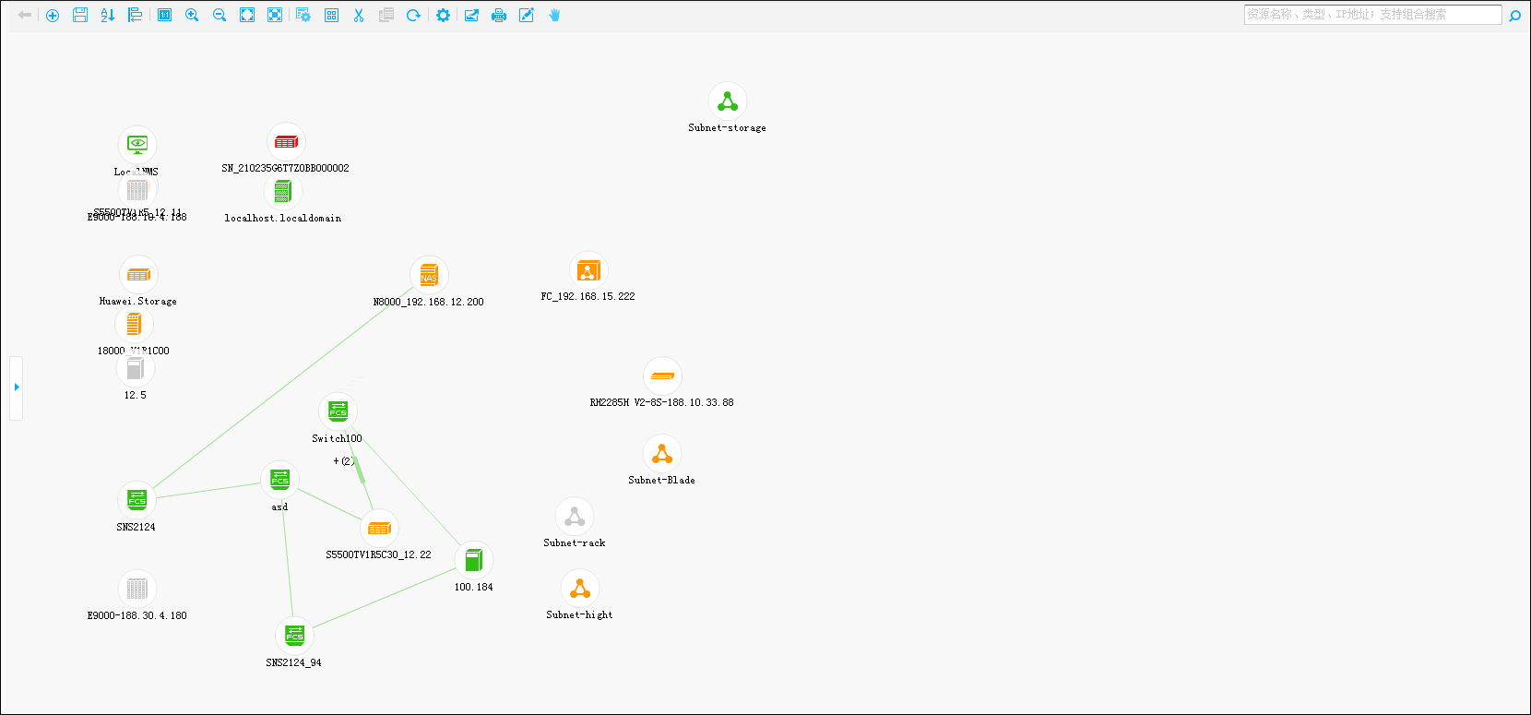

1. Acronyms and Abbreviations

|  |  |
| --- | --- |
| **M** |  |
| MM | Management Module |