 |  | Agile Controller-Campus Simplified Brochure
[Product Overview] | [Solution Description]  With the rapid development of the enterprise business and the comprehensive digitalization of campus network, the campus network becomes complicated. A comprehensive network that can carry wired, wireless, IoT and isolated from each other is constructed, in which the requirements for access and isolation of various data terminals and sensor devices in a campus are increasingly urgent. The overall network architecture is required to meet the development needs of the future technologies in terms of performance, capacity, high reliability, and technical application. It also can be expanded as needed, without adjustment of the architecture. These types of services pose the following challenges on statically configured traditional networks:  - How to achieve multi-network convergence management and effective isolation for different private networks, different devices, different locations, and different terminals?  - How to dynamically configure and adjust the user access location, user permissions, QoS, bandwidth, application and security policies?  In Huawei next-generation campus virtualization network solution, the Agile Controller-Campus provides unified network access and management for the enterprise campus network, centrally controls user rights, QoS, bandwidth, applications, and security policies, and provides automatic configuration of VXLAN virtual networks. It realizes multi-network convergence and private network dedicated to the network, effectively implement enterprise service policies, guarantees the user's business experience, and enables the network to serve the business more agilely and conveniently.  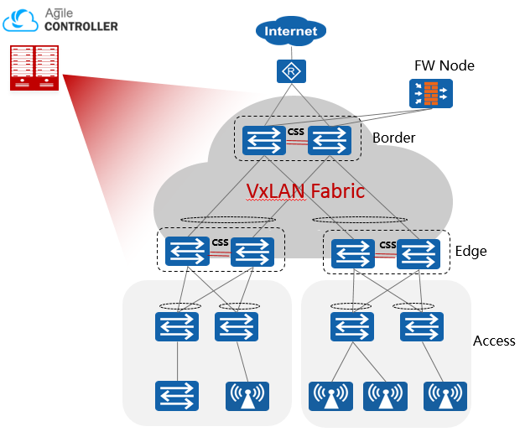  Based on the Spine-Leaf architecture, the Huawei campus virtualization network is composed of a large Layer 2 virtual network: the core switch acts as the Spine and southbound and northbound gateways (Border), and the aggregation node acts as the leaf and east-west distributed gateway. The Agile Controller-Campus controls the Spine/Leaf network devices to automatically deliver the Overlay network and adjust the policy. The virtual network can be automatically deployed based on the actual needs of the service. Each virtual network is isolated from each other by default to improve network security.
The Agile Controller-Campus is a cloud-based management and control platform networks provided by Huawei for campus network.
It can centrally control user rights, quality of service QoS , bandwidth, applications, and security policies over campus networks. It also supports automatic configuration of VXLAN virtual networks, provides simple, fast, and intelligent campus virtualization provisioning based on services, making networks more agile for services.

The Agile Controller-Campus provides a virtual network automation management solution, which supports multiple services to share the same physical network. The logical isolation between services and the ability to control internal communication within the same service can cover industries such as finance, government, education, medical, hotels and etc.

[Architecture and Key Components/Key Components]
Based on the distributed architecture, Agile Controller-Campus provides the following feature, basic network configuration, plug-and-play, Network access, Online service, which implement the end-to-end automatically cloud management.
Besides, Agile Controller-Campus has not only provides the Northbound API for the valued application scenario from third party vendor, but also the southbound API for the communication with Cloud devices(AP, switch, Firewall, AR) via the following protocols, Netconf, SSH, Http2.0/Https, etc.
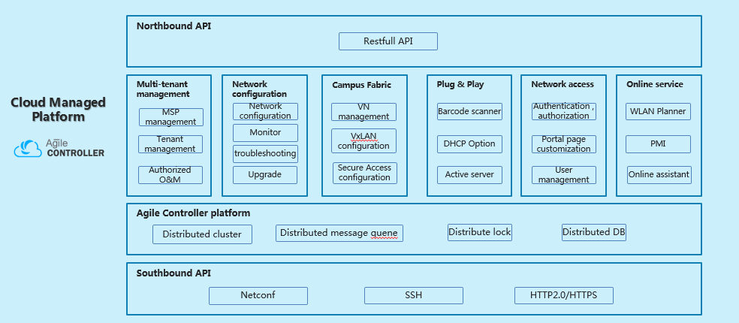
Huawei Agile Controller-Campus System Architecture

[Key Features]
Virtual network automation management
The Agile Controller-Campus implements automatic management of device, fabric and virtual network.
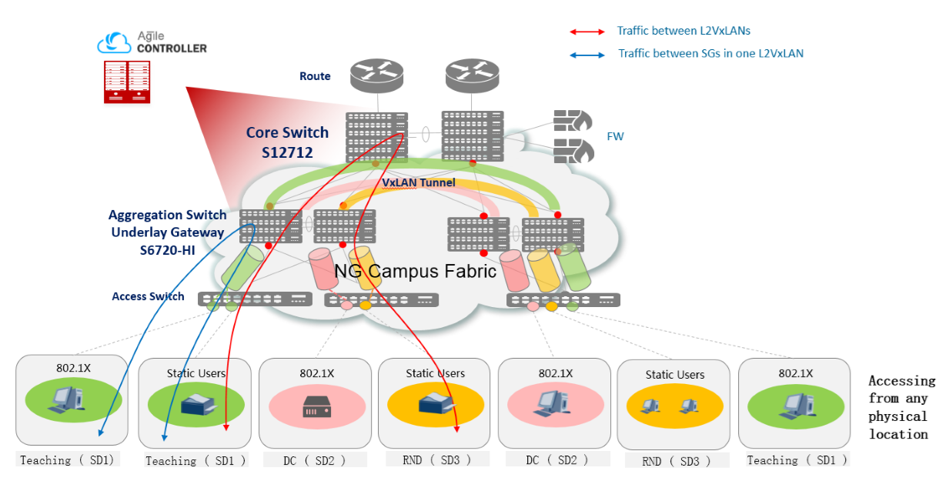
- Device management
Device management is a basic resource management function. You can add devices to be used on a virtual network by using the ESN or model and configure global resource information on the virtual network.
- Fabric management
In the fabric management, you need to add the device information to be used in the current fabric network, and set the device roles, such as the core, aggregation, and access, link management, and physical topology presentation (Underlay), configure the fabric to use external resources, such as the DHCP server and external gateway.
- Virtual network management
In the virtual network management, adds the virtual network subnet configuration, wired access configuration, such as PC, IP phone, and user-defined device access, wireless access configuration, and logical topology presentation (overlay). All virtual network configurations are configured on the web page, after the configuration is complete, the configuration is automatically delivered and the virtual network is created.

Automatic deployment of user policies
Agile Controller-Campus supports user access control policies and user group access and isolation policies insides the virtual network.
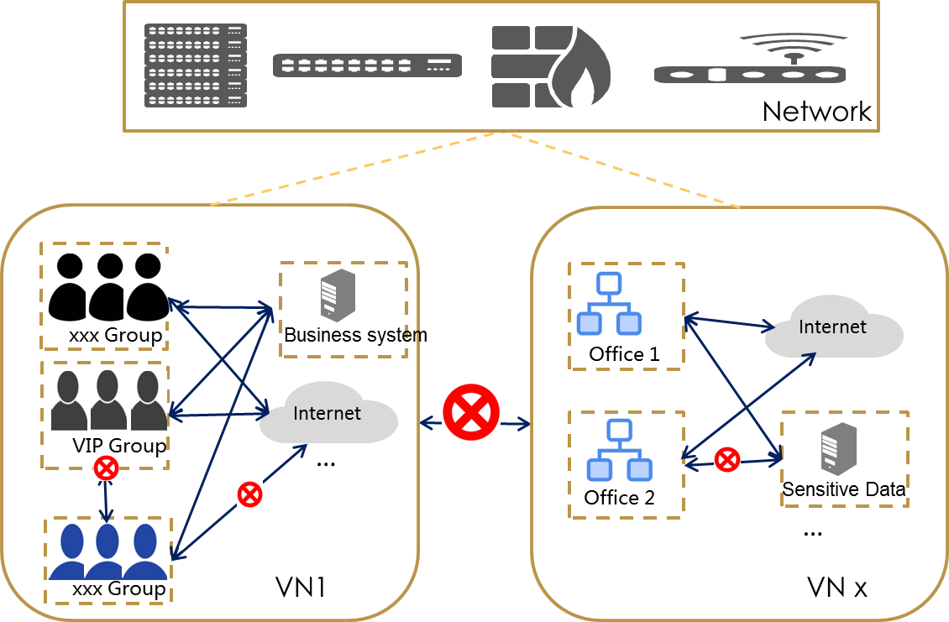
Policy control
It has two layer policies:
- Macro level:
All the virtual network is standalone and isolated to each other by default. With the isolation between the VNs, and the virtual network is secure. If there is any access requirement between the VNs, network administrator must configure the access permit policy on the FW which is bypass to the Core switch. So the access permit policy between the VNs will be execution on the FW in the macro level.
- Micro level:
The solution has provided the network access control policy according to different user group for one VN, and network administrator can configure the access or deny network access control permission for different user group. Network access control policy insides the VN will be executed by the aggregation layer switch in the micro level.
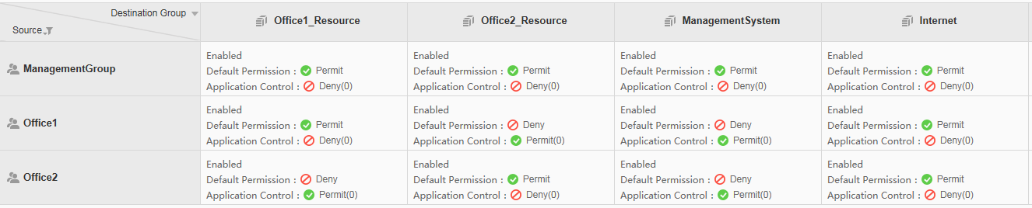
User group access control policy in VN
According to the requirement in the customer network, the whole network will plan into Business Department1, and Business Department2, and the Management department (such as administration team). Business department 1 will has permission to access internet, resource server group 1; Business department 2 will has permission to access internet, resource server group 2; Management department will has permission to access internet, resource server group 1 and resource server group 2 and the management system.
The platform has provide the refined access control policy on the Policy Matrix for the network access requirement.
- Visualized management of virtualized networks
After the service configuration is completed, you can query the service configuration status and view the network delivery result in real time.
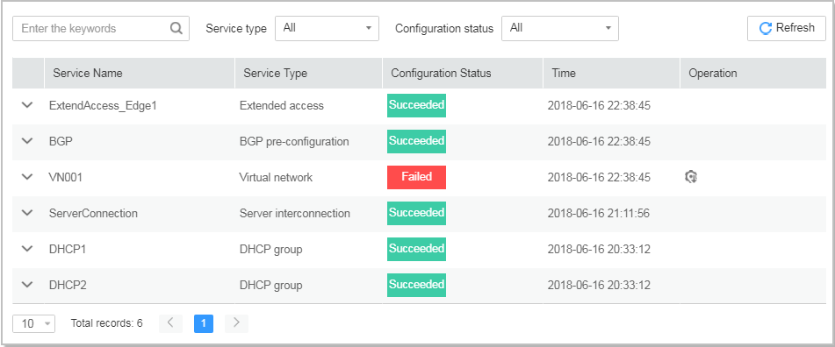
- Physical network and underlay physical topology display
The physical topology is displayed in dimension of fabric. The device information, link information, and connected AP list are displayed to facilitate the management of physical network underlay.
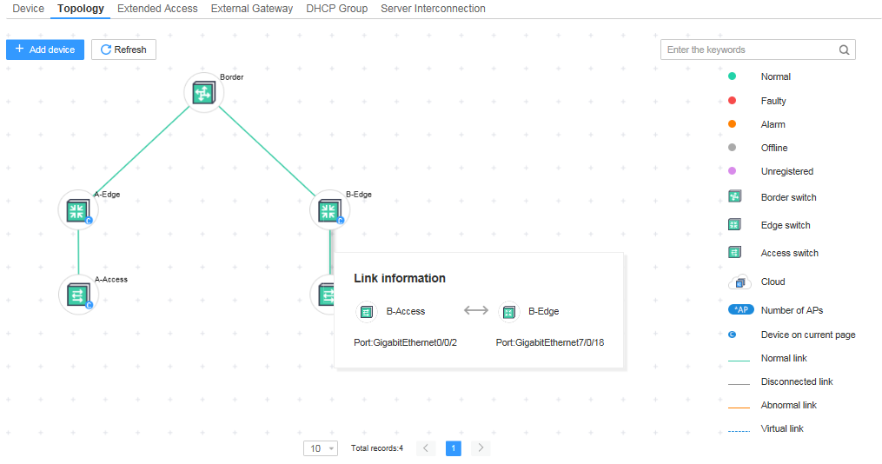
- Virtual network overlay logical topology display
The logical network topology and parameter information are displayed, based on the VN granularity of the virtual network, facilitating the maintenance of the virtual overlay network.
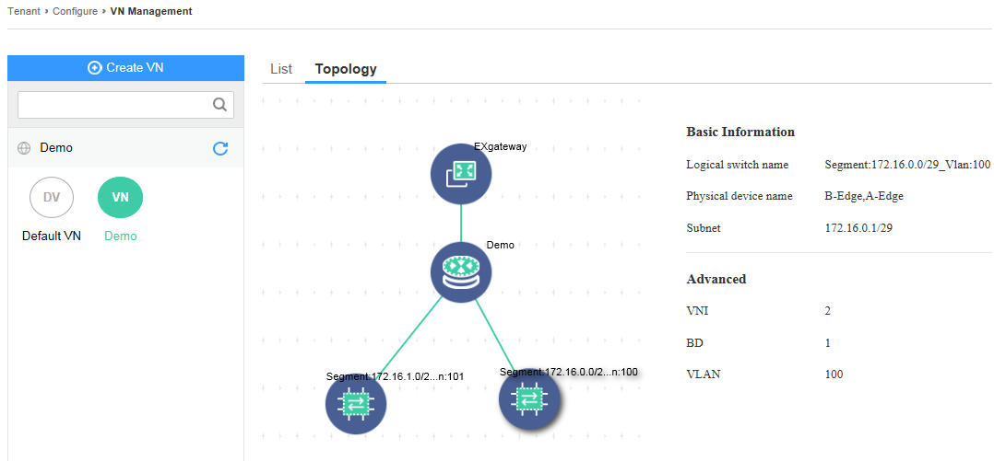

[Highlight/Benefits]
Rapid construction of campus network services, effectively reducing the OPEX of network deployment
- Network configuration wizard, network administrator can implement the deployment of virtual network with 3 steps in 10 minutes.
- Virtual network automation configuration distribution.
- Policy matrix configuration, reduce the difficult of network design plan.

Converged access management, covering wired and wireless network scenarios
- Converged wired and wireless network access control in the VxLAN network.
- Multiple authentication protocols, including 802.1x, Portal, and MAC authentication.
- Unified user policy for staff of company, guest, device admin, and dumb terminals.
- Unified authorization resulton the Access permit/deny access, Access bandwidth, Application filtering, QoS, and Security policies.

Simplified O&M and visualized physical network
- Whole network visible, physical network and logical network topo, etc..
- Network O&M based on the network topo.

Flexible and openness
- The distributed VxLAN solution is based on the standard and open BGP-EVPN protocol.
- Flexible architecture design, supporting elastic capacity expansion of virtual networks and server platforms
- Comprehensive reliability design to ensure smooth service running

[Specification List]
Specifications | Description
Basic network management | Support adding devices according to ESN or models, supporting batch import and replacement of devices.
 | Supports upload, modify, delete, and query functions of software package files/patch files and supports for software package/software patch file installation.
 | Supports fabric management, and creates and modifies fabric names. Supports the device to be added to the fabric, and supports setting the device role and setting the route reflector (RRs). Supports the broadcast, multicast, and unknown unicast suppression of the fabric, and sets the corresponding CIR and CBS.
 | Supports global resource pool management, including BD resource management, VLAN resource management, VNI resource management, and subnet resource management.
 | Supports the core acts as VXLAN's north-south export gateway, aggregate acts as the VXLAN distributed gateway, performs overall policy authentication control, and access acts as the access control point of the campus authentication user.
 | Support for setting device roles in the fabric: core, aggregation, and access.
 | Support three types of service scenarios: aggregation for access control and authentication point in VXLAN, policy linkage between aggregation and primary AS, and policy linkage between aggregation and secondary AS.
 | Wireless access supports AP access to implement policy association and wireless access supports AP as the access control point.
Authentication management | Supports multiple authentication modes, such as 802.1X, Portal, and MAC.
 | Supports PAP, CHAP, EAP-MD5, EAP-PEAP-MSCHAPv2, EAP-TLS, EAP-TTLS-PAP, and EAP-PEAP-GTC identity authentication protocols.
 | Supports anonymous authentication, account authentication, certificate authentication, AD/LDAP authentication, third-party database authentication, and RADIUS relay authentication.
Authorization management | Supports authorization based on user groups, accounts, roles, SSIDs, time ranges, terminal IP addresses, terminal device groups and access device groups.
 | Supports authorization based on the dynamic ACLs, static ACLs, VLANs, user groups, and security groups.
Free mobility | Supports security group-based authorization and deployment of rights and QoS based on security groups.
 | Supports global and local policies, and separate policy deployment for a single device.
Virtual network management | Supports distributed virtual network management. The core device is the southbound and northbound gateway. The aggregation device acts as the distributed VXLAN gateway to distribute internal networks. The BGP-EVPN protocol is used as the control plane protocol of the virtual network.
 | Support for deploying third-party DHCP servers to manage IP distribution. Multiple DHCP servers can be configured as a DHCP group to provide backup or load balancing capabilities, and multiple DHCP groups can be created.
 | Supports the service provisioning of the virtual network, including configuring multiple external gateways; configuring the DHCP relay group; supporting the configuration of subnets; supporting the configuration of wired access services; and supporting the configuration of wireless services.
 | The virtual network supports wired access, including PC, IP Phone wired, and custom wired terminals (printers, cameras, etc.).
 | The virtual network VN supports wireless access. The wireless access supports the AP as the access control point, and the aggregated as the e authentication point, and then the VXLAN is entered. Wireless terminal access can be authenticated and non-authenticated, including 1X, MAC, and Portal authentication.
Visualized O&M | Support port management, including reading ports on the device, viewing physical ports and eth-trunk ports based on a single device
 | Supports link management, including reading links on devices, viewing physical links based on a single device, enabling start/stop reading of links on devices, and viewing read progress and results.
 | Supports physical topology presentation, including displaying physical topologies by fabric, displaying device information, displaying link information, and viewing the list of connected APs.
 | Supports logical topology display, including displaying the logical network topology and parameter information based on the virtual network.
Online assistant | - The Agile Controller-Campus integrates Huawei's iKnow intelligent online service platform.  - The Agile Controller-Campus supports smart FAQs and online customer services to help users quickly resolve problems.
System Architecture | - The Agile Controller-Campus is based on the B/S architecture.  - The Agile Controller-Campus supports minimum cluster and distributed deployment modes.

[Running Environment]
Platform | Configuration Requirements of Physical Server | Configuration Requirements of VM | Software requirment
Cloud management platform | CPU：10 core 2.4G * 2；  Memory：128G；  Hard disk：system disk 600G*2（RAID1），FI data disk：600G*3；  IO：IOPS：5k IOPS，4kB random write rate：up to 20MB/s；  Network adapter：8*GE NICs | CPU：30 core >=2.4G；  Memory：128G（at least 112G）；  Hard disk：600G，FI data disk:600G*3；  IO：IOPS：5k IOPS、4kB random write rate：up to 20MB/s；  Network adapter：4*GE NICs | SuSE Linux 12SP2(English)
Authentication component | CPU：2*8Core2.1GHz（E5-2620 V4）  Memory：32G  Hard disk：2*600G  Network adapter：4* GE NICs | CPU：2*8Core 2.1GHz, exclusive mode  Memory：32G  Hard disk：2*600G  Network adapter：4* GE NICs | - Windows Server 2012/2016 R2 Standard (X64) (Chinese) +Microsoft SQL Server 2012/2016 R2 Standard (Chinese)  - Windows Server 2012/2016 R2 Standard (X64) (English) +Microsoft SQL Server 2012/2016 R2 Standard (English)  - SUSE Linux 11 SP3+Oracle 11G R2

[Subscription information/Ordering Information]
Description | Quantity Range | Remarks
1.1 Cloud management software
Cloud management platform | 1 | Mandatory
SnS annual fee of the cloud management platform | 1,2,3 | Mandatory. It can be 1, 2, or 3 years.
Automatic virtual network management | 1-N | Mandatory. It is quoted based on the number of Border and Edge devices.
SnS annual fee for virtual network automation management | 1,2,3 | Mandatory. It can be 1, 2, or 3 years.
1.2 Authentication server software
Access management | 1 | Optional
Access management terminal license | Step | There are more than 50, 200, 500, 1000, 2000, 5000, 10000, and 50000 users.
Free mobility | 1 | Optional
1.2 Hardware server and other purchased parts (optional)
Rack server RH1288H | 1-N | Optional
Rack server RH2288H V2 | 1-N | Optional
Operating system SuSE Linux 12 SP2 | 1-N | Optional
Operating system: Windows Server 2008 | 1-N | Optional
Big data analysis platform | 3-N | Mandatory. Select the number of nodes based on the network scale.
Big data analysis SnS annual fee | 1,2,3 | Mandatory. It can be 1, 2, or 3 years.

More information
For more information about Huawei Agile Controller-Campus, please visit
http://www.huawei.com

