Indoor High Power Ceiling AP
Model: A293

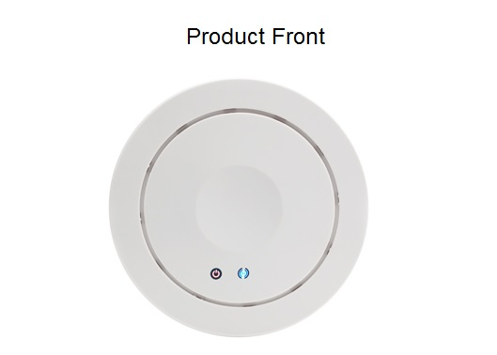

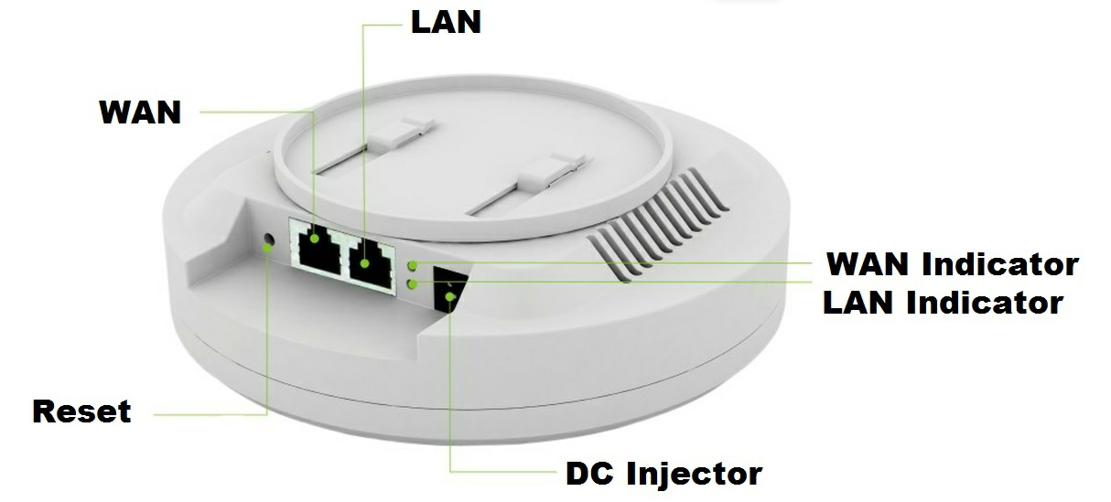

Description:

What It Does
XD9508 is a best-in-class 802.11n indoor access point designed specifically for business-class environments such as hotels, airports, coffee shops, shopping centers, sporting venues, and university campus. With transfer rates of up to 300Mbps in the 2.4 GHz frequency range, the device provides an adequate level of service to all users who connect with legacy 802.11b/g adapters in addition to the latest 802.11n adapters for faster downloads and instant communication. Integrated 802.3af Power over Ethernet (PoE) allows installation in areas where power outlets are not readily available. Internally equipped with 2X2 multiple-input, multiple-output (MIMO) antennas improve range and maximize data rates. Field tested to wirelessly cover 16-20 hotel rooms at an indoor operating distance of 40-50 meters and allow simultaneous accesses by up to 30 users.

Stylish Ceiling Mount Design
Housed in a stylish ceiling mountable case, the XD9508 can be installed on a wall or ceiling just as a ceiling lamp and blends in nicely with most interior decorations in a modern hotel. Installed highly on ceiling, it extends optimum wireless signal to multiple neighboring rooms.

Whole Coverage
Internally equipped with 2X 2 multiple-input, multiple-output (MIMO) antennas improve range and maximize data rates. Field tested to wirelessly cover 16-20 hotel rooms at an indoor operating distance of 40-50 meters and allow simultaneous accesses by up to 30 users. Up to 300Mbps wireless rate ensures multiple users an adequate level of service.

Power over Ethernet
The device has integrated 802.3af/at Power over Ethernet (PoE) for easy installation and lower cost. So it can be installed in areas where power outlets are not readily available, eliminating the mess of altering existing network infrastructure.

VLAN & Access Control System
Our XD9508 compatiable with 802.1Q standard, it make network broadcast more effective, more easy to monitor the networking, manage the LAN traffic, then to achieve the communication between different geographical sectors;

With Access Control System, it is easy to manage and control our ceiling AP in user name, passwords, channel, IP address change...

Specification
Hardware
MCU | RT3052
RF | 2T2R, 300Mbps MIMO tech , comply with IEEE 802.11N standard  IEEE 802.3af/at
Memory | 32MB DDR RAM (May extend to 64MB)
Flash | 4MB(May extend to 8MB)
Interface | 2 x RJ-45 for 10/100 Mbps WAN/LAN Port (Support 48V POE)
Interface | 1 x Reset button(Reset & Factory Defaults)
Interface | 1 x Power DC Jack
Power | PoE: 48V/1A; DC: 12V/1A; 110V/220V
Antenna | Build in 2PCS Omni Airgain 5dbi antenna
Size | 16.8*4.5CM
RF
Frequency | 802.11b/g/n:
Frequency | 2.4~2.4835GHz
Frequency | U.S.,Europe and Japan product covering 2.400 to 2.4835 GHz,programmable for different country regulations
Modulation | OFDM = BPSK,QPSK, 16-QAM, 64-QAM
Modulation | DSSS = DBPSK, DQPSK, CCK
Throughput | 300 Mbps
Sensitivity | 802.11n(2.4GHz) | 802.11g | 802.11b
Sensitivity | -90dBm @ MCS0 | - 90dBm @ 6Mbps | - 95dBm @ 1Mbps
Sensitivity | -70dBm @ MCS7 | - 72dBm @ 54Mbps | - 90dBm @ 11Mbps
Sensitivity | -90dBm @ MCS8
Sensitivity | -68dBm @ MCS15
Output Power |  | Radio1(WLAN1)
Output Power | 802.11n(2.4GHz)(± 1.5dBm) | 802.11g(± 1.5dBm) | 802.11b(±1.5dBm)
Output Power | 29dBm@ MCS0~2/MCS8~10 | 29dBm @ 6~24Mbps | 29dBm @1~11Mbps
Output Power | 28dBm @ MCS3/MCS11 | 28dBm @ 36Mbps
Output Power | 27dBm @ MCS4/MCS12 | 27dBm @ 48Mbps
Output Power | 25dBm @ MCS5/MCS13 | 25dBm @ 54Mbps
Output Power | 25dBm @ MCS6/MCS14
Output Power | 24dBm @ MCS7/MCS15

Software
Operation Mode | Gateway/ AP/ Repeater/ WDS / WISP
Protocol/Standard | IEEE 802.3(Ethernet)
Protocol/Standard | IEEE 802.3u(Fast Ethernet)
Protocol/Standard | IEEE 802.11b/g/n(2.4G WLAN)
Wireless | Auto-Channel selection
Wireless | Distance Control (802.1x Ack timeout)
Wireless | Multiple SSID (4 SSID)
Wireless | BSSID
Security | WEP Encryption-64/128/152 bit
Security | WPA/WPA2 Personal (WPA-PSK using TKIP or AES)
Security | WPA/WPA2 Enterprise (WPA-EAP using TKIP)
Security | Hide SSID
Management
System Settings |  | Web-based configuration (HTTP/Telnet)
Firmware Upgrade |  | Upgrade firmware via web browser or TFTP
Administration |  | Admin Password can be configured
System monitoring |  | Watch dog, Status in hand , useful statistic and Event log
Logs |  | Supports local logs, logs host, logs file export
Reset |  | Reset or factory defaults
Backup |  | Restore settings & configuration of the device to local file, Scheduled reboot
Physical Property
Temperature |  | Working: 0°C~55°C
 |  | Storage: -20°C to 70°C
Humidity |  | 5%~95% (typical)
Package
XD9508 complete set

User Manual
90mm LAN Cable

Application:
- Application place: hotels, airports, coffee shops, shopping centers, sporting venues, and university campus...
- Working Mode: Gateway/ AP/ WDS/ Bridge/WISP, pls refer following picture for more info

